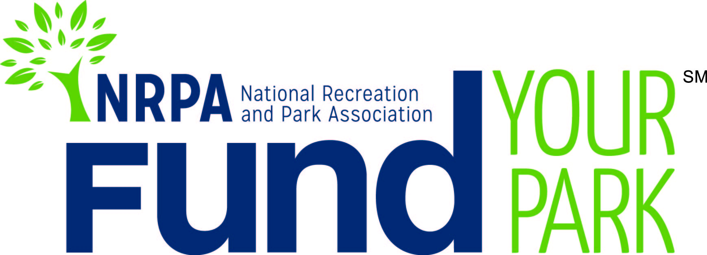

Campaign Toolkit
Toolkit Purpose

This toolkit will provide you with the basic information you need to plan and execute a successful campaign on the Fund Your Park platform. From crafting your story to garnering media attention, this kit will give you tactics used by the most successful crowdfunding campaigns.

If you have questions or need assistance, don’t hesitate to contact me.

Thank you,

Michele White
Executive Assistant
Phone: 703.858.2144
Email: mwhite@nrpa.org

Before You Start
Pick Your Project
First things first, what is it that you are going to fundraise around? Remember crowdfunding is no different than other types of fundraising in that, you need others to help support and fund your project. What is it that you community really wants? Are there friends groups working on a project that you can use as a grassroots team in your fundraising? Consider projects that already have awareness in your community. If your project is a brand new idea, your ramp up time will be much longer as you will have to develop support for your project first to ensure a successful campaign.

Build Your Campaign

Tell Your Story
To get funding for your project, it’s important to make your story personal and compelling. You aren’t just asking for funds to complete a project on your to-do list, you’re asking your community to rally around a project that will have a direct impact on their lives. When crafting your story, tell your audience why you are passionate about your project, what you are trying to achieve and how it will impact your community. Tell it in a way that would make you want to support it too!

Answer these questions and use the answers as talking points for your website, emails and other communications:

- What will your project do?
- What need will your project fill?
- What makes your project special?
- How will your project make a difference?

Put Together Your A-Team
Choose at least 2 to 3 people to join your crowdfunding team. Whether they are from your organization or not, a good team will help with the outreach and development of your campaign. If you can, choose people with expertise in social media, have large social networks, or are seasoned fundraisers. If more people are willing to help spread the word, add them to the team.

Visuals for Your Campaign
Showing the impact of your story is as important as telling it. Videos and photos are essential to making your campaign stand out.

- Videos
  - Campaigns with videos get 300 percent more attention than those without. If you can, create a video that is specific, honest, personal and less than 3 minutes long. Videos don’t have to be professionally done.
  - To incorporate your video on the Fund Your Park platform, just post to YouTube or Vimeo and grab the embed code.

- Photos
  - Photos should be used throughout your campaign on all your marketing platforms.
  - Obtain a photo release form from community members, if necessary.
  - Photo requirements for your Fund Your Park page:
    - Should be 4:3 aspect ratio and JPEG, PNG or GIF format
    - No more than 1200 x 1200px and under 2MB
    - Photos under 730 x 550px will be scaled to fit
    - All uploaded photos to your Fund Your Park page will appear in a slider along with your video. However, you can also take the URL from your uploaded photo and insert it into the text using the text editor feature.

Set Your Goal
When setting your funding goal, keep these hints in mind:

- Make your goal realistic. Setting a lower, more realistic goal often means you’ll raise more money than setting a lofty one. People want to be a part of a successful project and, generally, won’t stop funding once a goal has been met.
- Try breaking large projects into smaller ones so each is realistically fundable with one campaign.
- Approximately 15 to 20 percent of those you contact will donate to your project and the average donation is around $60. Make sure your prospective donors list includes enough people to accommodate these averages.

Communicate Your Campaign

Communicate, Collaborate, Connect
Getting the word out about your crowdfunding project early is critical as your first donors will help prime the pump for other donations. A great way to find funding before you launch your campaign is to connect with local sponsors or partner in your community. You can leverage these large donations throughout your campaign and they encourage others to donate to a winning team. Also securing the donations from businesses and other groups on the front end may take some time, so plan accordingly as it might take your team more preparation time than you think before you are ready to launch your campaign.

Reach out to businesses and organizations that might be interested and able to help your project. Ways local businesses may be able to help include:
- Spreading the word through posters, emails or other communications to their networks and customers.
- Provide matching gifts to funds raised.
- Provide a large donation to the funding goal.

Press Releases
You should start crafting your press release well before the launch of your project to ensure it is distributed in time to kick it off and generate a buzz. Use the “Sample Press Release” to get started. If you are unsure of your agency’s procedures for press releases, check with your communications manager or CIO. They can also help you get your message out to local media.

To amplify your press release, look to connect with reporters on these platforms:
- Twitter
- Help a Reporter Out
- Seek or Shout

Marketing 101
You’ll want to utilize all methods of communication and marketing to spread the word about your crowdfunding project. Not only to help solicit donations, but also to make it easy for your community to find out more information about the project. Remember to take into consideration the time and steps that may be required by your internal approval processes. This may impact the timing of your campaign materials.

Marketing opportunities for your project include:
- Your website
  - Once you create your project on the Fund Your Park website, you’ll be able to grab an embed code. Work with your agency’s webmaster to embed the campaign on your homepage.
- Emails
  - Announce the launch of the project, strategic updates and the conclusion. You’ll want to build urgency towards the end of your campaign without getting “spammy.” Ask your Board, volunteers and other supporters to do the same. Always include a link to your Fund Your Park page.
  - Collect a database of emails from your agency, friends groups and sponsors before you start so you can focus on marketing throughout your campaign
- Newsletters and bulletin boards
  - Incorporate information to whatever communications vehicles reach the majority of your community, like your quarterly program guides.
- Social media
  - Use Facebook, Twitter, Instagram and any other social sites you have. See “Sample Social Media Posts” for ideas.
  - Use lots of pictures to show the impact of your project.
  - For Facebook, check your page’s insights to see when your audience is most active and plan posts around those times.
  - Create a hashtag to elevate the visibility of your posts and to tie your social conversations together. Choose a hashtag that is short, related to your project and that isn’t being used by another group or organization.
  - Put your hashtag on your Fund Your Park page and encourage potential donors to share the campaign directly from your page with the social sharing buttons.
- Local Media
  - Newspapers, radio, TV or any other local media outlets you can use to help get the word out

Launch Your Campaign

Build Early Momentum
Ask dedicated leaders and supporters to donate to your campaign in the first 72 hours. Create an early momentum so others will want to donate as well. Try to secure 1/3 of your overall funding goal from dedicated funders by the close of the second week as this will likely spur others to donate.

Keep Communicating
Keep your network engaged and updated by:
- Updating your blog twice a week.
- Posting to Facebook about three times a week—mix up your posts to keep them interesting.
- Tweeting about your project 1 to 2 times a day with updates and pictures. You can use tools like Tweet Deck or Hootsuite to schedule out posts.
- Thanking contributors. Send personal thank you emails or notes after each donation as 20 percent of donations are repeat donors and 62 percent of successful campaigns have repeat funders.
  - Remember to keep donors updated on your progress!

Push Through the Middle Slump
Don’t get concerned if fundraising slows down in the middle of your campaign. However, to keep your network engaged and to secure repeat donors:
- Listen to feedback on your campaign and incorporate any good suggestions or address any concerns.
- Share any great updates/milestones with media—especially if they covered your campaign initially.

Create a Sense of Urgency at the End
While stressful, the end of your campaign gives you some great opportunities to secure the rest of the funds needed to meet your goal. Some ideas include:
- Trying a stunt in the closing days or hours of your campaign (i.e. “We will dance until we are funded!”).
- Using a countdown to create a sense of urgency with your donors.
- Boosting your Facebook posts. For a small fee you can boost your posts to the top of your followers’ newsfeeds.
- Asking involved supporters to close the gap. Make sure to tailor a message specifically to them.

Conclude Your Campaign
Take a bow and remember to:
- Thank everyone who assisted your project through time, money or other means of support.
- Keep your network and donors updated on the progression of your project. As your project evolves, make sure to keep your supporters informed.

Consider throwing a project celebration party when it is completed or invite supporters to a ribbon cutting event. Keeping your supporters engaged is a great way to make them return donors and advocates.

Other Fundraising Resources
The most successful projects use crowdfunding as one of their main tools during their fundraising campaign. For other fundraising resources, please visit http://www.nrpa.org/uploadedFiles/nrpa.org/Grants_and_Partners/Fundraising%20Strategies.pdf

Sample Materials
See following pages

Sample Press Release
[GROUP LOGO/LETTERHEAD]

FOR IMMEDIATE RELEASE
Media Contact:
[Contact Name]
[Agency Name]
[Phone]
[Email]

[Agency Name] Launches Crowdfunding Project to Raise [$Amount] for [Community Project]
Project will [include succinct impact statement about what the project will achieve]

[CITY, STATE ABRV] – [DATE] – [1 to 2 sentences that are straight to the point about how much money you are trying to raise and why. Think of this as your elevator speech.]

The money raised for this project will be used for [explain project in more detail—two shorter paragraphs would be better than one long one. Use the information from your project page].

[QUOTE from Agency leadership, discussing ways you impact your community through health and wellness, social equity, conservation, etc. and tie to Fund Your Park project.]

[Project name] was chosen to be featured on the crowdfunding site, Fund Your Park, through a competitive application process with the National Recreation and Park Association (NRPA). Fund Your Park is a crowdfunding platform designed by NRPA exclusively for park and recreation agencies.

[Agency boilerplate/ “about” information]

The National Recreation and Park Association is a national not-for-profit organization dedicated to advancing park, recreation and conservation efforts that enhance quality of life for all people. Through its network of 50,000 recreation and park professionals and citizens, NRPA encourages the promotion of healthy and active lifestyles, conservation initiatives and equitable access to parks and public space. For more information, visit www.NRPA.org. For digital access to NRPA’s flagship publication, Parks & Recreation, visit www.parksandrecreation.org.
# # #
Sample Social Media Posts

Facebook

- Imagine how great this spot will look with a new [insert element of project]! Donate today. Include photo of a location that will be transformed by the project and shortened link to your Fund Your Park page.
- A donation of just [$X] can provide [X elements of project] to our [project name]! Donate today and be part of this great project! Include photo of the item/element and shortened link to your Fund Your Park page.

Twitter
- Support our crowdfunding campaign to [goal of campaign] that will enrich the lives of all [city] residents! Include shortened link to your Fund Your Park page and project hashtag.
- Retweet! Support @[AgencyHandle]’s [project name]! A [$X] donation can have a big impact! Include shortened link to your Fund Your Park page and project hashtag.
- COUNTDOWN! Only 24 hours left to donate to our [project name/goal]. We’re so close to the goal! Include shortened link to your Fund Your Park page and project hashtag.

