Marketing Toolkit

Contents
Quickstart Checklist 2
Program Background 3
Toolkit Purpose and Overview 3
Timeline 4
Messaging 5
Social Media 7
Sample Posts 7
Facebook and Twitter Images 10
Email Promotion 11
Sample Email Text 11
Press Release 12

Quickstart Checklist

Use the following checklist to help promote the Meet Me at the Park Earth Month campaign and encourage nominations for a local park in your city to receive a $20K grant.
 | Use social media to educate your community about the value and benefits of community parks and the Meet Me at the Park Earth Month campaign. See sample posts on page 7.
 | Follow NRPA and our campaign partners on social media to get all the latest campaign updates. See how to connect on page 7.
 | Visit your favorite park and take a park selfie (aka parkie) to show why you love local parks and encourage others to do the same.
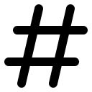 | Use the campaign hashtags on social posts: #MeetMeAtThePark, #CelebrateEarth #Parkies
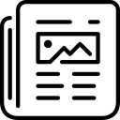 | Send a press release to local print and online newspapers, bloggers and radio personalities to promote your parks and encourage nominations. Sample press release on page 12.
 | Use email and newsletters to encourage nominations from your community. Sample email copy on page 11.
 | Connect with involved citizens and influencers in your community and encourage them to share information about the Meet Me at the Park Earth Month campaign and nominating your city. See campaign talking points on page 5.

Program Background
For the fourth year, the National Recreation and Park Association (NRPA) is collaborating with The Walt Disney Company on the Meet Me at the Park Earth Month campaign to provide communities with resources to improve local parks through projects that connect kids with nature, promote healthy living and provide access to sports.
The general public can nominate a city or town anywhere across the country to be entered for the chance to receive a $20,000 grant that will be used to support a local park within that community. The city with the most nominations during April 1–30, 2018 will receive the funding. This year, everyone who votes will be entered into a drawing for a chance to win one (1) GoPro Prize Pack.
This year’s campaign will not include a text to vote component. Instead, when the public texts , they will receive a link that sends them to the mobile friendly version of the website where they can nominate their city.
Keyword: PARKS
Short Code: 31279

Please note that when you promote this part of the campaign, you should include a disclaimer that standard message and data rates may apply.
Please note the 15 communities below are ineligible to receive the nomination grant because they will already be receiving $20,000 for a park project.
Austin, Texas | Fresno, California | New York, New York
Brevard County, Florida | Hartford, Connecticut | Orlando, Florida
Charlotte, North Carolina | Houston, Texas | Philadelphia, Pennsylvania
Chicago, Illinois | Los Angeles, California | San Francisco, California
Durham, North Carolina | Miami, Florida | Seattle, Washington

Toolkit Purpose and Overview
This toolkit includes tips, suggestions and messaging to help you promote your city’s involvement in the Meet Me at the Park Earth Month campaign. Use it to communicate the impact a park improvement project could have in your community and to encourage your community to promote your cause and help you take advantage of Earth Month in April.

NRPA, and Disney, including ESPN, ABC Television Network, ABC-owned and affiliate stations, Freeform, Disney Channel, Disney XD, Disney Junior, and Radio Disney, will also be using traditional media and social media to promote the campaign. NRPA will amplify any of your social media posts and traditional media coverage so please make sure to share with us so that we may help promote your success!

If you need more information or have questions about this toolkit, please contact us:

Marla Collum  Senior Manager of Programs, NRPA  Phone: 703.858.2162  Email: mcollum@NRPA.org | Heather Williams  Senior Manager of Public Relations, NRPA  Phone: 703.858.4743  Email: hwilliams@NRPA.org

Timeline
Use this timeline to guide your marketing and communications efforts.
- March 29
  - Push out press release
  - Engage with local print media, bloggers and radio shows
- April 1
  - Voting begins
  - Begin social media messaging
- April 1-30
  - Use social media to encourage your community to nominate your city
  - Release stories and information about how this grant will make a difference in your community
- April 30
  - Voting ends
- May 15 (on or about)
  - NRPA notifies city with the most nominations
- May 23
  - Nominated city with the most nominations confirms participation and the local park that will receive the $20,000 grant with NRPA
- June 1
  - Grant recipients are publicly announced

Messaging
Following are suggested messages you can use to promote the Meet Me at the Park Earth Month campaign. Because nominations are restricted to people over 18, we have differentiated messages based on age below. Those that promote nominating should be targeted to audiences over 18. Include the following disclaimers on any posts mentioning the campaign/voting/sweepstakes: Ends 4/30. 50 US & DC 18+ Insert URL to rules from the voting site.
Key Messages
- Parks are the cornerstone of nearly every community. They serve millions as places to get active, engage in healthy living, connect with nature and gather with loved ones to make memories and have a blast.

- By their nature, parks make our lives and communities better. When we support local parks, we help the environment, economy and our health thrive.

- For Earth Month the National Recreation and Park Association and The Walt Disney Company Company have collaborated on the Meet Me at the Park Earth Month campaign to help improve parks across the country, including parks in [LOCAL COMMUNITY]. The collaboration is an opportunity to give back to the places that shape so much of our lives.

- [FOR AUDIENCE 18 and OVER] [YOUR CITY]’s community can get involved in the Meet Me at the Park Earth Month campaign by going online and nominating our city for a grant. The city with the most nominations will receive grant funding to help make park improvements!

- [FOR AUDIENCE 18 and OVER] This April, celebrate Earth Month by nominating our city to receive a $20,000 grant to improve a park.

- [FOR AUDIENCE 18 and OVER] When you nominate our city, you’ll be entered into a drawing to win a GoPro Prize Pack.

- [FOR AUDIENCE UNDER 18] During Earth Month, visit your favorite [LOCAL COMMUNITY] park with your family and go for a hike, enjoy a healthy picnic together, or meet your friends and play basketball or soccer!

Talking Points
- [FOR AUDIENCE 18 and OVER] This April, [YOUR CITY] could be part of the Meet Me at the Park Earth Month campaign, a collaboration between the National Recreation and Park Association and The Walt Disney Company to improve parks across the country. The Meet Me at the Park Earth Month campaign offers one city the chance to receive a $20,000 grant to improve a park. Nominate our city at NRPA.org/DisneyMeetMeAtThePark.

- [YOUR CITY]’s parks connect kids and families with nature to protect the planet for future generations.

- [YOUR CITY]’s parks and programs allow kids and families to get outdoors, be active and have fun.

- [FOR AUDIENCE UNDER 18] During Earth Month, visit a [YOUR CITY] park with your family and go for a hike, enjoy a healthy picnic, or find a new favorite playground! Learn more about community parks at NRPA.org/Disney.
Call to Action Messages
- [YOUR CITY] could use your help this Earth Month to get a grant for a local park. Find out how you can get involved by visiting NRPA.org/DisneyMeetMeAtThePark.

- During Earth Month, find out about the important role parks play for your community by visiting NRPA.org/DisneyMeetMeAtThePark.

- Head out to your favorite local park and take a selfie by yourself or with your friends. Share why you love your park and encourage others to do the same. Use #Parkies, #MeetMeAtThePark and #CelebrateEarth.
[FOR AUDIENCE 18 and OVER]
- This Earth Month, nominate [YOUR CITY] to receive a $20,000 grant to improve a local park. Visit NRPA.org/DisneyMeetMeAtThePark.
- You can support local parks and have the opportunity to win a GoPro Prize Pack! Visit NRPA.org/DisneyMeetMeAtThePark to learn more.

- By nominating [YOUR CITY] during Earth Month, you could help improve one of our local parks. Go to NRPA.org/DisneyMeetMeAtThePark.

- Enjoy going to your local park? You can help make one of [YOUR CITY]’s parks even better. Visit NRPA.org/DisneyMeetMeAtThePark and nominate [YOUR CITY]. The city with the most nominations will receive funding to make improvements!

- Want to help a park in [YOUR CITY]? Go to NRPA.org/DisneyMeetMeAtThePark and nominate our city.

Social Media
Engage your community and share the great news about the Meet Me at the Park Earth Month campaign on your social media networks throughout April.
Connect with NRPA on the following platforms, if you have not already. To tag on Facebook, Twitter and Instagram use the @ symbol and the “handle” or name. For example: @National Recreation and Park Association (Facebook), @NRPA_news (Twitter) and @NRPA (Instagram).
Include the following disclaimers on any posts mentioning the campaign/voting/sweepstakes: Ends 4/30. 50 US & DC 18+ Insert URL to rules from the voting site.
Facebook
Twitter
Instagram
YouTube

Please connect with the Disney Corporate Social Responsibility Twitter - @DisneyCSR if you have not already. Additional social media platforms and handles may come in a later update.
Use the campaign hashtags on Twitter and Instagram. Check out this blog for more ideas on how to incorporate hashtags into your marketing plans and events. Official hashtags for this program are #MeetMeAtThePark, #Parkies #CelebrateEarth

Sample Posts

Examples for Facebook
Voting Related:
- Help a local park in [YOUR CITY] receive $20,000 as part of #MeetMeAtThePark. We need YOU to nominate our city! www.NRPA.org/DisneyMeetMeAtThePark #CelebrateEarth

- You have the chance to help make a difference for one of our parks! Nominate [YOUR CITY] and one of our parks could get a $20,000 grant! www.NRPA.org/DisneyMeetMeAtThePark #MeetMeAtThePark #CelebrateEarth
- We need your help so a [YOUR CITY] park can get a $20,000 grant in the #MeetMeAtThePark campaign! Nominate [YOUR CITY] this #EarthMonth at www.NRPA.org/DisneyMeetMeAtThePark #CelebrateEarth

- Here’a to [YOUR CITY]! Nominate our city in the #MeetMeatthePark campaign. Your nomination could also win you a GoPro Prize Pack!

Parkies:
- Show us how you play at our local parks. Take your best park selfie! #Parkies #EarthMonth #MeetMeAtThePark [insert selfie related picture]
- This #EarthMonth show us how you have fun at local parks! #Parkies #MeetMeAtThePark #CelebrateEarth [insert picture of people at one of your parks]
- Show us your best park selfie aka parkie! #Parkies #MeetMeAtThePark #CelebrateEarth [insert selfie related picture]
General:
- Get outside this #EarthMonth and have fun at the park! #MeetMeAtThePark #CelebrateEarth [insert picture of people at one of your parks]
- Our local parks help make [YOUR CITY] awesome. Get outside and play at the park during #EarthMonth! #CelebrateEarth #MeetMeAtThePark [insert Earth month related picture]
- Parks help us learn and grow, so this #EarthMonth come hang at the park and let us know why you love them! #MeetMeAtThePark #CelebrateEarth [insert picture of kids exploring one of your parks]

Examples for Twitter
Voting Related:
- #CelebrateEarth! Nominate our city to help one of our local parks get a $20K grant: www.NRPA.org/DisneyMeetMeAtThePark

- Nominate our city to get a $20K grant and you could win a GoPro Prize Pack! www.NRPA.org/DisneyMeetMeAtThePark #MeetMeAtThePark #CelebrateEarth
- You can make one of our local parks even better! Nominate our city at www.NRPA.com/DisneyMeetMeAtThePark #MeetMeAtThePark #CelebrateEarth
- You can help revitalize one of [YOUR CITY]’s parks! Help us get a $20K grant: www.NRPA.org/DisneyMeetMeAtThePark #MeetMeAtThePark
- Help one of [YOUR CITY]’s parks receive a $20K grant during #EarthMonth at www.NRPA.org/DisneyMeetMeAtThePark #MeetMeAtThePark #CelebrateEarth

Parkies:
- Show us what you love about our local parks. Visit your favorite park and show us your best #parkies! #MeetMeAtThePark #CelebrateEarth [insert selfie related picture]
- This April, show us how you have fun at your local park with your best park selfie. #Parkies #MeetMeAtThePark #CelebrateEarth[insert picture of people at one of your parks]
General:
- Parks are awesome! Visit your favorite park this #EarthMonth. #MeetMeAtThePark #CelebrateEarth
- This #EarthMonth, visit one of our local parks to get active and have fun! #MeetMeAtThePark #CelebrateEarth
- Parks make our community great! Visit your favorite local park this #EarthMonth! #CelebrateEarth #MeetMeAtThePark
- Learn more about how you can help improve a park in [YOUR CITY] this #EarthMonth: www.NRPA.org/DisneyMeetMeAtThePark #MeetMeAtThePark #CelebrateEarth
- Thanks to @DisneyCSR and @NRPA_news for supporting our local parks this #EarthMonth! #MeetMeAtThePark

Examples for Instagram
Use or modify any of the Facebook or Twitter suggestions for Instagram, but make sure to incorporate your visual in a way that makes sense. Remember to spell out the actual URL versus using a shortened version because post URLs aren’t clickable. You may want to update your Instagram bio to reflect the campaign and change your bio link to NRPA.org/DisneyMeetMeAtThePark, which will link out to the page.
Hashtags to use: #MeetMeAtThePark, #CelebrateEarth, #Parkies

- [Park photo] Help [YOUR CITY] get $20K for a local park! Nominate our city today at NRPA.org/DisneyMeetMeAtThePark #MeetMeAtThePark #CelebrateEarth
- [Park photo] YOU can help a park in our city get a $20K grant! Nominate [YOUR CITY] during #EarthMonth at NRPA.org/DisneyMeetMeAtThePark! #MeetMeAtThePark #CelebrateEarth
- [Park photo] Nominate [YOUR CITY] to receive a $20K grant and you could win a GoPro Prize Pack! www.NRPA.org/DisneyMeetMeAtThePark #MeetMeAtThePark #CelebrateEarth
- [Selfie related graphic] Show us how you stay active at our local parks! Share your best park selfie using #Parkies. #MeetMeAtThePark #CelebrateEarth

Facebook and Twitter Images
You may use the following graphics to help promote the Meet Me at the Park Earth Month campaign.

Download the full size versions here.

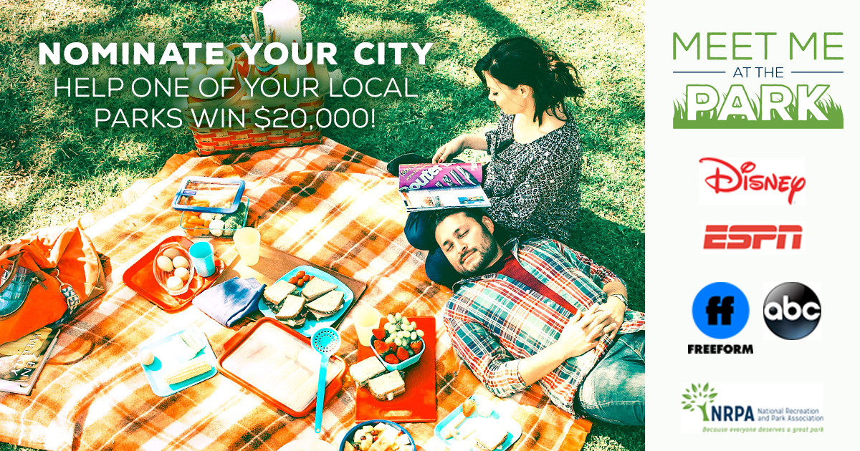

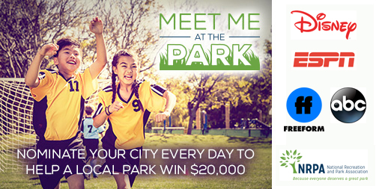
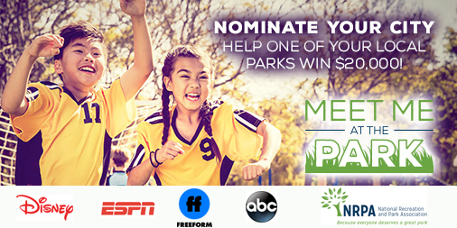

Email Promotion
Use your email lists to spread the word about the Meet Me at the Park Earth Month campaign with your community. Just make sure you have permission to email the individuals on your list.

Sample Email Text
Subject: Help [YOUR CITY] get $20K for a park
Nominate [YOUR CITY] to receive a $20K grant for a local park this Earth Month
Help get our city nominated for the Meet Me at the Park Earth Month campaign, which kicks off this April. If we get the most nominations, one of our parks will receive a $20,000 grant for improvements. In its fourth year, the Meet Me at the Park Earth Month campaign is a collaboration of the National Recreation and Park Association (NRPA) and The Walt Disney Company to help fund local park improvement projects.
You could win, too
When you nominate our city, you’ll be entered into a sweepstakes to win a GoPro Prize Pack. The city with the most nominations at the end of April will receive the funding.
Parks help make our lives better. They inspire healthy living, help protect the environment, provide access to sports and bring people together. Support our local parks this Earth Month by visiting them and nominating our city to improve a lucky park!
Nominate our city today [hyperlink to NRPA.org/DisneyMeetMeAtThePark]

Press Release
Customize this template press release and distribute it to media in your local community. Feel free to contact NRPA if you need further assistance or information about circulating your press release.
[ORG LETTERHEAD]

FOR IMMEDIATE RELEASE

Media Contact:
[Contact Name]
[Agency Name]
[Phone]
[E-mail]

NOMINATE OUR CITY TO RECEIVE A $20K GRANT DURING EARTH MONTH

City with the most nominations gets a grant for a local park through
‘Meet Me at the Park’ Earth Month campaign

[City, State Abbr., Date, Year] – For the fourth year in a row, the National Recreation and Park Association (NRPA) is collaborating with The Walt Disney Company to help fund local park improvement projects across the country through the national “Meet Me at the Park” Earth Month campaign. The city that receives the most nominations will receive a $20,000 grant to improve a local park.

Local parks make [YOUR CITY] a better place to live and shape so many of our lives. Parks are essential to our city’s health and wellbeing. They provide safe places to be active and enjoy nature—and they help preserve the environment and bring people together. That’s why from April 1 to April 30 [YOUR CITY] residents will have the opportunity to nominate our city to receive $20,000 in grant funding to make improvements at a local park.

By visiting NRPA.org/Disney, park supporters can nominate our city. At the end of April, the city with the most nominations will receive the grant funding. Everyone who nominates a city will be entered into a drawing for a GoPro Prize Pack.

[INSERT QUOTE FROM ORG LEADER]

“At NRPA we believe everyone deserves a great park. That’s why we’re proud to collaborate with The Walt Disney Company on this campaign,” said Lori Robertson, NRPA director of conservation. “Everyone is encouraged to join us in giving back to the places that shape so much of our lives by participating in this year’s campaign. A nomination for your favorite park is all it takes.”
During April, a public service announcement (PSA) supporting the Meet Me at the Park campaign will be shared with audiences across Disney, including ESPN, ABC Television Network, ABC-owned and affiliate stations, Freeform, Disney Channel, Disney XD, Disney Junior, the ABC app and other digital platforms. The PSA will also be available to view on the voting site at www.NRPA.org/DisneyMeetMeAtThePark. Additionally, Radio Disney will support the campaign with an on-air radio spot.

This Earth Month, [YOUR CITY] can show what parks mean to our community by nominating our great city. Encourage your friends to nominate our city by taking a selfie in your favorite park and using the hashtags #MeetMeAtThePark, #Parkies and #CelebrateEarth.

For more information and to nominate your city, visit www.NRPA.org/DisneyMeetMeAtThePark.

[Add Agency Boiler Plate]

Both promotions (defined below) begin at 12 a.m. ET on April 1, 2018 and conclude at 11:59 p.m. ET on April 30, 2018. No Purchase Necessary to participate. The NRPA Meet Me at the Park Promotion and Voter’s Sweepstakes (collectively, “promotions”) are open to legal residents of the 50 US & DC, who are 18 years of age or older. For complete details and Official Rules for both promotions, visit www.meetmeatthepark.org.

About The National Recreation and Park Association
The National Recreation and Park Association is a national not-for-profit organization dedicated to ensuring that all Americans have access to parks and recreation for health, conservation and social equity. Through its network of 60,000 recreation and park professionals and advocates, NRPA encourages the promotion of healthy and active lifestyles, conservation initiatives and equitable access to parks and public space. For more information, visit www.NRPA.org. For digital access to NRPA’s flagship publication, Parks & Recreation, visit www.parksandrecreation.org.
# # #

