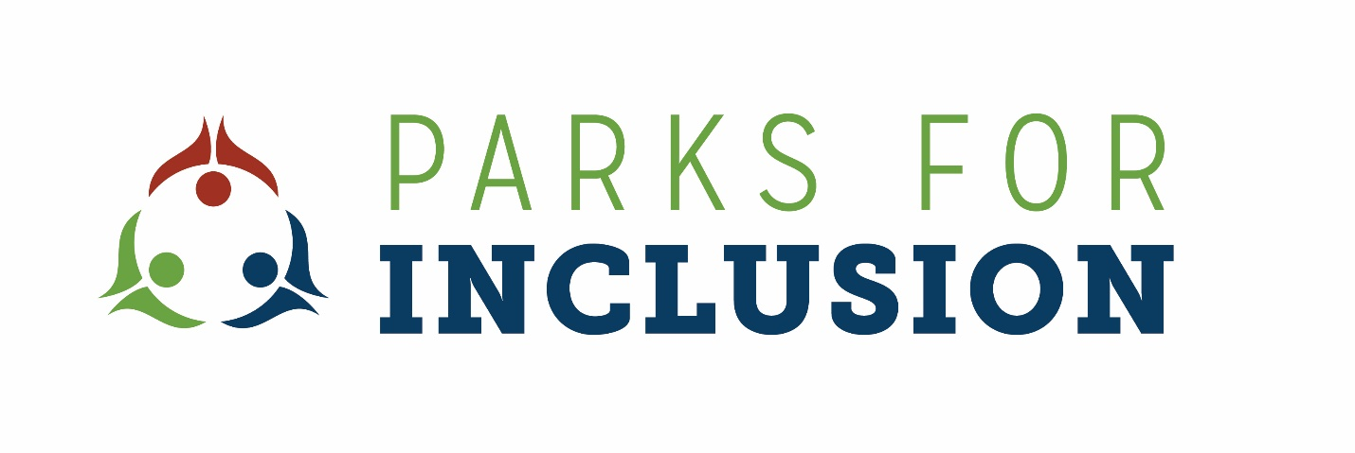

Inclusion Policy Template
Use this template as a blueprint for creating your agency’s inclusion policy. To use the template, replace yellow highlighted text with information specific to your agency. Make sure yellow highlight and brackets are removed from final document. You should delete this cover page before finalizing your policy. For help completing this template, please refer to the Parks for Inclusion Guidelines for Developing an Inclusion Policy at www.nrpa.org/parksforinclusion

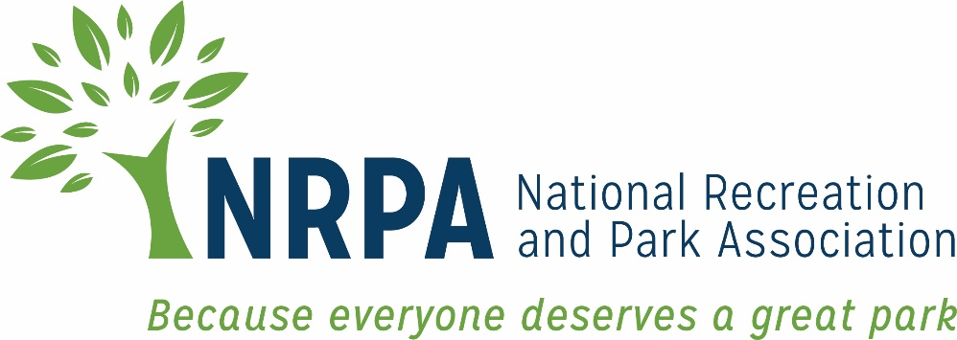

[Policy Name]

Introduction

[AGENCY NAME] is committed to creating and promoting inclusion across all public spaces, places, facilities and programs that the department manages. Through the [POLICY NAME] and supporting practices, we aim to ensure that everyone has access to the benefits of quality parks and recreation, including [INSERT TARGET AUDIENCES--those who have been historically marginalized, including those with a physical or cognitive disability, the LGBTQ community, racial and ethnic minorities, and new Americans, or refugees and immigrants].
[AGENCY NAME] defines inclusion [INSERT DEFINITION OF INCLUSION--as the process of including all persons, regardless of their ethnic origin, socioeconomic level, color, language or abilities].

Policy Goals
[POLICY NAME] outlines [AGENCY NAME] approach to ensuring inclusive environments and equitable opportunities for all community members in local parks and recreation.
This policy ensures that:
- Community members utilizing our facilities, programs and services have equitable and appropriate access to programs and services, regardless of ability, race, age, sexual orientation, gender identity, religion or country of origin.
- Site staff, community partners and stakeholders engage in the support of all community members and promote inclusive behaviors in park and recreation facilities and in public spaces throughout the community.
- [AGENCY NAME] establishes and maintains an organizational infrastructure for management, oversight, implementation, communication about and monitoring of the policy and its established goals and objectives.
- [AGENCY NAME] will continuously measure and improve inclusive practices.
- [INSERT OTHER GOALS]
This policy applies to all community members, staff, and sites in [AGENCY NAME].

Staff Training
[AGENCY NAME] staff will regularly participate in trainings grounded in effective training models using evidence-based content. Training will be comprehensive (covers multiple topics), based on credible research and delivered by qualified personnel. All new staff members will be quickly oriented to inclusive policies and practices.
[INSERT TRAINING PLAN AND TRAINING PARTNERS]

Organizational Support
[AGENCY NAME] and staff will put in place organizational supports that create a social environment (including positive relationships among staff, youth, families and community) that encourages all to be inclusive. This includes:

Staff
Demonstrating an attitude of inclusion, including nondiscriminatory language and actions
Determining and addressing any potential unintended outcomes of activities, programs or parks to ensure that they do not limit participation or cause worse outcomes based on ability, age, sexual orientation, identity, religion or country of origin
Providing educational materials about inclusion to all constituents at community events
Sharing and discussing practices during community meetings

Agency
Developing an advisory group and/or community network of groups that support inclusive behaviors in the community
Assessing agency hiring practices to ensure staff is representative of the diverse community and is an equal-opportunity employer

Communications
Providing positive messages about diversity and inclusion through written and verbal messaging, posters, pictures and books.
[INSERT OTHER ORGANIZATIONAL SUPPORTS]

Environmental Support
[AGENCY NAME] will establish environmental supports and practices that promote inclusion for all community members. Examples of environmental supports include:
- Program adaptation for inclusion, depending on the individual needs and abilities of participants
- One-on-one trained staff support throughout the program
- Language interpretation, including but not limited to:
- Sign language interpreters
- Braille
- Language translation services
- Audio/visual support
- Large-print signage
- Accessible transportation
- Built environment enhancements, including modified equipment and ramps
- Gender-neutral restrooms and changing rooms
- Culturally sensitive program hours (i.e., women-only pool hours);
- Signage and additional facility enhancements (artwork, murals, etc.) that promote diversity and inclusion
- [INSERT OTHER ENVIRONMENTAL SUPPORTS]

Continuous Measurement and Improvement
[AGENCY NAME] will work to continuously improve our equity and inclusion efforts, measuring the effectiveness of this policy through staff and community qualitative and quantitative feedback through meetings, community engagement events, public forums, surveys; and monitoring economic and health indicators. [AGENCY NAME] will establish a communications plan for reporting on progress [INSERT PLAN AND TIMELINE FOR PUBLIC REPORTING].
[AGENCY NAME] will monitor the following indicators to track progress of inclusive efforts:
- Does our agency communicate a vision that values the participation of all people as members of the community?
- Does our agency’s improvement plan include inclusive practices with action steps to support implementation?
- Is there adequate, regularly scheduled, ongoing planning time for agency staff to collaborate on inclusive programs and events?
- Does our agency engage the whole community by providing multiple opportunities and modes for participating?
- Are there professional development opportunities for staff regarding inclusive strategies and supports?
- Are community members from targeted populations engaged in programing, utilizing facilities and taking part in future planning conversations?
Long-term indicators:
- Are there improvements in health (physical, social, mental) outcomes across targeted populations?
- [LIST OTHER INDICATORS]

Policy Development
[AGENCY NAME] developed this inclusive policy with the input, engagement and support of key community stakeholders and representatives, including:
- [LIST STAKEHOLDERS]

Resources
[AGENCY NAME] recognizes that this document is an ever-growing resource and aims to keep it updated on a [TIMELINE] basis. For more on inclusion and equity, we encourage staff and community members to visit [AGENCY WEBSITE] or the National Recreation and Park Association’s Parks for Inclusion website, www.nrpa.org/ParksForInclusion.

Glossary
[AGENCY NAME] provides these definitions for historically marginalized audiences, including those with physical or cognitive disabilities, the LGTBQ+ community, racial and ethnic minorities, and new Americans (refugees and immigrants).
Individuals with a disability include those with:
- Hearing difficulty (e.g., deaf or having serious difficulty hearing [DEAR])
- Vision difficulty (e.g., blind or having serious difficulty seeing, even when wearing glasses [DEYE])
- Cognitive difficulty (e.g., because of a physical, mental or emotional problem, having difficulty remember, concentrating or making decisions [DREM])
- Ambulatory difficulty (e.g., having serious difficulty walking or climbing stairs [DPHY])
- Self-care difficulty (e.g., having difficulty bathing or dressing [DDRS])
- Independent living difficulty (e.g., because of a physical, mental or emotional problem, having difficulty doing errands alone, such as visiting a doctor’s office or shopping [DOUT]
- New Americans include immigrants, refugees and/or noncitizens living in America
LGBTQ community (Lesbian, Gay, Bisexual, Transgender, Queer), defined as:
- Lesbian: A woman who is attracted to other women.
- Gay: A man who is attracted to other men.
- Bisexual: An individual who is attracted to both genders.
- Trans: An umbrella term that seeks to incorporate individuals whose gender identities do not match their biological sex, for example, someone who is born male-bodied and identifies as a woman.
- Queer or Questioning: Individuals who experience fluidity in their experience of sexuality or gender and, therefore, do not identify strictly as LGB or T. The term ‘Queer’ can also include those who do not identify as either gender.
Racial/Ethnic communities, as defined by the U.S. Census Bureau, are composed of several different race categories — black, American Indian, Asian, Pacific Islander, other, and two or more races. Hispanics are also considered a minority, although Hispanic or Latino, is defined by the U.S. Census Bureau as an ethnicity rather than as a race. Other considerations include religious communities, such as Muslim, that practice cultural traditions based around gender.

