SAMPLE PARK CHAMPION™ INVITATION – SUMMER AND AFTERSCHOOL MEALS
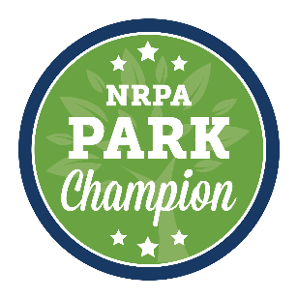
*Edit this invitation, then copy and paste it into the body of your email. Use the spreadsheet of schedulers in the Park Champion™ Advocacy Toolkit to find the appropriate contacts*
TO: Scheduler [firstname.lastname@mail.house.gov] or [first.lastname@membername.senate.gov]
SUBJECT: [Your agency] USDA Meal Program Visit
BODY:
Dear [Scheduler name],
The USDA Child Nutrition Program is making a big difference for [Your city]’s children, and we would like to invite [Congressman/Congresswoman X or Senator X] to visit one of our summer meal program sites to see it in action. Based on [Congressman/Congresswoman X or Senator X]’s schedule, we can work with your office to determine a date and time for the visit. [Include details of program schedule and possible dates/times, including any special event opportunities like a program kick-off. Also include any opportunities for the member to participate, such as joining the meal or helping to hand out meals/snacks.].
Across the nation and in [Your city], millions of children benefit from the healthy food they receive from the [USDA After-School Snack Program or Summer Meal Program]. We would like to show [Congressman/Congresswoman X or Senator X] how essential child nutrition programs are to the children of [Your city]. Local park and recreation agencies use this funding to provide healthy meals and snacks to children who might otherwise go hungry outside of school time, especially during the summer months. When children are served healthy meals, park and recreation agencies are helping to address the immediate need of hunger and are engaging these children in educational and enrichment activities.
The USDA Child Nutrition Program is improving the lives of low-income children, and we hope we will have the opportunity to show this to you firsthand. Thank you for your service to our community and for your consideration of this invitation. If you have any questions you can contact me at: [Add your contact information]
Sincerely,
[Name of agency Director or appropriate contact]
[Title]
[Email and phone number where they may reach you during the day]

