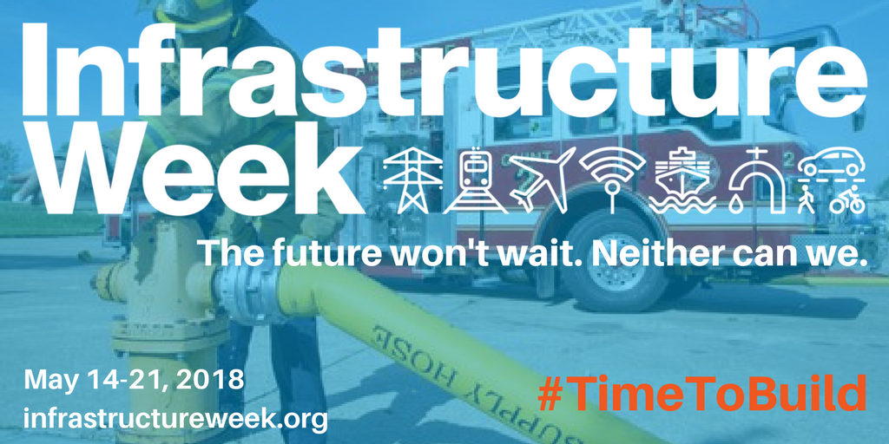
Infrastructure Week Park Champion Talking Points

- Approximately 50% of car trips taken in the United States could be accomplished by riding a bicycle for 20 minutes or less.
- 81% of millennials and 77% of active baby boomers say affordable and convenient transportation alternatives are somewhat important when decide where to live and work.
- Parks serve as active transportation hubs for a community, along with providing recreation and activity space.
- Green infrastructure projects in parks across the country are reducing stormwater impacts in parks from 50-90 percent depending on design.
- The federal investment in active transportation through the TIGER Grant program (a discretionary grant program administered by the Department of Transportation which provides direct funding to localities) and the Transportation Alternative Program (a formula based program which provides funding to states for multimodal transportation) provide vital resources to allow communities to invest in active transportation.

