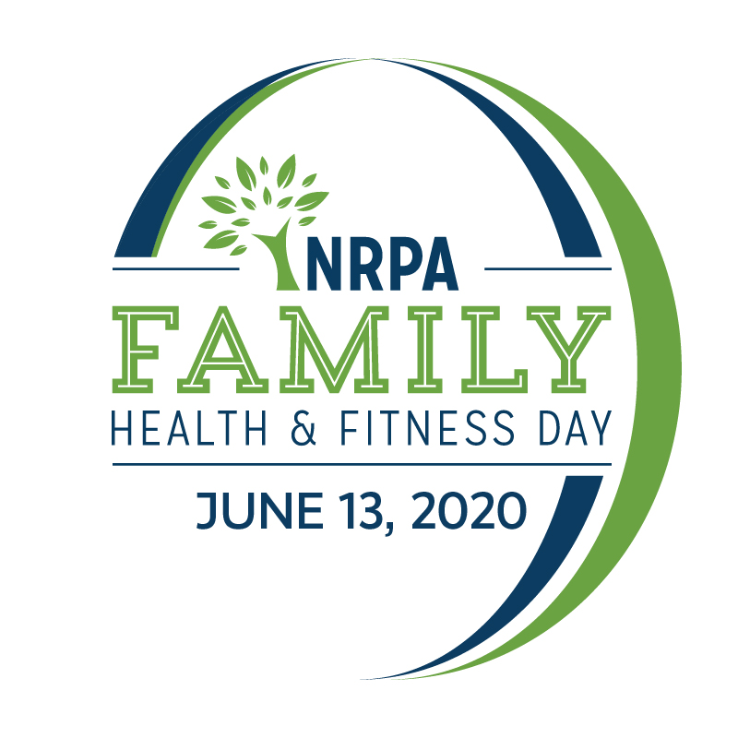

June 13, 2020

Family Health & Fitness Day
Parks Build Healthy Communities

OUTREACH TOOLKIT
Contents
Toolkit Purpose 3
2020 Family Health & Fitness Day Fact Sheet 4
2020 Family Health & Fitness Day Template Press Release 6
2020 Family Health & Fitness Day Social Media Materials 8
2020 Family Health & Fitness Day Web and Email Copy 11
2020 Family Health & Fitness Day Media Outreach – “How To” 12

Toolkit Purpose

This toolkit is meant to make promoting and celebrating Family Health & Fitness Day in your community a little easier! This toolkit is designed to help you generate positive media coverage and support for your Family Health & Fitness Day virtual activities, and ultimately, the work of your agency and the benefits you bring to your community. Now more than ever, park and recreation agencies are providing innovative ways for your communities to remain active, connected and engaged, and Family Health & Fitness Day is a great way to bring awareness to your great work.

This kit includes template media materials such as media alerts for special events, press releases, fact sheets, social media posts and web ads, along with sample web and email copy you can use in your publications. Feel free to customize these materials with localized information, quotes and details that best meet your needs.

When using social media, please make sure you are tagging NRPA in your Facebook, Twitter and Instagram posts and using the hashtag #NRPAFamilyFitDay.

Don’t forget, we want to see your successes too – send us photos and videos showing how you’re celebrating Family Health & Fitness Day or the creative ways you have used the marketing materials!

If you have questions or need further assistance, please don’t hesitate to contact us.

General Family Health & Fitness Day, Toolkit or Media Questions
Cort Jones
Communications Manager, NRPA
703.858.4730
cjones@nrpa.org

Suzanne Nathan
Public Relations Manager, NRPA
703-858-4748
snathan@nrpa.org

Social Media or Email Questions / Submit Photos or News Coverage
Audrey Fox
Communications Specialist, NRPA
703.858.2160
afox@nrpa.org

We hope this toolkit helps you generate great support for Family Health & Fitness Day!

Thank you,

Cort, Suzanne and Audrey

2020 Family Health & Fitness Day Fact Sheet

- NRPA’s Family Health & Fitness Day — celebrated the second Saturday in June each year — promotes the importance of parks and recreation in keeping communities healthy. Agencies everywhere are encouraged to participate by sharing ways families can get active while practicing safe physical distancing on June 13 — whether through participating in virtual programs at home or in their local parks where state and local ordinances allow. Members of the healthcare community are encouraged to participate, as well, even as sponsors.

- Various research studies are confirming that community parks and recreation, green space and time outdoors is critical for creating healthy, active and sustainable communities. You can experience the benefits by connecting with your community parks and recreation any time of the year, and especially on Family Health & Fitness Day — just be sure to be mindful of physical distancing guidelines and guidance from your state and local government and public health officials.

- Due to the COVID-19 pandemic, we realize many of your celebrations will be virtual or tailored to maintain physical distancing. Some creative program ideas for your celebration include:

  - Encouraging family bike rides/hikes on trails that are open
  - Host a sidewalk chalk art contest
  - Have “Bear hunts” – encourage people in your community place a stuffed animal in a easily-visible window of their home so that families can go for a walk and search for them and take photos of the things they find
  - Host a virtual race
  - Host a virtual morning yoga/meditation session
  - Stream a healthy cooking class or healthy cooking tips on your social media channels

- In addition to promoting your programs on June 13, you can get involved in Family Health & Fitness Day by:

  - Using the tagline, Parks Build Healthy Communities to promote your health and wellness programs and activities
  - Using the social media images and #NRPAFamilyFitDay leading up to and on June 13.

  - Highlighting NRPA’s top five ways to get fit with parks and recreation while physical distancing on your website, social media channels and promotional materials:

    - Take a Walk
    - Cook a Healthy Meal
    - Enroll in a Virtual Fitness Program
    - Create Your Own Exercise Routine
    - Play Outside

- Join the conversation on Facebook, Twitter and Instagram using #NRPAFamilyFitDay.

- For additional information, visit www.nrpa.org/familyfitness. —

Health and Wellness Benefits of Parks

- According to a recent poll conducted by the National Recreation and Park Association, 83 percent of U.S. adults agree that visiting their local parks, trails and open spaces is essential for their mental and physical well-being during the COVID-19 pandemic.

- Nearly three in five adults say that access to park and recreation amenities are very or extremely essential to their mental and physical health.

- Living close to parks and other recreation facilities is consistently related to higher physical activity levels for both adults and youth. Moreover, parks provide a connection to nature, which studies demonstrate relieves stress, tightens interpersonal relationships and improves mental health.

- On average, children who live in greener environments weigh less than children who live in less green areas.

- Between 2000 and 2012, more than 85 studies have been published that link parks to better physical and mental health.

- In the United States, more than 46 million people live with mental health illnesses, according to 2017 data from the National Institute of Mental Health (NIMH). In a recent Parks & Recreation article, contributors Barbara Heller and Molly Young share their thoughts on how the field of parks and recreation can assist those struggling with mental health challenges, How Parks and Recreation Can Support Mental Health Initiatives.

- According to a recent article in Yale Environment 360 – Ecopsychology: How Immersion in Nature Benefits Your Health – a growing body of research points to the beneficial effects that exposure to the natural world has on health, reducing stress and promoting healing. Now, policymakers, employers, and healthcare providers are increasingly considering the human need for nature in how they plan and operate.

2020 Family Health & Fitness Day Template Press Release

[GROUP LOGO/LETTERHEAD]

FOR IMMEDIATE RELEASE
Media Contact:
[Contact Name]
[Agency Name]
[Phone]
[Email]

[Agency Name] Invites [Town/City] Communities to Get Healthy With Parks and Recreation
[Agency Name] celebrates Family Health & Fitness Day, Saturday, June 13

[CITY, STATE ABRV] – [DATE] – [Agency Name] invites all [Town/City] residents to celebrate Family Health & Fitness Day on Saturday, June 13, and discover how Parks Build Healthy Communities. Organized by the National Recreation and Park Association (NRPA), Family Health & Fitness Day promotes the importance of local parks and recreation in keeping communities healthy.

To celebrate, [Agency Name] encourages everyone to connect with [Park/Facility Name] and find out how you can celebrate safely. [Insert Health/Wellness Program Details and/or Virtual Event Details]

[Insert Quote from Program Director on the Importance of Parks and Recreation in Keeping Communities Active and Healthy]

Residents also can participate in one of NRPA’s top five ways to get fit with parks and recreation:

- Take a Walk
- Cook a Healthy Meal
- Enroll in a Virtual Fitness Program
- Create Your Own Exercise Routine
- Play Outside

Park and recreation professionals nationwide offer year-round opportunities for families and individuals to stay active and fit, and now more than ever, they are providing innovative ways for people to stay connected to critical programs during the COVID-19 pandemic. Living close to parks and other recreation facilities is also consistently related to higher physical activity levels for both adults and youth. To learn more about the health and wellness opportunities offered at [Park/Facility Name], visit [Insert Website].

Celebrated the second Saturday in June each year, Family Health & Fitness Day is an opportunity for everyone to discover all the health benefits provided by their local park and recreation department. To learn more about Family Health & Fitness Day, visit www.nrpa.org/familyfitness.

# # #

[Agency boilerplate/ “about” information]

About the National Recreation and Park Association
The National Recreation and Park Association is a national not-for-profit organization dedicated to ensuring that all people have access to parks and recreation for health, conservation and social equity. Through its network of 60,000 recreation and park professionals and advocates, NRPA encourages the promotion of healthy and active lifestyles, conservation initiatives and equitable access to parks and public space. For more information, visit www.nrpa.org. For digital access to NRPA’s flagship publication, Parks & Recreation, visit www.parksandrecreation.org.

2020 Family Health & Fitness Day Social Media Materials

  - Social Covers and Badges
You can find social media images at www.nrpa.org/familyfitness. We encourage you to update your Facebook and Twitter pages with these images to show your support of Family Health & Fitness Day with these 800x800 graphics!

  - 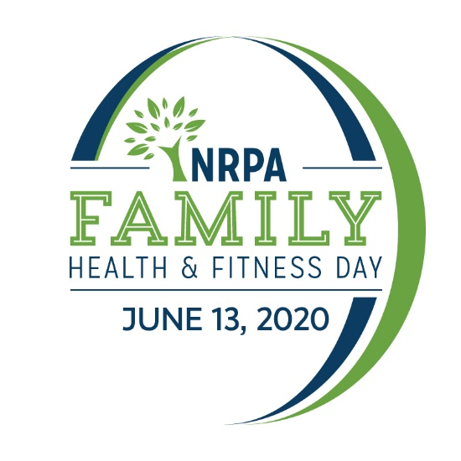
2020 Logo 2020 Social Frame

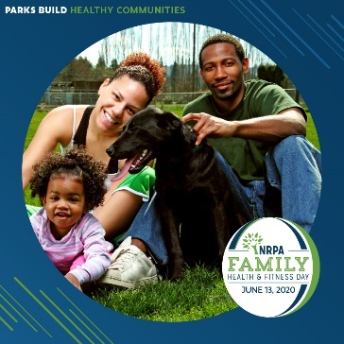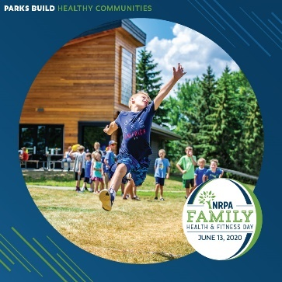

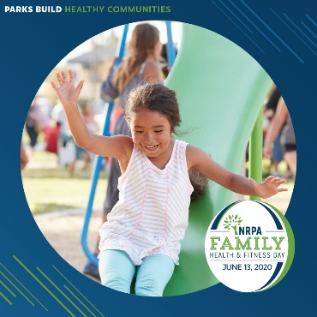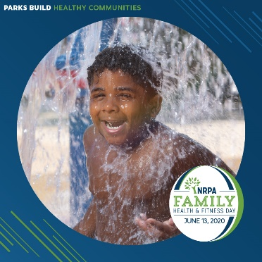

  - Sample Social Media Posts
If you have social media platforms such as Facebook, Twitter and Instagram, here are some sample messages to generate awareness among your friends and followers. Customize these posts for Family Health & Fitness Day on June 13 and feel free to develop some more on your own!

Tag NRPA in your posts, too.
- Facebook: @National Recreation and Park Association
- Twitter: @NRPA_News
- Instagram: @nrpa

Official Family Health & Fitness Day Hashtags
- #NRPAFamilyFitDay

Sample posts for Facebook

- We’re building a healthy [insert town name] by providing access to nature to relieve stress, strengthen interpersonal relationships and improve mental well-being. #NRPAFamilyFitDay
- Celebrate Family Health & Fitness Day with [insert facility or park name] on Saturday, June 13! #NPRAFamilyFitDay
- Today, we’re celebrating Family Health & Fitness Day! How does your family get healthy virtually with parks and rec? #NRPAFamilyFitDay (include photo of program or activity)
- This weekend, we’re celebrating Family Health & Fitness Day! Discover how Parks Build Healthy Communities at (insert park/facility name)! #NRPAFamilyFitDay
- Family Health & Fitness Day encourages families and individuals to use their local parks and recreation to stay healthy and active. #NRPAFamilyFitDay (include photo of program or activity)
- Check out how Parks Build Healthy Communities! #NRPAFamilyFitDay (include photo of program or activity)
- Did you know? Parks and recreation play an important role in keeping communities active and healthy. Discover these benefits with (insert agency name). #NRPAFamilyFitDay
- We want to know. How does your Park Build a Healthy Community? Tell us using #NRPAFamilyFitDay. (include photo of program or activity)
Sample posts for Twitter:

- We’re building a healthy community! Help us celebrate on June 13. #NRPAFamilyFitDay
- Today, we’re celebrating @NRPA_News Family Health & Fitness Day! How do you get healthy with parks and rec? #NRPAFamilyFitDay
- Celebrate Family Health & Fitness Day with (insert park or facility name) on June 13! #NRPAFamilyFitDay
- Looking for a fun way to get active and healthy? Check out @NRPA_News to find out how parks build healthy communities. #NRPAFamilyFitDay (insert graphic)
- Check out how Parks Build Healthy Communities! #NRPAFamilyFitDay (include photo of program or activity)
- Parks and recreation plays a vital role in keeping communities active and healthy. Discover these benefits with @NRPA_News and (insert agency name or Twitter handle). #NRPAFamilyFitDay
- How do you get fit with parks and recreation? Share a picture using #NRPAFamilyFitDay. (include photo of program or activity)

Sample posts for Instagram:
- We’re building a healthy [insert town name] by providing access to nature to relieve stress, strengthen interpersonal relationships and improve mental well-being. #NRPAFamilyFitDay
- Today, we’re celebrating @nrpa’s Family Health & Fitness Day! How do you get healthy with parks and rec? #NRPAFamilyFitDay
- Celebrate @nrpa’s Family Health & Fitness Day with (insert park or facility name) on June 13! #NRPAFamilyFitDay
- Looking for a fun way to get active and healthy? Check out @nrpa’s top five ways to get fit with parks and rec. #NRPAFamilyFitDay (insert graphic)
- Check out how Parks Build Healthy Communities! #NRPAFamilyFitDay (include photo of program or activity)
- Parks and recreation plays a vital role in keeping communities active and healthy. Discover these benefits with @NRPA and (insert agency name or Instagram handle). #NRPAFamilyFitDay
- How do you get fit with parks and recreation? Share a picture using #NRPAFamilyFitDay. (include photo of program or activity)

2020 Family Health & Fitness Day Web and Email Copy

Ensure that your community members can find out all the information they need to know about your Family Health & Fitness Day events by updating your website with the event information. If you already have a template you use for events, use it! If you need some inspiration for copy, feel free to modify and edit the text below and use the following web ad.

Banner ad (650x80):

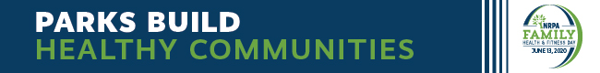

You can use the copy below in an email to those who have opted-in to any of your email lists.

Family Health & Fitness Day – June 13, 2020
Join us in celebrating the amazing health and wellness resources located right here in [COMMUNITY]. We’ll be celebrating Family Health & Fitness Day — an initiative of the National Recreation and Park Association (NRPA) — by [list event details, include any prizes or fun activities taking place].

You also can participate in NRPA’s top five ways to get fit with parks and recreation:

- Take a Walk
- Cook a Healthy Meal
- Enroll in a Virtual Fitness Program
- Create Your Own Exercise Routine
- Play Outside

Celebrated the second Saturday of June each year, Family Health & Fitness Day promotes the importance of parks and recreation in keeping communities active and healthy. While many communities typically host special events on this day, and others simply encourage their residents to visit a local park or recreation center, this year, with keeping safe physical distancing in mind, we encourage you to celebrate safely with us by [virtual event details,etc.].

[Agency Name] takes pride in providing health and wellness resources for the community and we hope you’ll connect with us to learn about the many diverse opportunities we offer and see how Parks Build Healthy Communities.
Time:
Location:

Partners: [List any partners working with you to host your event]
2020 Family Health & Fitness Day Media Outreach – “How To” Email

The following are general guidelines for conducting media outreach for special events you may be hosting on June 13 for Family Health & Fitness Day.

  - Leveraging the Press Release

To announce your involvement in Family Health & Fitness Day and what activities you will have happening on June 13, customize the Press Release template and distribute it to appropriate reporters, bloggers and broadcast media in your local area.

- Search online for the “news desk” emails and/or submission guidelines of your local TV stations and radio stations.

- Search for the contact information for reporters and publications in your local area that cover topics related to parks, the outdoors and community affairs. Be sure to pitch to only one reporter from each newspaper/print agency. It is a good idea to review the stories the reporter writes to get a feel for what they are most interested in so that you can tailor your outreach to meet their interests. Most reporters prefer email.

- Search online for bloggers in your area; these social media journalists are powerful influencers and can virally spread the word about the events you have going on for Family Health & Fitness Day.

- Once you have your list together, prepare your pitches. Make sure you tailor the pitch for the type of outlet and personalize it as much as possible for the journalist or blogger you are contacting. Keep it brief.

- You’ll want to send the release out at the end of May or beginning of June to journalists and reporters, and to TV/radio stations approximately two days before the virtual event you want them to attend.

- Customize the press release template with the appropriate information, as marked with brackets and yellow highlight, EX: [NAME].

- You can distribute your press release on any newswires you subscribe to or use regularly. This will give you added visibility in news rooms and with online media.

- In addition to wire distribution, reach out directly via email to journalists and bloggers. Insert your pitch and paste the text of the press release into the email.

- Put an engaging tag line or sentence in the “Subject” line of the email to entice reporters.

- Once you have sent your release, follow up with a phone call to reporters. Be sure to have a short pitch ready, and be prepared to answer questions about why your event or story is a “must see/cover.”

  - Inviting Press to Your Event

If you are hosting a virtual event on June 13 and would like to invite reporters to cover your event:

- Search online for the “news desk” emails and/or submission guidelines of your local TV stations and radio stations.

- Search for the contact information for reporters and publications in your local area that cover topics related to parks, the outdoors, and community affairs. Be sure to pitch to only one reporter from each newspaper/print agency. Most reporters prefer email.

- Consider inviting local bloggers to your event as well or creating a special opportunity for them to come out and get sneak peek of your Family Health & Fitness Day event. These social media journalists are powerful influencers and can virally spread the word about the events you have going on for Family Health & Fitness Day.

- It’s a good idea to send Media Advisories to journalists and reporters at least two weeks in advance and to TV/radio stations approximately two days before an event.

- Customize the media alert template with the appropriate information, as marked.

- Write a brief, one-paragraph pitch to the reporter, and attach the Media Advisory as a PDF or Word Document, or paste the text into the email, beginning with “Media Advisory.”

- Put an engaging tag line or sentence in the “Subject” line of the email to entice reporters.

- Once you have sent your Media Advisory, follow up with a phone call to reporters you are particularly interested in having attend. Be sure to have a short pitch ready, and be prepared to answer questions about why your event is a “must see.”

- Consider sending a post-event press release to generate coverage after the event. It is a good idea to send this immediately following the event or the next morning. Often times, this means drafting most of the release in advance, and adding a few pertinent details afterward.

- Reach back out to the reporters that you previously contacted. If you can, offer footage from the event or high-resolution photos.

  - Tips and Tactics

- Remember that timeliness is a big factor in press coverage.

- Try to keep the message brief. One page is best—do not exceed two.

- Don't forget to add complete contact information. If a reporter is interested, they may wish to email or call you with questions or requests for clarification.

- Write using short paragraphs and sentences, and in the third person—don’t refer to yourself as “I” or “we,” except in a direct quote.

- Avoid testimonials or other promotional language. A press release is news; not advertising.

- Don’t be discouraged if you do not receive interest, or if a reporter doesn’t make it to your event. Reporters receive hundreds of press releases every day and cover news based on many factors (timeliness, the amount of current events taking place/space, editor approval, capacity, etc.). It’s never personal.

- If a reporter does email or call with interest, be sure to respond in a very timely manner.

Let us know if your Family Health & Fitness Day event is covered in the news! Send links of online coverage to snathan@nrpa.org.

