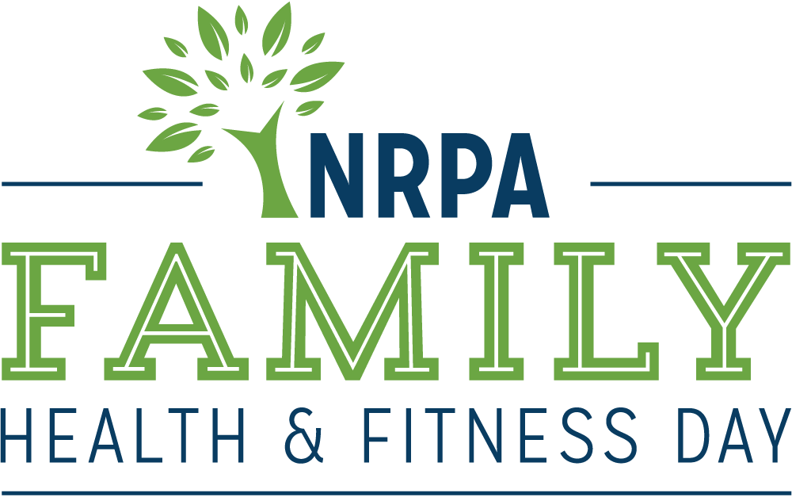

June 9, 2018

Family Health & Fitness Day

OUTREACH TOOLKIT

Contents
Toolkit Purpose 3
2018 Family Health & Fitness Day Fact Sheet 4
2018 Family Health & Fitness Day Template Media Advisory 5
2018 Family Health & Fitness Day Template Press Release 6
2018 Family Health & Fitness Day Social Media Materials 8
2018 Family Health & Fitness Day Web and Email Copy 10
2018 Family Health & Fitness Day Media Outreach – “How To” 11

Toolkit Purpose

This toolkit is meant to make promoting and celebrating Family Health & Fitness Day in your community a little easier! This kit is designed to help you generate positive media coverage and support for your Family Health & Fitness Day activities and ultimately the work of your agency and the benefits you bring to your community.

This kit includes template media materials such as media alerts for special events, press releases, fact sheets, social media posts, and a sample web and email copy you can use in your publications. Feel free to customize these materials with localized information, quotes and details that best meet your needs.

When using social media, please make sure you are tagging NRPA in your Facebook, Twitter and Instagram posts and using the hashtag #NRPAFamilyFitDay.

Don’t forget, we want to see your successes too – send us photos and videos from your Family Health & Fitness Day events or the creative ways you have used the marketing materials!

If you have questions or need further assistance, please don’t hesitate to contact us.

General Family Health & Fitness Day, Toolkit or Media Questions
Heather Williams
Sr. Public Relations Manager, NRPA
703.858.4743

Social Media or Email Questions (or general inquiries about cats and coffee)
Roxanne Sutton
Sr. Communications Manager, NRPA
703.858.2166
rsutton@nrpa.org

Social Media or Email Questions / Submit Photos or News Coverage
Audrey Fox
Communications Specialist, NRPA
703.858.2160
afox@nrpa.org

We hope this toolkit helps you generate great support for Family Health & Fitness Day!

Thank you,

Heather, Roxanne and Audrey

2018 Family Health & Fitness Day Fact Sheet

- NRPA’s Family Health & Fitness Day — celebrated the second Saturday in June each year — promotes the importance of parks and recreation in keeping communities healthy. Agencies everywhere are encouraged to participate by inviting families to get active at their local park or recreation center, or by hosting an event, such as a health fair or family fun run, on June 9. Members of the healthcare community are encouraged to participate, as well, even as sponsors.

- Various research studies are confirming that community parks and recreation, green space and time outdoors is critical for creating healthy, active and sustainable communities. You can experience the benefits by visiting your community parks and recreation any time of the year, and especially on Family Health & Fitness Day.

- In addition to visiting a park or recreation area on June 9, you can get involved in Family Health & Fitness Day by:

  - Using the social media images and #NRPAFamilyFitDay leading up to and on June 9.
  - Downloading the official Family Health & Fit Day poster and hanging it up, taking pictures with it or sharing copies of it with your community.

- Join the conversation on Facebook, Twitter and Instagram with the hashtag #NRPAFamilyFitDay.

- For more information visit www.nrpa.org/familyfitness.

Health and Wellness Benefits of Parks

- Living close to parks and other recreation facilities is consistently related to higher physical activity levels for both adults and youth.

- On average, children who live in greener environments weigh less than children who live in less green areas.

- Between 2000 and 2012, more than 85 studies have been published that link parks to better physical and mental health.

2018 Family Health & Fitness Day Template Media Advisory
[GROUP LOGO/LETTERHEAD]

MEDIA ADVISORY
Media Contact:
[Contact Name]
[Agency Name]
[Phone]
[Email]

[Agency Name] to Host Family Health & Fitness Day at [Park/Facility Name]
[Agency Name] joins the National Recreation and Park Association and parks across the country to celebrate and promote healthy lifestyles

WHO/WHAT: [Name of major public officials, celebrities or local organizations who are participating, as well as the number of people who will be in attendance.]

[List and briefly describe any programs or activities that will take place. Concentrate specifically on the highlights.]

WHEN: [Date/Time]
[Be sure to mention individual start times for notable speakers/happenings.]

WHERE: [Location/Address]
[Provide parking information, if relevant.]

WHY: Celebrated the second Saturday of June each year, Family Health & Fitness Day is an opportunity for local community members to get out and discover all of the health benefits provided by their local parks and recreation department. An initiative of the National Recreation and Park Association, [Agency Name] joins parks and recreation departments around the country in showcasing easily accessible, close-to-home health and wellness opportunities.

For more information about the national event, go to www.nrpa.org/familyfitness or search #NRPAFamilyFitDay on social media.

EDITOR’S NOTE: [Mention any opportunities for interesting visuals and tours. Provide onsite contact information.]
# # #

2018 Family Health & Fitness Day Template Press Release

[GROUP LOGO/LETTERHEAD]

FOR IMMEDIATE RELEASE
Media Contact:
[Contact Name]
[Agency Name]
[Phone]
[Email]

[Agency Name] Invites [Town/City] Residents to Celebrate Family Health & Fitness Day
Family Health & Fitness Day organized by the National Recreation and Park Association

[CITY, STATE ABRV] – [DATE] – [Agency Name] invites all [Town/City] residents to join them on Saturday, June 9 for national Family Health & Fitness Day. Organized by the National Recreation and Park Association (NRPA), Family Health & Fitness Day promotes the importance of local parks and recreation in keeping communities healthy.

To celebrate, [Agency Name] encourages everyone to gather with family and friends to get active at [Park/Facility Name]. [Insert Health/Wellness Program Details and/or Event Details]

[Insert Quote from Program Director on the Importance of Parks and Recreation in Keeping Communities Active and Healthy]

Parks and recreation departments nationwide offer year-round opportunities for families and individuals to stay active and fit. In fact, living close to parks and other recreation facilities is consistently related to higher physical activity levels for both adults and youth. To learn more about the health and wellness opportunities offered at [Park/Facility Name], visit [Insert Website].

Celebrated the second Saturday in June each year, Family Health & Fitness Day is an opportunity for everyone to get out and discover all of the health benefits provided by their local parks and recreation department. To learn more about Family Health & Fitness Day, visit www.nrpa.org/familyfitness.

[Agency boilerplate/ “about” information]

About The National Recreation and Park Association
The National Recreation and Park Association is a national not-for-profit organization dedicated to ensuring that all Americans have access to parks and recreation for health, conservation and social equity. Through its network of 60,000 recreation and park professionals and advocates, NRPA encourages the promotion of healthy and active lifestyles, conservation initiatives and equitable access to parks and public space. For more information, visit www.nrpa.org. For digital access to NRPA’s flagship publication, Parks & Recreation, visit www.parksandrecreation.org.

# # #

2018 Family Health & Fitness Day Social Media Materials

  - Social Covers and Badges
You can find social media images at www.nrpa.org/familyfitness. We encourage you to update your Facebook and Twitter pages with these images to show your support of Family Health & Fitness Day!

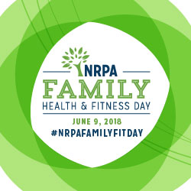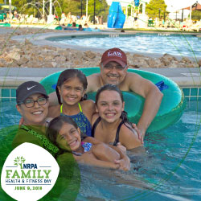

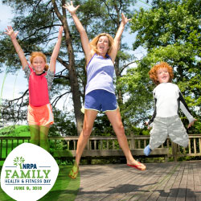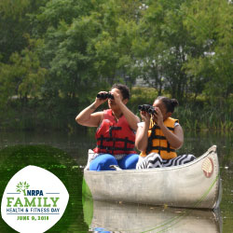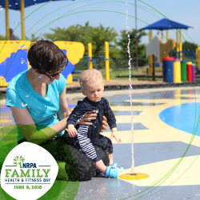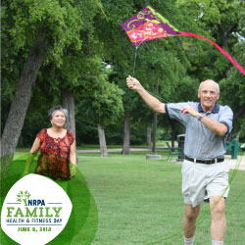

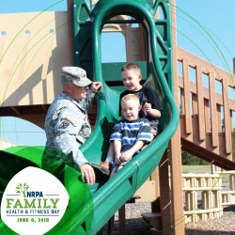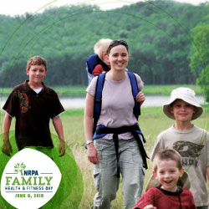

  - Sample Social Media Posts
If you have social media platforms such as Facebook, Twitter and Instagram, here are some sample messages to generate awareness among your friends and followers. Customize these posts for Family Health & Fitness Day on June 9 and feel free to develop some more on your own!

Tag NRPA in your posts, too.
- Facebook: @National Recreation and Park Association
- Twitter: @NRPA_News
- Instagram: @nrpa

Official Family Health & Fitness Day Hashtags
- #NRPAFamilyFitDay

Sample posts for Facebook:

- Today we’re celebrating all of the ways families can get healthy and stay fit using their local parks and recreation! What’s your family’s favorite way to get healthy? #NRPAFamilyFitDay.
- We’re celebrating Family Health & Fitness Day at (insert park/facility name)! #NRPAFamilyFitDay
- Family Health & Fitness Day encourages families to use their local parks and recreation to stay healthy and active. #NRPAFamilyFitDay
- Check out how families in our community get active at (insert park/facility name)! #NRPAFamilyFitDay (include photos from activity)
- Parks and recreation play a vital role in the health and wellbeing of families in our community. Your (community) parks are the best places to get fit and stay healthy! #NRPAFamilyFitDay
Sample posts for Twitter:

- We’re celebrating #NRPAFamilyFitDay by getting active at (insert park/facility name)! (insert photos of your Family Fit Day events)
- Your (community) parks are a great place to get healthy with your family! #NRPAFamilyFitDay
- Parks and recreation play a vital role in the wellbeing and health of the families in our community. Celebrate #NRPAFamilyFitDay with us!
- What’s your favorite way to get fit and stay healthy with your family? #NRPAFamilyFitDay
- Celebrate #NRPAFamilyFitDay with us and @NRPA_News by visiting your local (community) park!

Sample post for Instagram:

- In honor of #NRPAFamilyFitDay we’re getting active at (insert park/facility name)!
- (Community) parks are the perfect places to take your family to get active and have fun! #NRPAFamilyFitDay

2018 Family Health & Fitness Day Web and Email Copy

Ensure that your community members can find out all the information they need to know about your Family Health & Fitness Day event by updating your website with the event information. If you already have a template you use for events, use it! If you need some inspiration for copy, feel free to modify and edit the below.

You can also use the copy in an email to those who have opted in to any of your email lists.

***

Family Health & Fitness Day – June 9, 2018
Join us in celebrating the amazing health and wellness resources located right here in [COMMUNITY]. We’ll be celebrating Family Health & Fitness Day — an initiative of the National Recreation and Park Association — by [list event details, include any prizes or fun activities taking place].

You can participate by [insert details about how to participate].

Family Health & Fitness Day occurs each year on the second Saturday of June. The day was created to showcase the vital role of local parks and recreation in creating healthy and active communities. The day is an opportunity for local community members to discover all of close-to-home health and wellness benefits available to them.

[Agency Name] takes pride in providing health and wellness resources for the community and we hope you’ll come out and discover the many diverse opportunities we offer.

Time:
Location:

Partners: [List any partners working with you to host your event]

2018 Family Health & Fitness Day Media Outreach – “How To”

The following are general guidelines for conducting media outreach for special events you may be hosting on June 9 for Family Health & Fitness Day.

  - Leveraging the Press Release

To announce your involvement in Family Health & Fitness Day and what activities you will have happening on June 9, customize the Press Release template and distribute it to appropriate reporters, bloggers and broadcast media in your local area.

- Search online for the “news desk” emails and/or submission guidelines of your local TV stations and radio stations.

- Search for the contact information for reporters and publications in your local area that cover topics related to parks, the outdoors and community affairs. Be sure to pitch to only one reporter from each newspaper/print agency. It is a good idea to review the stories the reporter writes to get a feel for what they are most interested in so that you can tailor your outreach to meet their interests. Most reporters prefer email.

- Search online for bloggers in your area; these social media journalists are powerful influencers and can virally spread the word about the events you have going on for Family Health & Fitness Day.

- Once you have your list together, prepare your pitches. Make sure you tailor the pitch for the type of outlet and personalize it as much as possible for the journalist or blogger you are contacting. Keep it brief.

- You’ll want to send the release out at the end of May or beginning of June to journalists and reporters, and to TV/radio stations approximately two days before an event you want them to attend.

- Customize the press release template with the appropriate information, as marked with brackets and yellow highlight, EX: [NAME].

- You can distribute your press release on any newswires you subscribe to or use regularly. This will give you added visibility in news rooms and with online media.

- In addition to wire distribution, reach out directly via email to journalists and bloggers. Insert your pitch and paste the text of the press release into the email.

- Put an engaging tag line or sentence in the “Subject” line of the email to entice reporters.

- Once you have sent your release, follow up with a phone call to reporters. Be sure to have a short pitch ready, and be prepared to answer questions about why your event or story is a “must see/cover.”

  - Inviting Press to Your Event

If you are hosting a special event on June 9 and would like to invite reporters to cover your event on site:

- Search online for the “news desk” emails and/or submission guidelines of your local TV stations and radio stations.

- Search for the contact information for reporters and publications in your local area that cover topics related to parks, the outdoors, and community affairs. Be sure to pitch to only one reporter from each newspaper/print agency. Most reporters prefer email.

- Consider inviting local bloggers to your event as well or creating a special opportunity for them to come out and get sneak peek of your Family Health & Fitness Day event. These social media journalists are powerful influencers and can virally spread the word about the events you have going on for Family Health & Fitness Day.

- It’s a good idea to send Media Advisories to journalists and reporters at least two weeks in advance and to TV/radio stations approximately two days before an event.

- Customize the media alert template with the appropriate information, as marked.

- Write a brief, one-paragraph pitch to the reporter, and attach the Media Advisory as a PDF or Word Document, or paste the text into the email, beginning with “Media Advisory.”

- Put an engaging tag line or sentence in the “Subject” line of the email to entice reporters.

- Once you have sent your Media Advisory, follow up with a phone call to reporters you are particularly interested in having attend. Be sure to have a short pitch ready, and be prepared to answer questions about why your event is a “must see.”

- Consider sending a post-event press release to generate coverage after the event. It is a good idea to send this immediately following the event or the next morning. Often times, this means drafting most of the release in advance, and adding a few pertinent details afterward.

- Reach back out to the reporters that you previously contacted. If you can, offer footage from the event or high resolution photos.

  - Tips and Tactics

- Remember that timeliness is a big factor in press coverage.

- Try to keep the message brief. One page is best—do not exceed two.

- Don't forget to add complete contact information. If a reporter is interested, they may wish to email or call you with questions or requests for clarification.

- Write using short paragraphs and sentences, and in the third person—don’t refer to yourself as “I” or “we,” except in a direct quote.

- Avoid testimonials or other promotional language. A press release is news; not advertising.

- Don’t be discouraged if you do not receive interest, or if a reporter doesn’t make it to your event. Reporters receive hundreds of press releases every day and cover news based on many factors (timeliness, the amount of current events taking place/space, editor approval, capacity, etc.). It’s never personal.

- If a reporter does email or call with interest, be sure to respond in a very timely manner.

Let us know if your Family Health & Fitness Day event is covered in the news! Send links of online coverage to cbelt@nrpa.org.

