2020 BioBlitz Toolkit
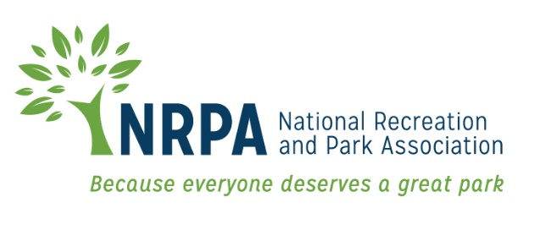

This toolkit is designed to help you develop and run a BioBlitz in your community.

Contents
Introduction 3
What is a BioBlitz? 3
What is the Parks for Pollinators BioBlitz? 3
Creating Your Project on iNaturalist 4
Key Steps To Create Your Project Page 6
What are your desired outcomes? 7
Agency outcomes could include 7
Individual outcomes may include 7
Community Outcomes 7
Environmental Outcomes 7
What Resources Will You Need? 8
Getting Started 8
Site Logistics 8
Pick a location 8
Pick a date and time 8
Select a Base Camp at Your Location 9
Designate a Wrap-Up location 9
How Much Wi-Fi Do We Need? 9
Recruiting Volunteers and Participants 10
Recruit Experts and Volunteers 10
Promote your Event! 10
Organizing Participants 10
Preparing You, Your Team and Participants 11
Example Email to Attendees 11
During Your Event 12
Orientation for Participants 12
Activities to Do During Your BioBlitz 13
After Your Bioblitz 14

Introduction
This guide has been designed to help you develop and run a BioBlitz in your community. We’ll walk through creating your project and share ideas to help market your event to the community. While this guide focuses on using the iNaturalist platform to host your project and to record findings, there are many other platforms or ways to conduct one.

What is a BioBlitz?
‘Bio’ means ‘life’ and ‘Blitz’ means ‘to do something quickly and intensively’. Together they make ‘BioBlitz’ — a collaborative race against the clock to discover as many species as possible within a set location during a defined time period.
A BioBlitz usually comprises a group of scientists, naturalists, parks staff and other members of the public working together. If you have wildlife experts or a master naturalist who can get involved, that’s great! If not, no need to worry, you and your park staff can handle the task. As an informal and fun way to create a snapshot of the variety of life found in an area, these events provide an opportunity for participants to learn together and share their expertise and enthusiasm for nature. BioBlitzes make engaging with science easy and fun while raising awareness about the role of biological recording. It also gives the public an opportunity to contribute to a genuine scientific survey. A BioBlitz can be carried out anywhere there is wildlife, including urban and rural areas, or inland and coastal locations.
The concept is flexible: it’s up to you to decide how many people to invite, how big an area to explore and what activities to include.

What is the Parks for Pollinators BioBlitz?
The Parks for Pollinators BioBlitz is a national effort for people to find and document pollinator friendly plants and pollinators across the country in partnership with their local park and recreation agency. It’s a national campaign to see who can make the most observations, engage the most people and promote pollinator awareness and education. The results not only make an impact for awareness of pollinators nationally and for those that participate, but also helps agencies know what pollinator species are in their parks and helps them plan for how to protect them.
The Parks for Pollinators BioBlitz is organized by the National Recreation and Park Association with support from The Scotts Miracle-Gro Foundation.

Creating Your Project on iNaturalist
The Parks for Pollinators BioBlitz will be utilizing the iNaturalist platform. This platform allows every agency’s results to be shared and calculated up to a national page within the platform and will show our collective impact for this event.
Instructions below describe how to create your project page. Pay close attention to the details under “Key Steps To Create Your Project Page” on page 6 that explain the criteria for your page as part of the NRPA Parks for Pollinators BioBlitz.
Sign up for iNaturalist and use the App
- You will need to sign up for iNaturalist as a user. To ensure you understand how to use the site and can successfully set up your page, iNaturalist requires you to use the app before setting up your page. You will have to make at least 50 verifiable observations before you can create a new project. If you are new to the platform, give yourself some time to familiarize yourself with it. This will help not only you, but also those you will be leading and educating about the tool!
Create your project page on iNaturalist
- As for the type of project you will create on iNaturalist, we suggest creating a collection project, which will allow you to count any observation within your selected area and timeframe towards your project and doesn’t require users to find and sign up for your specific project. This will prevent any barriers for participants. Learn how to set up your project (and scroll down to “Getting Started” on page 8 for steps to create a Bioblitz project). This information will help you create your page, upload graphics, create spatial boundaries, set observation rules and identify the species you will accept.

- Project Title — To ensure all our projects represent the overarching campaign, please ensure your project title is formatted as:
    - Parks for Pollinators 2020: City or Agency Name (i.e., Parks for Pollinators: Loudoun County Parks and Recreation)
- Project Summary — Please feel free to use and edit the following text as needed:
Join [Agency Name] and parks throughout the country in a fun challenge to see how many pollinators species can be documented during National Pollinator Month in June. It is easy to participate by joining an event or making observations on your own using the iNaturalist app. With the iNaturalist app, you just take a picture of a pollinator (bee, butterfly, bat, etc.) or pollinator-friendly plant and the community will help identify the species. You can participate by exploring the nature and wildlife in [area in which your BioBlitz will be held]. Any observation you make will count during our event.
Park and recreation agencies from across the country will be hosting Parks for Pollinators BioBlitz events throughout the week. You can learn more about the Parks for
Pollinators initiative and see which agencies are participating by visiting nrpa.org/ bioblitz.
The Parks for Pollinators BioBlitz is organized by the National Recreation and Park Association.
- Data Quality — Please select all the options offered — “Research,” “Needs ID” and “Casual” — to ensure everyone’s observations are included.
- Media Type and Establishment Means — Please select “Any” for both these areas.

- To define the spatial boundaries of your event, you will need to create an ‘iNaturalist place’. iNaturalist already has a lot of political boundaries like counties, municipalities and parks, if you want to use one of these, then skip to the next bullet. But if the boundary you need isn’t already an iNaturalist place, you’ll need to create the place first. Go to the “Places” page and click on “add a new place” and it will walk you through the process. You will only be able to add a place if you have at least 50 observations with your account. But if you aren’t able to add a place, NRPA can help! Please contact Michele White at mwhite@nrpa.org for assistance.

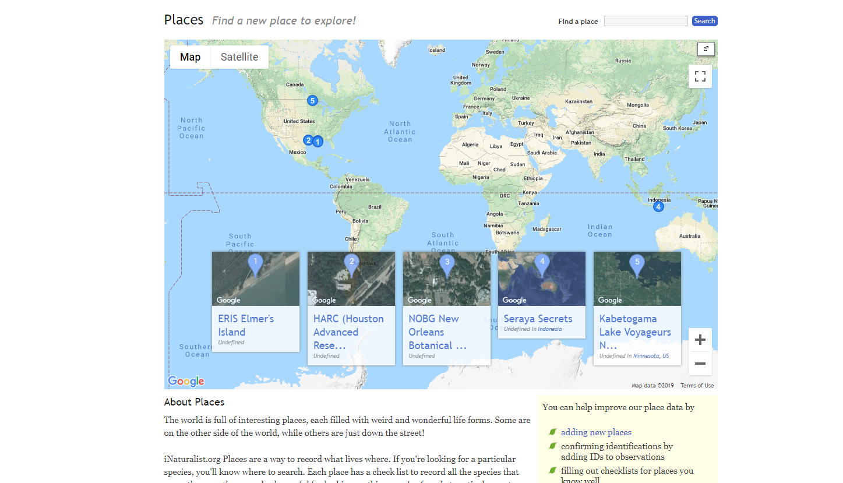

- There are options to show the attendee list or not in iNaturalist. Generally, people want to go to an event that is popular or that someone they know is attending, which argues for showing the list. Other groups may have more concern about privacy and will prefer not to show the list. This is up to you!

Key Steps To Create Your Project Page

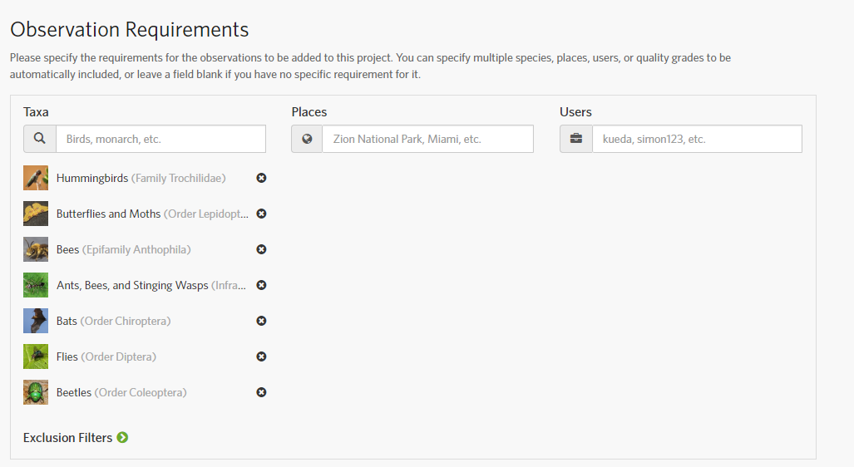
- To ensure your project is collecting the correct data, limit your taxa for the project to pollinator species. You can do this under the “Observation Requirements” section when you are creating your page. You can either identify the species you wish to include, and/or you can exclude those that you don’t. For the Parks for Pollinator BioBlitz, please include: “Butterfly and Moths;” “Ants, Bees, Wasps and Sawflies;” “Flies;” “Bats;” “Beetles;” and “Hummingbirds and Flowering Plants.” These will be the taxa that feed up into the national Parks for Pollinators BioBlitz campaign.
- To ensure your project is connected to the NRPA Parks for Pollinators 2020 National BioBlitz Campaign, please send your project name to Michele White at mwhite@nrpa.org so we can make sure to add your project to the national campaign! This ensures your data will be included in the national information and your numbers will count towards our overall impact.
- Add nrpaparks4pollinators as an administrator on your page. This will be at the bottom of the set-up page and titled “Admin(s).” If you have any questions regarding this, please contact Michele White at mwhite@nrpa.org.
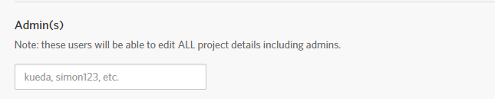

What are your desired outcomes?
NRPA’s goals for the Parks for Pollinators BioBlitz are to engage communities across the nation in pollinator awareness and education while also collecting national pollinator data. However, your agency, as well as your participants, may have other goals or desired outcomes from this event.

Agency outcomes could include:
- Engaging community members in a nature-based event that will bring them closer to local wildlife and habitats with a friendly competition
- Developing a baseline inventory of your park property natural resources
- Identifying invasive species
- Identifying endangered or critically threatened species
- Helping inform your conservation plans, planning or land management practices
- Raising awareness of the biodiversity within your parks
- Creating new partnerships with organizations and groups
- Raising your agencies profile in the media

Individual outcomes may include:
- Having fun and being inspired to enjoy the natural world and contribute to its conservation
- Developing an understanding of local wildlife and habitats
- Gaining first-hand experience of how biological recording works
- Developing wildlife identification skills alongside communication and teaching skills
- Becoming more aware of wildlife and conservation in local community
- Being encouraged to continue recording wildlife sightings after the event

Community Outcomes
By hosting an event in your “backyard,” BioBlitz events can lower barriers to engagement with nature – particularly for hard-to-reach groups such as young people, the elderly, disabled groups, racially diverse and minority ethnic groups, and those living in underserved areas.
If targeted well, BioBlitzes can bring together diverse groups of people, which can contribute to improved community cohesion. By encouraging people to participate in wildlife activities in their local areas, BioBlitzes can help foster a sense of belonging. They also can help build support for local conservation areas and may encourage the behavior changes required for their effective protection.

Environmental Outcomes
Data gathered during your BioBlitzes can generate biological records. These records can be used for scientific research, as well as inform conservation practices, local planning and land management on a multitude of levels.

What Resources Will You Need?
A BioBlitz will require resources from your agency. Staff and volunteers will be needed to plan, promote and run the event. The amount of resources will depend on the size of your event. Expertise with nature-based events also will be important to ensure participants have a rich and immersive experience. The outline below identifies how to plan, promote and execute a BioBlitz, but not all items suggested are necessary. You can customize your event with whatever will work best for your agency and the resources available.

Getting Started

Site Logistics

Pick a location
Whether it’s just one park or an entire county or state — here are some questions to ask when trying to decide which location is best for you:
- Is it safe?
- Is it easily accessed? If not, considering having an alternate activity for those that can’t participate due to physical limitations (ex: bioblitz around base camps which are described on the next page)
- Will it be able to cope with your expected audience size without any negative impact on biodiversity?
- Does it contain the desired habitats and species?
- Does it contain appropriate facilities?
- Does it contain somewhere to host your basecamp?
- Does it have good cell service in case of emergency? If not, do you have a plan to address this?

Pick a date and time
The NRPA Parks for Pollinators BioBlitz will be held during the entire month of June. Please make sure your event is hosted during the month to count towards the national impact and numbers we are counting.
- Pick a time that the species you are focusing on will be active. Most pollinators are most active during the daytime (8 a.m. to 3 p.m.). Pick a time that suites both them and your community members.
- Not all pollinators are daytime creatures. You also can do an evening event focused around moths!

Select a Base Camp at Your Location
Base camps provide one central meet-up location to start and end your event. It gives your participants a place to ask questions and gather with other community members — especially if you have individuals going out on their own.
Base Camp Considerations:
- Choose an easy to access space in a central location near an entrance, parking lot or other facilities
- Have tables and tents, if needed
- Consider having staff present at all times
- Consider requirements for powering laptops and/or charging mobile devices
- Supply educational materials such as guidebooks, microscopes, show and tell items, pollinator-related identification materials and other items to engaged participants

Designate a Wrap-Up location
The wrap-up location serves as a place to end your event. Make sure all sightings are uploaded to your iNaturalist project page and celebrate with participants. To make sure your wrap-up location fits your needs, ensure it has cell reception or Wi-Fi. Refreshments are also an option. This will allow everyone to ensure their sightings are uploaded from their smart phones and those that aren’t as familiar with the process can find help. You also can host a wrap-up session to answer any questions, to highlight the groups findings and to thank everyone who helped. If you can project the findings on a screen or wall, that might be good too!

How Much Wi-Fi Do We Need?
How big of a Wi-Fi pipe do you really need to pull off the wrap-up meeting? Speedtest.net is an excellent and easy way to evaluate the bandwidth of Wi-Fi system. Based on speed test results, 1Mb/s download, 0.2 Mb/s upload per user is a good guideline.

Recruiting Volunteers and Participants

Recruit Experts and Volunteers
You will need employees and/or volunteers to lead groups of participants and be able to assist those who aren’t as comfortable exploring on their own. Include those that have knowledge or experience identifying pollinators and their hosts plants in your leadership group. It would be good to involve partners like:
- Master naturalists
- Master gardeners
- Local universities or academic groups
- Park friends’ groups
- Species-specific experts or groups
- Park staff that have expertise in horticulture or biology
- School groups and other community groups

Ideas to reward and acknowledge your volunteers include:
- Allowing them to promote their group during the event
- Making t-shirts to distinguish them from the participants
- Creating a social activity for them
- Providing access to all data

Promote your Event!
Promoting your event could include using social media, working with local press, putting up posters, and contacting local radio and television stations. Also, reach out to community groups, partners and others potentially interested in the event. Use the Parks for Pollinators BioBlitz Marketing Toolkit to help with design, key messaging and outreach tactics.

Organizing Participants
Are you going to let participants go solo or are you going to organize them in groups with a leader who can help them through the experience?
If you are doing the latter, then you should divide up the park and make maps (if needed). Assign a leader to each group who can help participants through the event and provide some expertise with identifying species and recording findings. Consider the age and demographics of participants and select an engaging leader. You may want to request this information when participants register for the event, so you can be prepared ahead of time. You also can create friendly competition between the groups!

Provide participants with species list of what they might see in the park. That way they feel more comfortable identifying and recording sightings.

Preparing You, Your Team and Participants

In the weeks leading up to the BioBlitz:
- Keep promoting your event.
- Update staff and volunteers on their roles at the event and include information about key locations, event context and steps to take in an emergency.
- Run a training or briefing session for key staff and volunteers on how to use iNaturalist and how you will run your event.
- Consider running an on-site solo BioBlitz rehearsal to ensure you and your team are prepared.
- Share resources with your community on how to use iNaturalist. This video is a great to share. The team at iNaturalist have developed several flyers, handouts and tools to help. Check them out here and look under the “additional resources” tab.
- Communicate with participants. Link back to your iNaturalist project page, so participants have all the details they need to know.
- Address safety concerns. With all events there are always risks. Ensuring that everyone is aware of any potential hazards is important. Make sure your team is prepared with any authorization forms, first aid kits and other important safety measures. There are a few other things you should consider:
  - How you’ll keep track of participants. If you are hosting an in-person event at a large site, consider how you will make sure that no one is left behind.
  - We want to make sure everyone has a great experience, so make sure to highlight any toxic plants or dangerous animals that participants and leaders should stay away from.
  - If your area is prone to ticks, let participants know the ways they can protect themselves: light clothing, long sleeves and pants, tucking pant legs into socks and conducting tick checks occasionally.
- Send out reminder emails (three days out and one day out). Keep it short. People won’t read a long email. You could also use Eventbrite’s handy emailer. See an example email below:

Example Email to Attendees
What you really need to know:
- Sign up for iNaturalist.
- Download the app on your smart phone.
- Be at the parking lot of [park name] [link to directions here] at [either 9 a.m. or 2 p.m./or both times] with a fully charged phone, water bottle and appropriate clothing and footwear.
- Meet back at basecamp at noon for the morning shift and 4 p.m. for the afternoon shift to see our results, get some food and celebrate what we have accomplished.

During Your Event

Bring your gear and set up!
- Tables, tents, chairs, etc.
- Printed maps
- Mark zone boundaries with flags or other obvious markers before the BioBlitz so participants don’t wander (if needed)
- Sign-up forms or releases
- Name tags (might be a nice touch)
- Wrap-up session materials (projector, extension cord, portable hotspot, array of field guides, food, drinks, etc.)
- Snacks
  - Ask participants to bring their own water bottles to ensure your event is conservation friendly. You may want to provide water dispensers.

Orientation for Participants
What is a BioBlitz?
An event that focuses on finding and identifying as many species as possible in a specific area over a short period of time to create a snapshot of an area’s biodiversity.
How will this event be structured?
Share with your participants how you will run your event. Will they work in groups or go out on their own? What would you like them to find (pollinators)? How long will it last and other details to help them understand the event?
How does iNaturalist work?
It’s an easy-to-use app where you take picture of what you find, upload them to the iNaturalist site and be included in your agencies project.
How do I use the app?
This video is a great to share, it walks you through the simple process of taking a photo, identifying species, adding detail, and sharing it to the iNaturalist site.
What do I take a picture of?
- Whatever is interesting to you, and whatever you think you can get a pretty good close-up photograph of.
- It is generally important to document invasive and exotic species as well as natives so don’t worry too much about how “special” or “rare” a plant or animal is. You are trying to get a representative sample of the entire place, not just the best parts.
- Diversity is important, too, so look for things you personally haven’t yet photographed.
- If you can, take several photographs of one object to show different features — bark, leaves, seeds, flowers, etc. — as well as the whole plant. Sometimes this is the only way to make a definite identification.
Smartphone tips:
- Turn screen brightness up on a bright day to make sure your focus is good.
- Rest your “camera hand” on something else to steady it.
- Touch the portion of screen where you want the camera to focus, some newer phones will do this automatically.

Activities to Do During Your BioBlitz

Depending on your participants and your resources, you could incorporate an activity during your BioBlitz.
- Guided Nature Walk: Take participants through a nature walk and have them take pictures of what they find along the way.
- Base Camp Mini BioBlitz: A small event focused on the immediate area around basecamp. This might be great for people with limited abilities, very small children or those not comfortable with the exercise.
- Moth Trapping: Use a white sheet and a light at night to attract moths.
- Sweep Netting: Ask park rangers not to cut an area of grass for a month or so before the event to give you a good area to sweep net in without damaging any valuable habitats. Cordon off the area with bunting so people can’t run off with sweep nets or other equipment.
- BioBlitz Hoopla: Throw a hula hoop, then spend time trying to find all the living things in that circle.
- Log Piles: Involve your participants in making a log pile six months or so before your BioBlitz event. On the day, you can explore what has moved in!

After Your Bioblitz

- Set up an identification (ID) party after the event. To help ensure all the records submitted are classified and counted, host a time where experts help identify species. Make sure to have experts in both identification of species as well as iNaturalist. Have them identify and classify as many unidentified submissions as possible to count towards your project. Make it a party! Grab some pizza, put on some music and make sure to have Wi-Fi and outlets to charge your laptops too.
  - iNaturalist Identification Tool: When you are hosting your ID party make everyone aware that the website version of iNaturalist has a great ID tool — it can make this work much easier!
- Say thank you. Make sure to thank all your volunteers, partners and participants who helped make the event a success.
- Share your results. Your participants and volunteers will want to know the impact they had, your agency will be interested to know the biological record you collected, researchers will be interested if you found a threatened species and the media may want to share your results. Many audiences may be interested in your findings, so it’s best to share with whomever you think would be interested. You can easily compile the information in iNaturalist.
- Catalogue your results. Ensuring your results are used by your agency for conservation planning is important. If you already have a protocol for doing this, that is great! If you don’t, iNaturalist does organize the information in an easy to digest way and you can also consider creating a guide with iNaturalist
- Make sure to note invasive species. Plan a way to control them.
- Note any species that are threatened, new or troublesome.
  - If you are doing a site smaller than a county, the endangered species won’t come up in your project (this is to protect them from not-so-nice people). You can see if you have endangered or threatened species by looking at the county level and filtering for the upload date. If it was uploaded the date of your event, you can reach out to the observer to ask permission to access where they documented the species.
- Use the findings to inform your plans for managing the land.
- Host annual BioBlitzes. This will help evaluate the impact of your conservation plans.
- Plan Your Next One!

