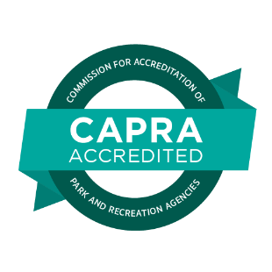

Embargoed until after hearings are complete and confirmed on Sept.7, 2022.

Media Contact:
[Contact Name]
[Agency Name]
[Phone]
[Email]

[Agency Name] Earns National Accreditation in Parks and Recreation
Mark of distinction recognizes commitment to highest level of service to the community

[City], [State Abbr.], Sept. X, 2022 – Today, [Agency Name] joins the ranks of elite park and recreation agencies across the country by earning accreditation through the Commission for Accreditation of Park and Recreation Agencies (CAPRA) and the National Recreation and Park Association (NRPA). This distinguished accomplishment was awarded during the 2022 NRPA Annual Conference.

CAPRA accreditation is the only national accreditation for park and recreation agencies, and is a measure of an agency’s overall quality of operation, management and service to the community. This mark of distinction indicates that an agency has met rigorous standards related to the management and administration of lands, facilities, resources, programs, safety and services.

As part of the accreditation process, [Agency name] had to demonstrate compliance with 154 recognized standards and document all policies and procedures. Often the process helps identify efficiencies and heighten areas of accountability, all of which translate into higher quality service and operation to benefit the community.

[Quote from Agency Director or other leader/notable about accreditation and what it means for the agency/community]

The process for accreditation involves a formal application, self-assessments, a site visit by a team of trained visitors that results in a written report, and a hearing with the commission to grant accreditation. Due to the COVID-19 pandemic, this year's visitations were held virtually. Once accredited, the agency must uphold the standards by submitting an annual report and is reviewed again in five years.

The Commission is comprised of representatives from NRPA, the American Academy for Park and Recreation Administration, the National Association of County Park and Recreation Officials, the International City/County Management Association, the Academy for Leisure Sciences, the Armed Forces Recreation Network and the Council of State Executive Directors.

For more information about CAPRA accreditation, visit www.nrpa.org/CAPRA.

[Agency Boiler Plate]

About the National Recreation and Park Association

The National Recreation and Park Association (NRPA) is the leading not-for-profit organization dedicated to building strong, vibrant and resilient communities through the power of parks and recreation. With more than 60,000 members, NRPA advances this mission by investing in and championing the work of park and recreation professionals and advocates — the catalysts for positive change in service of equity, climate-readiness, and overall health and well-being. For more information, visit www.nrpa.org. For digital access to NRPA’s flagship publication, Parks & Recreation, visit www.parksandrecreation.org.

# # #

