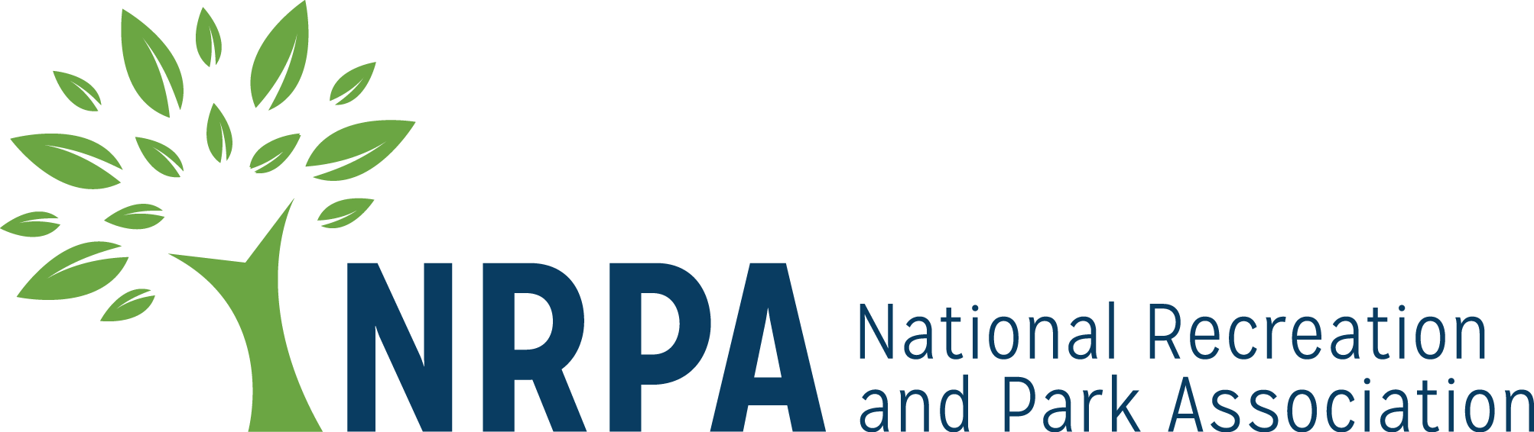

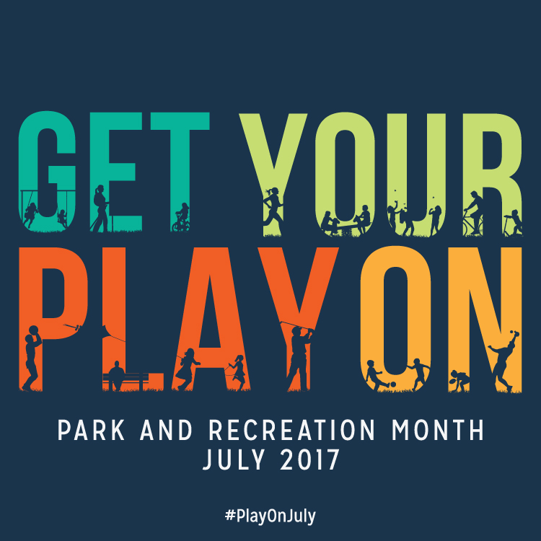

2017 PARK AND RECREATION MONTH

OUTREACH TOOLKIT

Contents
Toolkit Purpose 3
Park and Recreation Month 2017 Fact Sheet 4
NRPA 2017 Park and Recreation Month Key Messages 5
Template Media Advisory 8
Template 2017 Park and Recreation Month Press Release 9
2017 Park and Recreation Month Social Media Materials 11
Template 2017 Park and Recreation Month Editorial Story Sample 13
Media Outreach – “How To” 14

Toolkit Purpose

This toolkit is meant to make promoting and celebrating Park and Recreation Month in your community a little easier! This kit is designed to help you generate positive media coverage and support for your Park and Recreation Month activities and ultimately the work of your agency and the benefits you bring to your community.

This kit includes template media materials such as media alerts for special events, press releases, fact sheets, key messages for use during interviews, social media posts, and a sample editorial article you can submit to local publications. Feel free to customize these materials with localized information, quotes and details that best meet your needs.

When using social media, please make sure you are tagging NRPA in your Facebook, Twitter and Instagram posts and using the hashtag #PlayOnJuly.

Don’t forget, we want to see your successes too – send us photos and videos from your Park and Recreation Month events or the creative ways you have used the marketing materials!

If you have questions or need further assistance, please don’t hesitate to contact us.

General Park and Recreation Month or Toolkit Questions
Roxanne Sutton
Communications Manager, NRPA
703.858.2166
rsutton@nrpa.org

Press Release or Media Questions
Heather Williams
Sr. Public Relations Manager, NRPA
703.858.4743

Submit Photos or News Coverage
Catrina Belt
Senior Marketing and Communications Specialist, NRPA
703.858.2165
cbelt@nrpa.org

We hope this toolkit helps you generate great support for Park and Recreation Month!

Thank you,

Roxanne, Heather and Catrina

Park and Recreation Month 2017 Fact Sheet

- This July, discover the power of play and adventure. For children and adults, play is a vital part of our mental wellbeing, physical health and personal interactions.

- During Park and Recreation Month, NRPA is challenging everyone to get their play on with their local parks and recreation. Whether it’s summer camp, an adult sports league, exploring a trail, Zumba class, meeting friends on the playground, playing cards in the park, or discovering nature — parks and play go hand in hand.

- Various research studies are confirming that community parks and recreation, green space and time outdoors is critical for creating healthy, active and sustainable communities. You can experience the benefits by visiting your community parks and recreation any time of the year, and especially during Park and Recreation Month.

- In addition to visiting a park or recreation area during July, you can get involved in Park and Recreation Month by:

  - Using the social media graphics and #PlayOnJuly throughout the month.
  - Participating in the Park and Recreation Month contest.
  - Downloading the official Park and Recreation Month poster and hanging it up, taking pictures with it or sharing copies of it with your community.
  - Using the Park and Recreation Activity Book in your summer camps.

- This July, NRPA will host a weekly contest encouraging people to show us why play is so important in their lives. Entries can be submitted via the hashtag #NRPAPlayChallenge. Each week in July will have a theme:
  - July 3-9: Show us how you play in Parks.
  - July 10-16: Show us your favorite Leisure activities.
  - July 17-23: Show us how you Advocate for parks, recreation and play.
  - July 24-30: Show us how your Youth play at your local parks and rec.

- NRPA is featuring the winning photo of our Park and Recreation Month Cover Contest this July in Parks & Recreation magazine.

- You can learn more about Park and Recreation Month and find participating park and recreation areas in your community by visiting: www.nrpa.org/July.
- Join the conversation on Facebook, Twitter and Instagram with the hashtag #PlayOnJuly.

NRPA 2017 Park and Recreation Month Key Messages

  - General Key Messages
- Since 1985, Americans have celebrated Park and Recreation Month in July to promote the importance of parks and recreation in health and wellness, conservation and social equity, and to recognize the thousands of park and recreation employees that maintain our nation’s local and community parks.
- Through efforts by NRPA, the U.S. House of Representatives passed an official resolution for Park and Recreation Month in 2009.
- Park and recreation agencies across the country are recognizing the month with summer programs, events, contests, commemorations and celebrations.
- Park and recreation services are vital for our communities — from protecting open space and natural resources, to helping fight obesity, to providing activities and resources for all walks of life — Park and Recreation Month encourages everyone to reflect on the exponential value parks and recreation bring to communities.
  - 2017 Key Messages
- This July we’re celebrating the power of play. Play is a vital part of our mental wellbeing, physical health and personal interactions.
- Play is important and it’s going to happen in parks because local parks and recreation facilities are the accessible places for all people to play. Parks are ideally suited as the places where all people can play — regardless of ability.
- An obvious benefit of play is that it increases physical activity and mental agility. Parks make fitness fun through the use of outdoor exercise equipment, fun classes, sports leagues and so much more.
- 74% of children don’t get enough daily exercise — encouraging active play is a great way to get kids (and adults) more physically active.
- NRPA encourages all people that support parks and recreation to share why they think play is so important with the hashtag #PlayOnJuly.
- This July, NRPA will host a weekly contest encouraging people to show us why play is so important in their lives. Visit www.nrpa.org/July for more information on how to participate. Entries can be submitted via the hashtag #NRPAPlayChallenge.
- For more information visit www.nrpa.org/july.
  - Supporting Key Messages
Messages promoting support for parks and recreation:
- According to a 2015 study conducted by Penn State and commissioned by the National Recreation and Park Association, an overwhelming majority of Americans assert that they personally benefit from local parks and that their communities benefit from local parks.
  - Americans are in agreement that NRPA’s Three Pillars — Conservation, Health and Wellness and Social Equity — are chief priorities for local parks.
  - Parks are a great value: 4 in 5 Americans concur that local parks are well worth the tax dollars spent on them.
  - This passion for local parks has gone unabated over the past 25 years, even with dramatic demographic shifts in the United States and the ways technology transformed how we interact with others and entertain ourselves.
  - Support for local parks is widespread, spanning different age groups, income strata, household types and political affiliations.
Messages promoting health and wellness benefits of parks and recreation:
- The Centers for Disease Control found that increased access to places for physical activity led to a 25.6 percent increase in people exercising 3 or more times per week.
- Living close to parks and other recreation facilities is consistently related to higher physical activity levels for both adults and youth.
- On average, children who live in greener environments weigh less than children who live in less green areas.
- Children that have easy access to a playground are approximately five times more likely to have a healthy weight than children that do not have easy access to playgrounds.
- The nation’s park and recreation facilities are on the frontline in the battle against the obesity epidemic and other chronic health issues.
- Between 2000 and 2012, more than 85 studies have been published that link parks to better physical and mental health.

Messages promoting environmental benefits of parks and recreation:
- A park with one acre of trees absorbs the carbon dioxide produced by driving a car 11,000 miles.
- Parks do a great deal to contribute to species richness in urban settings — a review of more than 60 studies by IFPRA shows that there is strong evidence to support the concept that parks support both plant and animal biodiversity. This offers not only an important educational opportunity, but additionally supports overall ecosystem functionality.
- Parks reduce the impact of large storms and flooding by serving as sponges that soak up run off from nearby paved surfaces during rain events. This in turn prevents flooding and decreases property damage. Parks that are well-designed also reduce water usage by recycling and storing this water for use during times of low precipitation.
- Evidence not only shows that parks are cooler than their surrounding cities, but actually shows that parks contribute to overall urban cooling — parks make our cities more comfortable in the summer!
- According to a 2017 NRPA Park Pulse poll, 83% of Americans believe it is important that their local government makes environmental initiatives a priority.

Messages promoting the economic benefits of parks and recreation:
- According to a study conducted by the Center for Regional Analysis at George Mason University and the National Recreation and Park Association, America’s local and regional public park agencies generated nearly $140 billion in economic activity and supported almost 1 million jobs from their operations and capital spending alone in 2013.

Template Media Advisory
[GROUP LOGO/LETTERHEAD]

MEDIA ADVISORY
Media Contact:
[Contact Name]
[Agency Name]
[Phone]
[Email]

[Agency Name] to Kick Off Park and Recreation Month at [Park/Facility Name]
[Add a second-line description for a special appearance by celebrity or specific highlight.]

WHO/WHAT: [Name of major public officials or celebrities who are participating, as well as the number of people who will be in attendance.]

[List and briefly describe any programs or activities that will take place. Concentrate specifically on the highlights.]

WHEN: [Date/Time]
[Be sure to mention individual start times for notable speakers/happenings.]

WHERE: [Location/Address]
[Provide parking information, if relevant.]

WHY: Since 1985, America has celebrated July as Park and Recreation Month. A program of the National Recreation and Park Association (NRPA), the goal is to raise awareness of the vital impact that parks, recreation and conservation have on communities across the U.S.

This July, [Agency Name] and the National Recreation and Park Association are celebrating the power of play. Play is a vital part of our mental wellbeing, physical health and personal interactions, and local parks and recreation facilities are places where all people can play and have fun. For more information, go to www.nrpa.org/july or search Twitter and Instagram using #PlayOnJuly.
EDITOR’S NOTE: [Mention any opportunities for interesting visuals and tours. Provide onsite contact information.]
# # #

Template 2017 Park and Recreation Month Press Release

[GROUP LOGO/LETTERHEAD]

FOR IMMEDIATE RELEASE
Media Contact:
[Contact Name]
[Agency Name]
[Phone]
[Email]

This July, [City/Town/Community Name] Residents Invited to a Play Date with [Agency Name]
Month-long celebration highlights essential value of local parks and recreation

[CITY, STATE ABRV] – [DATE] – Summer is here, which means it’s time to get your play on. This July, discover the power of play with [Agency Name] as they celebrate Park and Recreation Month. A variety of fun activities are planned for residents of all ages and abilities — including [list top activities].

[Agency Name] is celebrating Park and Recreation Month, an initiative of the National Recreation and Park Association (NRPA), and all the ways parks and recreation has the power to transform our daily lives. From providing us places to play, get fit and stay healthy to fostering new relationships and forging a connection with nature, our close-to-home community park and recreation facilities provide essential services and improve quality of life.

[QUOTE from Agency leadership, discussing ways you impact your community through health and wellness, social equity, conservation, etc. and tie to the celebration of Park and Recreation Month.]

[Agency Name] will celebrate Park and Recreation Month through [provide brief summary of local activities].

NRPA is celebrating the month by hosting a weekly contest encouraging people to show them why play is so important in their lives. Visit www.nrpa.org/July for more information on how to participate. Entries can be submitted via the hashtag #NRPAPlayChallenge. NRPA also encourages all people that support parks and recreation to share why they think play is so important with the hashtag #PlayOnJuly.

To learn more about Park and Recreation Month, visit [Add local website information] and www.nrpa.org/July.

[Agency boilerplate/ “about” information]

About The National Recreation and Park Association
The National Recreation and Park Association is a national not-for-profit organization dedicated to ensuring that all Americans have access to parks and recreation for health, conservation and social equity. Through its network of nearly 60,000 recreation and park professionals and advocates, NRPA encourages the promotion of healthy and active lifestyles, conservation initiatives and equitable access to parks and public space. For more information, visit www.nrpa.org. For digital access to NRPA’s flagship publication, Parks & Recreation, visit www.parksandrecreation.org.

# # #

2017 Park and Recreation Month Social Media Materials

  - Social Covers and Badges
You can find social media covers and badges at www.nrpa.org/july/Park-and-Recreation-Month/ToolKit/. We encourage you to update your Facebook and Twitter pages with these images to show your support of Park and Recreation Month all throughout July!

  - Sample Social Media Posts
If you have social media platforms such as Facebook, Twitter and Instagram, here are some sample messages to generate awareness among your friends and followers. Customize these posts for Park and Recreation Month and feel free to develop some more on your own!

Tag NRPA in your posts, too.
- Facebook: @National Recreation and Park Association
- Twitter: @NRPA_News
- Instagram: @nrpa

Official 2017 Park and Recreation Month Hashtags
- #PlayOnJuly
- #NRPAPlayChallenge (contest hashtag—you can find more information about this year’s contest at www.nrpa.org/July)

Sample posts for Facebook:

- We’re celebrating Park and Recreation Month by discovering the power of play and adventure at (insert park/facility name)! #PlayOnJuly
- Get Your Play On this July! Play is vital for our health and wellbeing and your (community) parks are the best places for play! #PlayOnJuly
- Check out how we get our play on at (insert park/facility name)! #PlayOnJuly (include photos from activity)
- What’s your favorite way to play? We’re celebrating the importance of play all July for Park and Recreation Month alongside the @National Recreation and Park Association. #PlayOnJuly
- Park and Recreation Month encourages everyone to reflect on the value of parks and recreation in our communities. How do (insert City name) park and rec facilities help you discover the importance of play? #PlayOnJuly
Sample posts for Twitter:

- We’re celebrating Park and Recreation Month by discovering the power of play at (insert park/facility name)! #PlayOnJuly
- This Park and Recreation Month get your play on! #PlayOnJuly
- Play is a vital part of our mental and physical wellbeing and our personal interactions. Celebrate play with us and @NRPA_News! #PlayOnJuly
- What’s your favorite way to play? We’re celebrating the importance of play for Park and Recreation Month! #PlayOnJuly
- Your local parks and rec are the perfect places to play! Celebrate Park and Recreation Month with us and @NRPA_News this July! #PlayOnJuly
- We’re discovering the power of play this month in honor of Park and Rec Month! Check it out! #PlayOnJuly (insert shortened link to your website or calendar of activities for July)

Sample post for Instagram:

- We’re discovering the power of play at (insert park/facility name) in honor of Park and Recreation Month! #PlayOnJuly
- Get Your Play On this July! Play is vital for our health and wellbeing and your (community) parks are the best places for play! #PlayOnJuly

Template 2017 Park and Recreation Month Editorial Story Sample

Headline: This July, Go on a Play Date with (Agency Name)
Subhead: Celebrate Park and Recreation Month this July by (list a few planned activities here)
Get ready to get your play on this July with (Agency Name) and the National Recreation and Park Association (NRPA).
Since 1985, America has celebrated July as the nation’s official Park and Recreation Month. Created by NRPA, Park and Recreation Month specifically highlights the vital and powerful role local parks and recreation, such as [Agency Name], play in conservation, health and wellness, and social equity efforts in communities all across the country.
This year, it’s all about discovering the power of play with your local parks and recreation facilities. From learning a new sport like pickleball to meeting your friends on the playground, your [city/town] parks and recreation facilities are the places where everyone can play, regardless of age or ability. NRPA and [Agency Name] are encouraging everyone to get out there to experience the power of play for themselves.
In [city/town], you can celebrate Park and Recreation month by [complete sentence with local activities/ events /contests etc.].
“July is the perfect time to highlight all the benefits parks and recreation provides right here in [city/town],” said [Agency Leader]. Our local parks and recreation directly contribute to reduced obesity rates, an improved ecosystem and increased property values.”
[Agency name] is leading initiatives and providing opportunities for people of all ages to achieve healthier lifestyles, promote and understand nature and conservation as well as bringing the community closer through a variety of programs and services. [Add more details on any specific ways you make a difference in your community or any stats or success stories you may have that back up the impact you make.]
Nationally, NRPA is celebrating Park and Recreation Month with a weekly contest encouraging people to show them why play is so important in their lives. NRPA also encourages all people that support parks and recreation to share why they think play is so important with the hashtag #PlayOnJuly. For more information about the contest and Park and Recreation Month in general, visit www.nrpa.org/July.
Learn about the exciting Park and Recreation Month activities planned for [town/city name] and more at [Fill-in local contact information here] or visit online at [Fill-in local park website URL here].

Media Outreach – “How To”

The following are general guidelines for conducting media outreach for both special events you may be hosting in July and in general for Park and Recreation Month.

  - Leveraging the Press Release

To announce your involvement in Park and Recreation Month and what activities you will have going on throughout the month, customize the Press Release template and distribute it to appropriate reporters, bloggers and broadcast media in your local area.

- Search online for the “news desk” emails and/or submission guidelines of your local TV stations and radio stations.

- Search for the contact information for reporters and publications in your local area that cover topics related to parks, the outdoors and community affairs. Be sure to pitch to only one reporter from each newspaper/print agency. It is a good idea to review the stories the reporter writes to get a feel for what they are most interested in so that you can tailor your outreach to meet their interests. Most reporters prefer email.

- Search online for bloggers in your area; these social media journalists are powerful influencers and can virally spread the word about the events you have going on for Park and Recreation Month.

- Once you have your list together, prepare your pitches. Make sure you tailor the pitch for the type of outlet and personalize it as much as possible for the journalist or blogger you are contacting. Keep it brief.

- You’ll want to send the release out at the end of June or beginning of July to journalists and reporters, and to TV/radio stations approximately two days before an event you want them to attend.

- Customize the press release template with the appropriate information, as marked with brackets and yellow highlight, EX: [NAME].

- You can distribute your press release on any newswires you subscribe to or use regularly. This will give you added visibility in news rooms and with online media.

- In addition to wire distribution, reach out directly via email to journalists and bloggers. Insert your pitch and paste the text of the press release into the email.

- Put an engaging tag line or sentence in the “Subject” line of the email to entice reporters.

- Once you have sent your release, follow up with a phone call to reporters. Be sure to have a short pitch ready, and be prepared to answer questions about why your event or story is a “must see/cover.”

  - Using the Editorial Article Template

Many local newspapers and online media outlets are very interested in receiving already written editorial content that they can instantly use in their outlets. The template editorial article is a great way to get coverage for your agency and what you are doing for Park and Recreation Month.

- Contact your local community print publications and ask them if they take “drop in” articles or editorial content submissions.

- Find out if they have any requirements such as a particular word count and preferences such as submission process and deadline. They may only take submissions on a certain day or require that submissions be made via an online entry form only.

- If they take submissions, keep note of that in your records for the future. You may even want to explore the option of regularly contributing content from your agency.

- Confirm the lead time, or time it takes for content to appear once submitted. You will want to make sure that you provide the article in enough time to the publication so that it appears timed to your event you may be highlighting or within the month of July.

- Customize the sample editorial article with the appropriate information, as marked with brackets and yellow highlight, EX: [NAME].

- Submit your completed article per the outlet’s instructions and confirm when you can expect to see the coverage in print or online.

  - Inviting Press to Your Event

If you are hosting a special event during the month of July and would like to invite reporters to cover your event on site:

- Search online for the “news desk” emails and/or submission guidelines of your local TV stations and radio stations.

- Search for the contact information for reporters and publications in your local area that cover topics related to parks, the outdoors, and community affairs. Be sure to pitch to only one reporter from each newspaper/print agency. Most reporters prefer email.

- Consider inviting local bloggers to your event as well or creating a special opportunity for them to come out and get sneak peek of your Park and Recreation Month event. These social media journalists are powerful influencers and can virally spread the word about the events you have going on for Park and Recreation Month.

- It’s a good idea to send Media Advisories to journalists and reporters at least two weeks in advance and to TV/radio stations approximately two days before an event.

- Customize the media alert template with the appropriate information, as marked.

- Write a brief, one-paragraph pitch to the reporter, and attach the Media Advisory as a PDF or Word Document, or paste the text into the email, beginning with “Media Advisory.”

- Put an engaging tag line or sentence in the “Subject” line of the email to entice reporters.

- Once you have sent your Media Advisory, follow up with a phone call to reporters you are particularly interested in having attend. Be sure to have a short pitch ready, and be prepared to answer questions about why your event is a “must see.”

- Consider sending a post-event press release to generate coverage after the event. It is a good idea to send this immediately following the event or the next morning. Often times, this means drafting most of the release in advance, and adding a few pertinent details afterward.

- Reach back out to the reporters that you previously contacted. If you can, offer footage from the event or high resolution photos.

  - Tips and Tactics

- Remember that timeliness is a big factor in press coverage.

- Try to keep the message brief. One page is best—do not exceed two.

- Don't forget to add complete contact information. If a reporter is interested, they may wish to email or call you with questions or requests for clarification.

- Write using short paragraphs and sentences, and in the third person—don’t refer to yourself as “I” or “we,” except in a direct quote.

- Avoid testimonials or other promotional language. A press release is news; not advertising.

- Don’t be discouraged if you do not receive interest, or if a reporter doesn’t make it to your event. Reporters receive hundreds of press releases every day and cover news based on many factors (timeliness, the amount of current events taking place, space, editor approval, capacity, etc.). It’s never personal.

- If a reporter does email or call with interest, be sure to respond in a very timely manner.

Let us know if your Park and Recreation Month event is covered in the news! Send links of online coverage to cbelt@nrpa.org.

