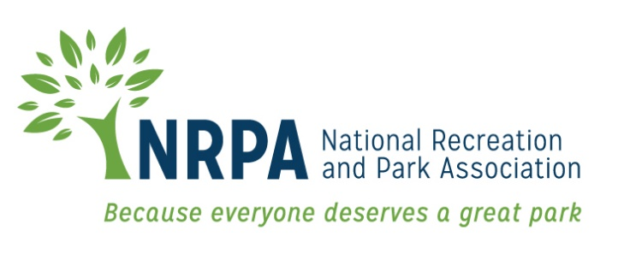

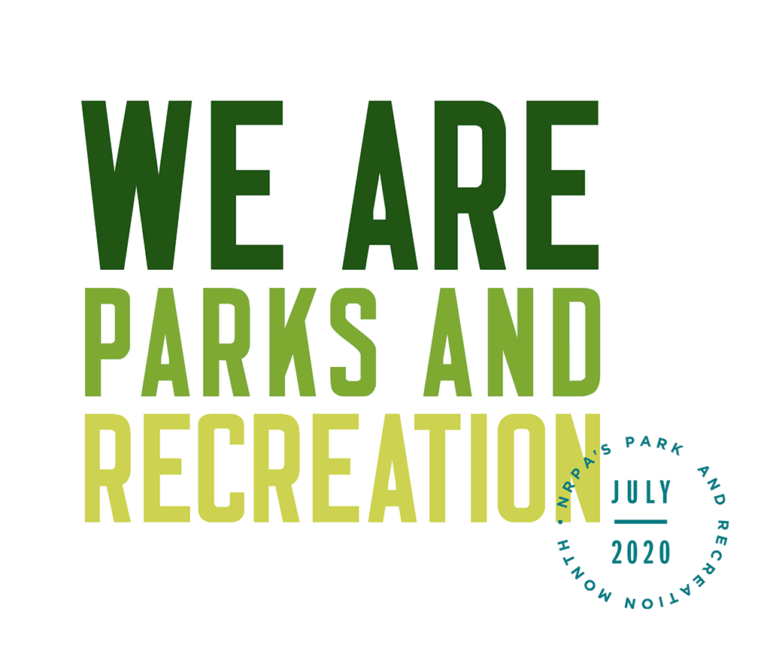

2020 PARK AND RECREATION MONTH

TEMPLATE MEDIA ADVISORY AND PRESS RELEASE

Template Media Advisory
[GROUP LOGO/LETTERHEAD]

MEDIA ADVISORY
Media Contact:
[Contact Name]
[Agency Name]
[Phone]
[Email]

[Agency Name] to Kick Off Park and Recreation Month at [Park/Facility/Virtual Event Name]
[Add a second-line description for a special appearance by VIP or specific highlight.]

WHO/WHAT: [Name of major public officials or celebrities who are participating]

[List and briefly describe any programs or activities that will take place. Concentrate specifically on the highlights.]

WHEN: [Date/Time]
[Be sure to mention individual start times for notable speakers/happenings.]

WHERE: [Location/Address]
[Provide parking information, if relevant.]

WHY: Since 1985, America has celebrated July as Park and Recreation Month. A program of the National Recreation and Park Association (NRPA), the goal is to raise awareness of the essential services that park and recreation professionals provide to communities across the U.S.

This July, [Agency Name] is celebrating with the theme We Are Parks and Recreation. All month long, we’ll be highlighting the selfless, passionate and essential work of park and recreation professionals who are providing services that are vital to a healthy [Your City/Town Name]. For more information, go to www.nrpa.org/july or search Twitter and Instagram using #WeAreParksAndRec.
EDITOR’S NOTE: [Mention any opportunities for interesting visuals and tours. Provide contact information.]
# # #

Template 2020 Park and Recreation Month Press Release

[GROUP LOGO/LETTERHEAD]

FOR IMMEDIATE RELEASE
Media Contact:
[Contact Name]
[Agency Name]
[Phone]
[Email]

This July, We Are Parks and Recreation at [Agency Name]
Month-long celebration highlights the essential services of local parks and recreation

[CITY, STATE ABRV] – [DATE] –This July, join [Agency Name] for Park and Recreation Month, as we celebrate the selfless, passionate and essential work of park and recreation professionals who are providing services that are vital to a healthy [Your City/Town Name]. A variety of [virtual] activities are planned for residents of all ages and abilities — including [list top activities/events].

[Agency Name] is celebrating Park and Recreation Month, an initiative of the National Recreation and Park Association (NRPA), by inviting you to learn more about our local park and recreation professionals and the essential services they provide. With everything from [list examples of offerings], there are plenty of ways that you can celebrate with us!

[QUOTE from Agency leadership, discussing ways you impact your community through health and wellness, social equity, conservation, etc. and tie to the celebration of Park and Recreation Month.]

[Agency Name] will celebrate Park and Recreation Month through [provide brief summary of local activities].

NRPA encourages people that support parks and recreation to share their park and recreation story, as well as why their local park and recreation professionals are important to them, with the hashtag #WeAreParksAndRec.

NRPA also encourages people to get creative throughout the month by participating in the Thank a Park and Rec Pro contest. Film a video thanking a park and recreation professional in your community for the services they provide and post it on social media using the hashtag #ThankAParkAndRecPro for a chance to win prizes throughout July.

To learn more about Park and Recreation Month, visit [Add local website information] and www.nrpa.org/July.

[Agency boilerplate/ “about” information]

About the National Recreation and Park Association
The National Recreation and Park Association is a national not-for-profit organization dedicated to ensuring that all Americans have access to parks and recreation for health, conservation and social equity. Through its network of 60,000 recreation and park professionals and advocates, NRPA encourages the promotion of healthy and active lifestyles, conservation initiatives and equitable access to parks and public space. For more information, visit www.nrpa.org. For digital access to NRPA’s flagship publication, Parks & Recreation, visit www.parksandrecreation.org.

# # #

