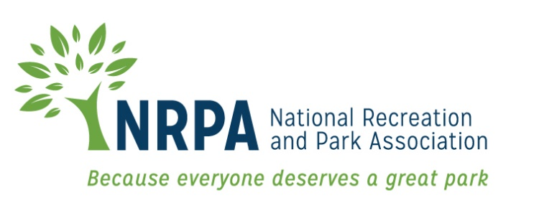

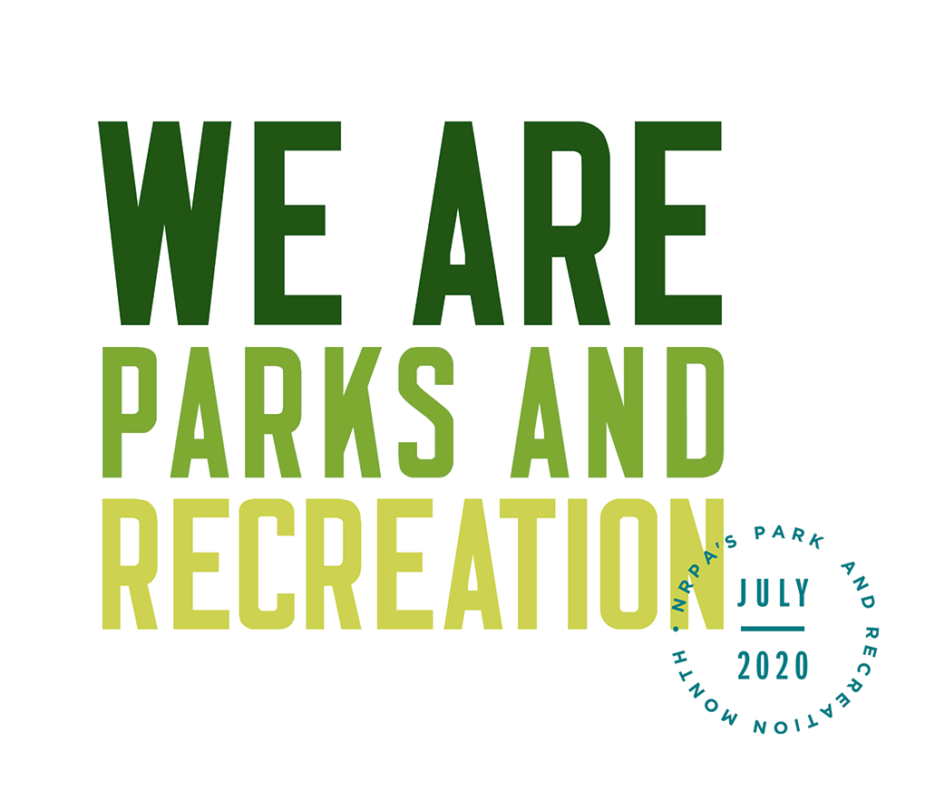

2020 PARK AND RECREATION MONTH

SOCIAL MEDIA MATERIALS

2020 Park and Recreation Month Social Media Materials

Social Covers and Badges
You can find social media covers at https://www.nrpa.org/events/july/toolkit/. We encourage you to update your Facebook and Twitter pages with these images to show your support of Park and Recreation Month all throughout July!

Sample Social Media Posts
If you have social media platforms such as Facebook, Twitter and Instagram, here are some sample messages to generate awareness among your friends and followers. Customize these posts for Park and Recreation Month and feel free to develop some more on your own!

Tag NRPA in your posts, too.
- Facebook: @National Recreation and Park Association
- Twitter: @NRPA_News
- Instagram: @nrpa

Official 2020 Park and Recreation Month Hashtags
- #WeAreParksAndRec
- #ThankAParkAndRecPro

Agency sample posts for Facebook:

- July is Park and Recreation Month and we’re celebrating by highlighting all the great work of our staff and volunteers at (insert park/facility/agency name)! #WeAreParksAndRec (insert staff photos)
- We are (Insert park/facility/agency name) and We Are Parks and Recreation. Did you know we offer (insert lesser known activities/programs) and more? #WeAreParksAndRec (insert photo from activity/event)
- Did you know (insert park/facility/agency name) has been providing (insert services) to our community throughout COVID-19? #WeAreParksAndRec (insert photos of services provided)
- We are selfless. We are passionate. We are essential. We Are Parks and Recreation. Join us and @National Recreation and Park Association to celebrate the good work of park and recreation professionals during Park and Recreation Month! (share toolkit poster image) #WeAreParksAndRec
- Stop by (insert event location event and time) to help us celebrate Park and Recreation Month! #WeAreParksAndRec (insert link to event details on your website)
- Want to get outside and still practice safe physical distancing during Park and Recreation Month? Our staff at (park/facility/agency name) is working hard to ensure a safe experience for everyone! #WeAreParksAndRec (insert photos of staff)
- If you’re unable to make it out to one of our local parks for Park and Recreation Month, (agency name) has plenty of virtual options for you to get active at home (insert link to virtual programs). #WeAreParksAndRec

Personal sample posts for Facebook:
- I am [NAME] and I am a [Job Title] at [Agency Name]. As a park and recreation professional, I provide essential services to my community like [list services relevant to you]. July is Park and Recreation Month and I’m helping bring awareness to our field and the work of park and recreation professionals across the country. We are selfless. We are passionate. We are essential. We Are Parks and Recreation. #WeAreParksandRec
- It’s Park and Recreation Month and this July, I am committed to sharing the essential role my profession plays in the health and well-being of our community. As a [Job Title] at [Agency Name], I provide essential services to our community like [list services relevant to you]. I’m proud of the work our field does! #WeAreParksandRec

Agency sample posts for Twitter:

- It’s Park and Recreation Month! Join us and @nrpa_news as we celebrate! #WeAreParksAndRec
- We are (Insert park/facility/agency name) and We Are Parks and Recreation. Did you know we offer (insert activities/programs) and more? #WeAreParksAndRec (insert photo from activity/event)
- We are selfless. We are passionate. We are essential. We Are Parks and Recreation. Join us and @nrpa_news in celebrating the good work of park and recreation professionals during July! (share toolkit poster image) #WeAreParksAndRec
- If you’re unable to make it out to one of our local parks for Park and Recreation Month, (agency name) has plenty of virtual options for you to get active at home (insert link to virtual programs). #WeAreParksAndRec
- Want to get outside and still practice safe physical distancing during Park and Recreation Month? Our staff at (park/facility/agency name) is working hard to ensure a safe experience for everyone! #WeAreParksAndRec (insert photos of staff)

Personal sample posts for Twitter:
- As a park and recreation professional, I provide essential services to my community. July is Park and Recreation Month and I’m celebrating the work of park and rec pros across the country. We are selfless. We are passionate. We are essential. #WeAreParksAndRec
- This July, I am committed to sharing the essential role my profession plays in the health and well-being of our community. As a [Job Title] at [@Agency Name], I provide essential services to our community like [list services relevant to you]. #WeAreParksandRec

Agency sample posts for Instagram

- July is Park and Recreation Month and we’re celebrating by highlighting all the great work of our staff and volunteers at (insert park/facility/agency name)! #WeAreParksAndRec (insert staff photos)
- We are selfless. We are passionate. We are essential. We Are Parks and Recreation. Join us and @nrpa to celebrate the good work of park and recreation professionals during Park and Recreation Month! (share images of staff interacting with public) #WeAreParksAndRec
- We are (Insert park/facility/agency name) and #WeAreParksAndRec. Did you know we offer (insert lesser known activities/programs) and more? (insert photo from activity/event)
Personal sample posts for Instagram
- As a park and recreation professional, I provide essential services to my community. July is Park and Recreation Month and I’m celebrating the work of park and rec pros across the country. We are selfless. We are passionate. We are essential. #WeAreParksAndRec (share photo of yourself and or colleagues at work)
- This July, I am committed to sharing the essential role my profession plays in the health and well-being of our community. As a [Job Title] at [@Agency Name], I provide essential services to our community like [list services relevant to you]. #WeAreParksandRec (share multiple photos of yourself and/or colleagues at work)

Sample social media themes for each day of the week
Use these themes to highlight various staff members and programs each day of the week (and be sure to include #WeAreParksAndRec along with the hashtags below):

- #MaintenanceMonday – use Monday to highlight members of your maintenance staff and educate the public on some of the day-to-day things the maintenance staff does to ensure your parks and recreation facilities are safe and running smoothly.
- #TeamTuesday – use Tuesday to introduce your followers and park goers to the staff at your agency, especially the ones who are making things happen behind the scenes!
- #WellnessWednesday – do you have a staff member who leads your health and wellness initiatives? Give them a shout out on Wednesday!
- #ThrivingThursday – you provide services that help your communities truly thrive, so share some of that success and give yourself, and your community, a pat on the back on Thursday.
- #FoodFriday – does your agency serve afterschool and summer meals? Did you provide meals to people who needed them during COVID-19? Friday is a great day to thank your staff who made sure even the most vulnerable had access to healthy meals.
- #SelflessSaturday or #SelflessSunday – park and recreation professionals truly do selfless work in their communities. Showcase members of your selfless staff over the weekend.

General Social Media Guidance

- Polish Your Language
Even if you normally pay little attention to spelling and grammar, try to use good punctuation and spelling so that your messages will be easily understood. When posting on Twitter with character limits, try to rephrase your post versus just shortening and abbreviating words.
- Be Consistent with Your Posts
Decide how often you plan to post and try to be consistent. Maybe you plan to post one Instagram post a day and three Facebook posts a week. You can increase your postings over time, just try to avoid posting 20 times in one day and then disappearing for two weeks.
- Be Inclusive, Be Diverse and Be Positive
Use positive language and avoid any expressions that express or imply ideas that are sexist, racist, or otherwise biased, prejudiced or discriminating to any particular group of people. Be respectful of those you take photos of, etc. Be sure to capture great moments outside your main area of work as well.
- Use Photos and Videos
Photos and videos catch people’s attention, but make sure you mix it up and post different types of photos, people, activities and events to keep your followers’ interest. Free web and mobile apps like Canva (www.canva.com) can help you create stylized photos that you can use too.
- Think of What You Want Your Audience to Do and Shape Your Message Around That
You may not raise a lot of interest in a single tweet by simply inviting people to your parks or recreation centers, but you can give them specific things they can do to let them know why they should visit. Instead of just saying, “Come to X park,” say, “Here are 5 things you and your family can do at X park.”

