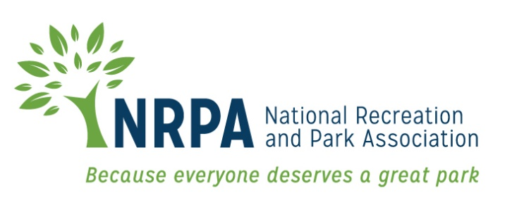

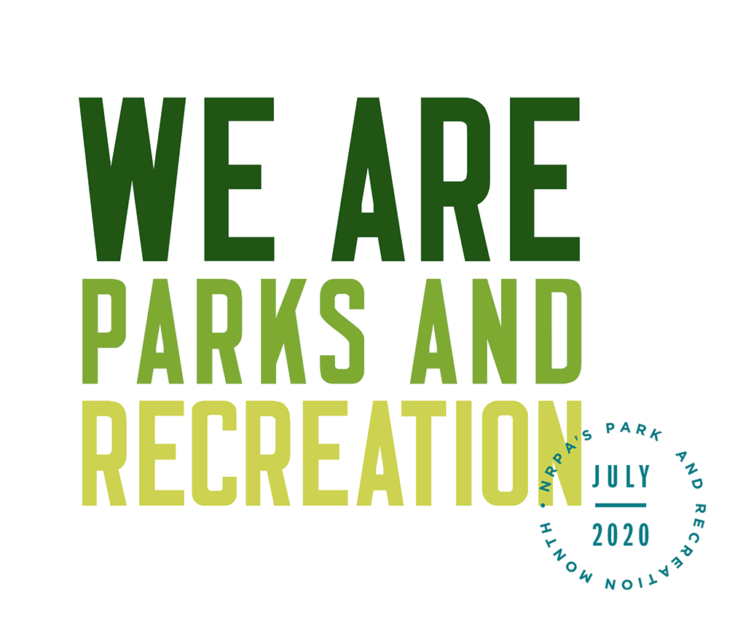

2020 PARK AND RECREATION MONTH

SAMPLE EDITORIAL ARTICLE

Template 2020 Park and Recreation Month Editorial Story Sample

Headline: (Agency Name) is Ready for Park and Recreation Month
Subhead: We’re redefining the field of parks and recreation as an essential, vital necessity
Since 1985, America has celebrated July as the nation’s official Park and Recreation Month. Created by the National Recreation and Park Association (NRPA), Park and Recreation Month specifically highlights the vital and powerful role local park and recreation professionals, such as our staff at [Agency Name], play in conservation, health and well-being, and social equity efforts in communities all across the country.
The services that park and recreation professionals provide are vital for our communities — from protecting open space and natural resources, to providing fitness programs, and, recently, providing essential services throughout the COVID-19 pandemic — Park and Recreation Month encourages everyone to reflect on the exponential value park and recreation professionals bring to communities.
In [city/town], you can celebrate Park and Recreation Month by [complete sentence with local activities/ events /contests etc.].
“July is the perfect time to highlight all the benefits park and recreation professionals provide right here in [city/town],” said [Agency Leader]. Our local parks and recreation directly contribute to [add in details of the impact your agency has on your specific community].”
[Agency name] is leading initiatives and providing opportunities for people of all ages to achieve healthier lifestyles, promote and understand nature and conservation as well as bringing the community closer through a variety of programs and services. [Add more details on any specific ways you make a difference in your community or any stats or success stories you may have that back up the impact you make.]
NRPA encourages everyone that supports parks and recreation to share how it has impacted their lives with the hashtag #WeAreParksAndRec. For more information about Park and Recreation month, visit www.nrpa.org/July.
NRPA also encourages people to get creative throughout the month by participating in the Thank a Park and Rec Pro contest. Film a video thanking a park and recreation professional in your community for the services they provide and post it on social media using the hashtag #ThankAParkAndRecPro for a chance to win prizes throughout July.

Learn about the exciting Park and Recreation Month activities planned for [town/city name] and more at [Fill-in local contact information here] or visit online at [Fill-in local park website URL here].

