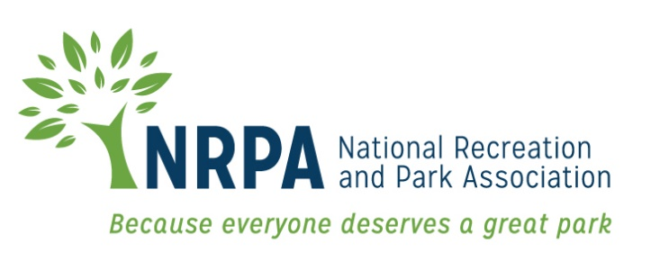

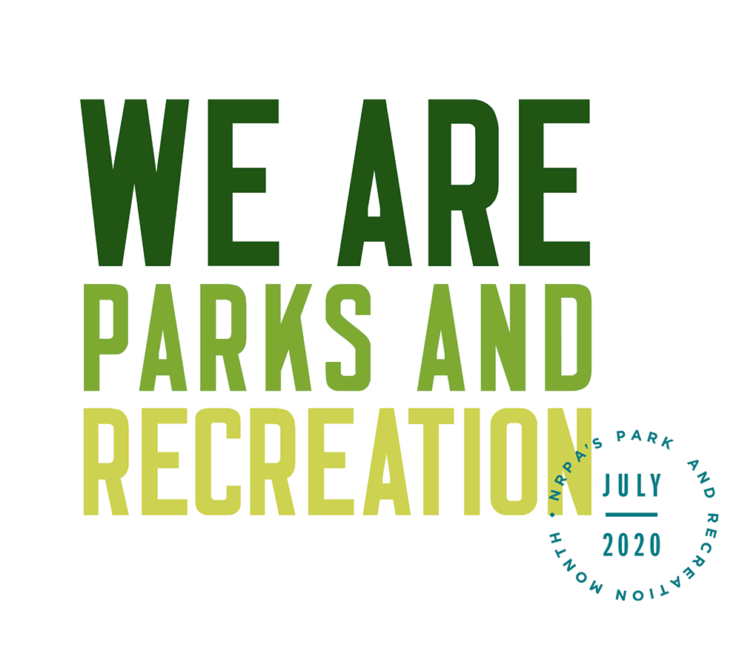

2020 PARK AND RECREATION MONTH

FACT SHEET AND KEY MESSAGES

Park and Recreation Month 2020 Fact Sheet
- This Park and Recreation Month, we want to shift the narrative of parks and recreation and redefine the field as an essential, vital necessity by sharing how park and recreation professionals — full of passion for their communities — represent a diverse group of professionals who are confronting our most pressing health, environmental and social challenges.

- During Park and Recreation Month, NRPA is encouraging park and recreation agencies to showcase the many ways their staff are providing essential services and making their communities better places to live, work and play.

- Park and recreation professionals serve their communities in a variety of ways as facilitators of health and wellness opportunities, public health professionals, planners, environmental educators, engineers, climate change experts, social service providers, nutritionists, inclusion advocates and more, and each of their diverse lived experiences contribute to a greater, wider-reaching impact.

- In addition to visiting a park or recreation area during July, you can get involved in Park and Recreation Month by:

  - Using the official logo and the hashtag #WeAreParksAndRec throughout the month.
  - Sharing what being a park and recreation professional means to you on social media with the hashtag #WeAreParksAndRec.
  - Participating in Park and Recreation Professionals Day on July 17, 2020.
  - Downloading the official Park and Recreation Month poster and hanging it up, taking pictures with it or sharing copies of it with your community.
  - Participating in the “Thank a Park and Recreation Professional” contest throughout the month.

- You can learn more about Park and Recreation Month and find additional resources by visiting: www.nrpa.org/July.
- Join the conversation on Facebook, Twitter and Instagram with the hashtag #WeAreParksAndRec.

NRPA 2020 Park and Recreation Month Key Messages
General Key Messages
- Since 1985, Americans have celebrated Park and Recreation Month in July to promote the importance parks and recreation has in health and well-being, conservation and social equity, and to recognize the more than 160,000 full-time park and recreation professionals — along with hundreds of thousands of part-time and seasonal workers and volunteers — that maintain our country’s local, state and community parks.
- Through efforts by NRPA, the U.S. House of Representatives passed an official resolution for Park and Recreation Month in 2009 and introduced the resolution in 2017 and 2018.
- Park and recreation agencies across the country are recognizing the month with summer programs, events, contests, commemorations and celebrations.
- The services that park and recreation professionals provide are vital for our communities — from protecting open space and natural resources, to helping fight obesity and providing activities and resources for all people. This has been especially true throughout the COVID-19 pandemic. Park and Recreation Month encourages everyone to reflect on the exponential value park and recreation professionals bring to communities.
- Key Messages
- Every day, in communities across the country, the people of parks and recreation are providing essential services and making their communities better places to live, work and play.
- July is the perfect time to see what your local parks and recreation has to offer and share your appreciation for the people who provide these essential services.
- We Are Parks and Recreation! We’re celebrating Park and Recreation Month with the National Recreation and Park Association by highlighting the people who make sure our parks and programs are well-maintained, safe, inclusive and welcoming.
- NRPA encourages all people that support parks and recreation to share their appreciate for their local parks and recreation professionals with the hashtag #WeAreParksAndRec.

- Everyone can get involved by participating in the National Recreation and Park Association’s month-long #ThankAParkAndRecPro social media contest.
- For more information visit www.nrpa.org/july.
Supporting Key Messages
Messages promoting support for parks and recreation:
- According to the National Recreation and Park Association’s 2019 Engagement with Parks Report, an overwhelming majority of Americans assert that they personally benefit from local parks and that their communities benefit from local parks.
  - Americans, on average, visit their local park and recreation facilities more than twice a month.
  - Three in four Americans live within a 10-minute walk of a local park or other recreational facility.
  - Eighty-three percent of U.S. adults agree that visiting their local parks, trails and open spaces is essential for their mental and physical well-being during the COVID-19 pandemic.
  - More than nine in 10 Americans agree that parks and recreation is an important local government service.
  - Support for local parks is widespread, spanning different age groups, income strata, household types and political affiliations.
Messages promoting health and wellness benefits of parks and recreation:
- The Centers for Disease Control found that increased access to places for physical activity led to a 25.6 percent increase in people exercising 3 or more times per week.
- Living close to parks and other recreation facilities is consistently related to higher physical activity levels for both adults and youth.
- On average, children who live in greener environments weigh less than children who live in less green areas.
- Children that have easy access to a playground are approximately five times more likely to have a healthy weight than children that do not have easy access to playgrounds.
- The nation’s park and recreation professionals are on the frontline in the battle against the COVID-19 pandemic, homelessness, substance use disorder, the obesity epidemic and other chronic health issues.

Messages promoting environmental benefits of parks and recreation:
- A park with one acre of trees absorbs the carbon dioxide produced by driving a car 11,000 miles.
- Parks do a great deal to contribute to species richness in urban settings — a review of more than 60 studies by IFPRA shows that there is strong evidence to support the concept that parks support both plant and animal biodiversity. This offers not only an important educational opportunity, but additionally supports overall ecosystem functionality.
- Parks reduce the impact of large storms and flooding by serving as sponges that soak up run off from nearby paved surfaces during rain events. This in turn prevents flooding and decreases property damage. Parks that are well-designed also reduce water usage by recycling and storing this water for use during times of low precipitation.
- Evidence not only shows that parks are cooler than their surrounding cities, but actually shows that parks contribute to overall urban cooling — parks make our cities more comfortable in the summer!
- According to a 2017 NRPA Park Pulse poll, 83% of Americans believe it is important that their local government makes environmental initiatives a priority.

Messages promoting the economic benefits of parks and recreation:
- According to a study conducted by the Center for Regional Analysis at George Mason University and the National Recreation and Park Association, America’s local park agencies generated more than $166 billion in economic activity and supported more than 1 million jobs from their operations and capital spending alone in 2017.

Messages promoting the essential need for parks:
- 83 percent of U.S. adults agree that visiting their local parks, trails and open spaces is essential for their mental and physical well-being during the COVID-19 pandemic.
- Nearly three in five adults say that access to these amenities is very or extremely essential to their mental and physical health.
- Parents are more likely than nonparents to find parks, trails and open spaces very or extremely essential (68 percent vs 56 percent, respectively).
- Millennials and Gen Z are more likely than Baby Boomers to say it is very or extremely essential to do physical activities at their local parks, trails and open spaces to maintain their mental and physical health (68 percent and 65 percent vs. 54 percent, respectively).

