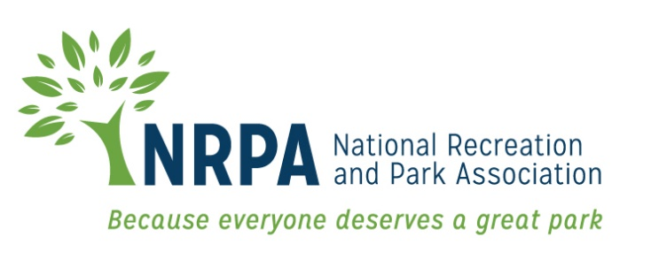

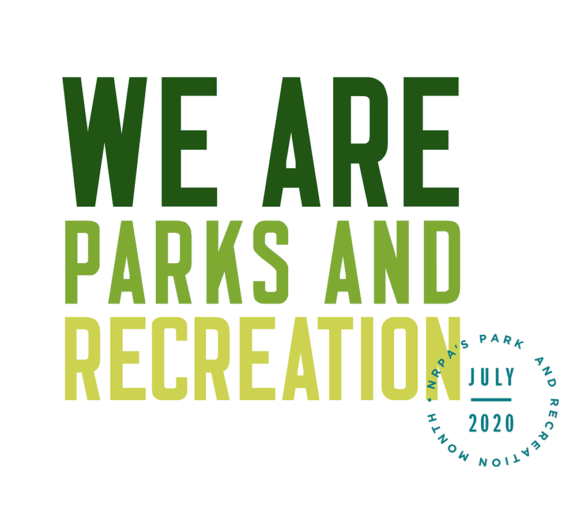

2020 PARK AND RECREATION MONTH

TOOLKIT

Contents
Toolkit Purpose 3
Park and Recreation Month 2020 Fact Sheet 4
NRPA 2020 Park and Recreation Month Key Messages 5
Template Media Advisory 8
Template 2020 Park and Recreation Month Press Release 9
2020 Park and Recreation Month Social Media Materials 11
Template 2020 Park and Recreation Month Editorial Story Sample 15
Media Outreach – “How To” 17

Toolkit Purpose

This toolkit is meant to make promoting and celebrating Park and Recreation Month in your community a little easier! This toolkit is designed to help you generate positive media coverage and support for your Park and Recreation Month activities, and ultimately, the good work you do and the benefits you bring to your community.

This toolkit includes template media materials such as media alerts for special events, press releases, fact sheets, key messages for use during interviews, social media posts, and a sample editorial article you can submit to local publications. Feel free to customize these materials with localized information, quotes and details that best meet your needs.

When using social media, please make sure you are tagging NRPA in your Facebook, Twitter and Instagram posts and using the hashtag #WeAreParksAndRec

Don’t forget, we want to see how you’re celebrating, too — send us photos and videos from your Park and Recreation Month activities and the creative ways you have used these materials!

If you have questions or need further assistance, please don’t hesitate to contact us.

General Park and Recreation Month or Toolkit Questions
Cort Jones
Communications Manager, NRPA
703.858.4730

cjones@nrpa.org

Press Release or Media Questions
Roxanne Sutton
Director of Communications, NRPA
703.858.2166
rsutton@nrpa.org

We hope this toolkit helps you generate great support for Park and Recreation Month and awareness for the essential work you do!

Thank you,

Cort and Roxanne

Park and Recreation Month 2020 Fact Sheet
- This Park and Recreation Month, we want to shift the narrative of parks and recreation and redefine the field as an essential, vital necessity by sharing how park and recreation professionals — full of passion for their communities — represent a diverse group of professionals who are confronting our most pressing health, environmental and social challenges.

- During Park and Recreation Month, NRPA is encouraging park and recreation agencies to showcase the many ways their staff are providing essential services and making their communities better places to live, work and play.

- Park and recreation professionals serve their communities in a variety of ways as facilitators of health and wellness opportunities, public health professionals, planners, environmental educators, engineers, climate change experts, social service providers, nutritionists, inclusion advocates and more, and each of their diverse lived experiences contribute to a greater, wider-reaching impact.

- In addition to visiting a park or recreation area during July, you can get involved in Park and Recreation Month by:

  - Using the official logo and the hashtag #WeAreParksAndRec throughout the month.
  - Sharing what being a park and recreation professional means to you on social media with the hashtag #WeAreParksAndRec.
  - Participating in Park and Recreation Professionals Day on July 17, 2020.
  - Downloading the official Park and Recreation Month poster and hanging it up, taking pictures with it or sharing copies of it with your community.
  - Participating in the “Thank a Park and Recreation Professional” contest throughout the month.

- You can learn more about Park and Recreation Month and find additional resources by visiting: www.nrpa.org/July.
- Join the conversation on Facebook, Twitter and Instagram with the hashtag #WeAreParksAndRec.

NRPA 2020 Park and Recreation Month Key Messages

  - General Key Messages
- Since 1985, Americans have celebrated Park and Recreation Month in July to promote the importance parks and recreation has in health and well-being, conservation and social equity, and to recognize the more than 160,000 full-time park and recreation professionals — along with hundreds of thousands of part-time and seasonal workers and volunteers — that maintain our country’s local, state and community parks.
- Through efforts by NRPA, the U.S. House of Representatives passed an official resolution for Park and Recreation Month in 2009 and introduced the resolution in 2017 and 2018.
- Park and recreation agencies across the country are recognizing the month with summer programs, events, contests, commemorations and celebrations.
- The services that park and recreation professionals provide are vital for our communities — from protecting open space and natural resources, to helping fight obesity and providing activities and resources for all people. This has been especially true throughout the COVID-19 pandemic. Park and Recreation Month encourages everyone to reflect on the exponential value park and recreation professionals bring to communities.
- Key Messages
- Every day, in communities across the country, the people of parks and recreation are providing essential services and making their communities better places to live, work and play.
- July is the perfect time to see what your local parks and recreation has to offer and share your appreciation for the people who provide these essential services.
- We Are Parks and Recreation! We’re celebrating Park and Recreation Month with the National Recreation and Park Association by highlighting the people who make sure our parks and programs are well-maintained, safe, inclusive and welcoming.
- NRPA encourages all people that support parks and recreation to share their appreciate for their local parks and recreation professionals with the hashtag #WeAreParksAndRec.

- Everyone can get involved by participating in the National Recreation and Park Association’s month-long #ThankAParkAndRecPro social media contest.
- For more information visit www.nrpa.org/july.
  - Supporting Key Messages
Messages promoting support for parks and recreation:
- According to the National Recreation and Park Association’s 2019 Engagement with Parks Report, an overwhelming majority of Americans assert that they personally benefit from local parks and that their communities benefit from local parks.
  - Americans, on average, visit their local park and recreation facilities more than twice a month.
  - Three in four Americans live within a 10-minute walk of a local park or other recreational facility.
  - Eighty-three percent of U.S. adults agree that visiting their local parks, trails and open spaces is essential for their mental and physical well-being during the COVID-19 pandemic.
  - More than nine in 10 Americans agree that parks and recreation is an important local government service.
  - Support for local parks is widespread, spanning different age groups, income strata, household types and political affiliations.
Messages promoting health and wellness benefits of parks and recreation:
- The Centers for Disease Control found that increased access to places for physical activity led to a 25.6 percent increase in people exercising 3 or more times per week.
- Living close to parks and other recreation facilities is consistently related to higher physical activity levels for both adults and youth.
- On average, children who live in greener environments weigh less than children who live in less green areas.
- Children that have easy access to a playground are approximately five times more likely to have a healthy weight than children that do not have easy access to playgrounds.
- The nation’s park and recreation professionals are on the frontline in the battle against the COVID-19 pandemic, homelessness, substance use disorder, the obesity epidemic and other chronic health issues.

Messages promoting environmental benefits of parks and recreation:
- A park with one acre of trees absorbs the carbon dioxide produced by driving a car 11,000 miles.
- Parks do a great deal to contribute to species richness in urban settings — a review of more than 60 studies by IFPRA shows that there is strong evidence to support the concept that parks support both plant and animal biodiversity. This offers not only an important educational opportunity, but additionally supports overall ecosystem functionality.
- Parks reduce the impact of large storms and flooding by serving as sponges that soak up run off from nearby paved surfaces during rain events. This in turn prevents flooding and decreases property damage. Parks that are well-designed also reduce water usage by recycling and storing this water for use during times of low precipitation.
- Evidence not only shows that parks are cooler than their surrounding cities, but actually shows that parks contribute to overall urban cooling — parks make our cities more comfortable in the summer!
- According to a 2017 NRPA Park Pulse poll, 83% of Americans believe it is important that their local government makes environmental initiatives a priority.

Messages promoting the economic benefits of parks and recreation:
- According to a study conducted by the Center for Regional Analysis at George Mason University and the National Recreation and Park Association, America’s local park agencies generated more than $166 billion in economic activity and supported more than 1 million jobs from their operations and capital spending alone in 2017.

Messages promoting the essential need for parks:
- 83 percent of U.S. adults agree that visiting their local parks, trails and open spaces is essential for their mental and physical well-being during the COVID-19 pandemic.
- Nearly three in five adults say that access to these amenities is very or extremely essential to their mental and physical health.
- Parents are more likely than nonparents to find parks, trails and open spaces very or extremely essential (68 percent vs 56 percent, respectively).
- Millennials and Gen Z are more likely than Baby Boomers to say it is very or extremely essential to do physical activities at their local parks, trails and open spaces to maintain their mental and physical health (68 percent and 65 percent vs. 54 percent, respectively).

Template Media Advisory
[GROUP LOGO/LETTERHEAD]

MEDIA ADVISORY
Media Contact:
[Contact Name]
[Agency Name]
[Phone]
[Email]

[Agency Name] to Kick Off Park and Recreation Month at [Park/Facility/Virtual Event Name]
[Add a second-line description for a special appearance by VIP or specific highlight.]

WHO/WHAT: [Name of major public officials or celebrities who are participating]

[List and briefly describe any programs or activities that will take place. Concentrate specifically on the highlights.]

WHEN: [Date/Time]
[Be sure to mention individual start times for notable speakers/happenings.]

WHERE: [Location/Address]
[Provide parking information, if relevant.]

WHY: Since 1985, America has celebrated July as Park and Recreation Month. A program of the National Recreation and Park Association (NRPA), the goal is to raise awareness of the essential services that park and recreation professionals provide to communities across the U.S.

This July, [Agency Name] is celebrating with the theme We Are Parks and Recreation. All month long, we’ll be highlighting the selfless, passionate and essential work of park and recreation professionals who are providing services that are vital to a healthy [Your City/Town Name]. For more information, go to www.nrpa.org/july or search Twitter and Instagram using #WeAreParksAndRec.
EDITOR’S NOTE: [Mention any opportunities for interesting visuals and tours. Provide contact information.]
# # #

Template 2020 Park and Recreation Month Press Release

[GROUP LOGO/LETTERHEAD]

FOR IMMEDIATE RELEASE
Media Contact:
[Contact Name]
[Agency Name]
[Phone]
[Email]

This July, We Are Parks and Recreation at [Agency Name]
Month-long celebration highlights the essential services of local parks and recreation

[CITY, STATE ABRV] – [DATE] –This July, join [Agency Name] for Park and Recreation Month, as we celebrate the selfless, passionate and essential work of park and recreation professionals who are providing services that are vital to a healthy [Your City/Town Name]. A variety of [virtual] activities are planned for residents of all ages and abilities — including [list top activities/events].

[Agency Name] is celebrating Park and Recreation Month, an initiative of the National Recreation and Park Association (NRPA), by inviting you to learn more about our local park and recreation professionals and the essential services they provide. With everything from [list examples of offerings], there are plenty of ways that you can celebrate with us!

[QUOTE from Agency leadership, discussing ways you impact your community through health and wellness, social equity, conservation, etc. and tie to the celebration of Park and Recreation Month.]

[Agency Name] will celebrate Park and Recreation Month through [provide brief summary of local activities].

NRPA encourages people that support parks and recreation to share their park and recreation story, as well as why their local park and recreation professionals are important to them, with the hashtag #WeAreParksAndRec.

NRPA also encourages people to get creative throughout the month by participating in the Thank a Park and Rec Pro contest. Film a video thanking a park and recreation professional in your community for the services they provide and post it on social media using the hashtag #ThankAParkAndRecPro for a chance to win prizes throughout July.

To learn more about Park and Recreation Month, visit [Add local website information] and www.nrpa.org/July.

[Agency boilerplate/ “about” information]

About the National Recreation and Park Association
The National Recreation and Park Association is a national not-for-profit organization dedicated to ensuring that all Americans have access to parks and recreation for health, conservation and social equity. Through its network of 60,000 recreation and park professionals and advocates, NRPA encourages the promotion of healthy and active lifestyles, conservation initiatives and equitable access to parks and public space. For more information, visit www.nrpa.org. For digital access to NRPA’s flagship publication, Parks & Recreation, visit www.parksandrecreation.org.

# # #

2020 Park and Recreation Month Social Media Materials

  - Social Covers and Badges
You can find social media covers at https://www.nrpa.org/events/july/toolkit/. We encourage you to update your Facebook and Twitter pages with these images to show your support of Park and Recreation Month all throughout July!

  - Sample Social Media Posts
If you have social media platforms such as Facebook, Twitter and Instagram, here are some sample messages to generate awareness among your friends and followers. Customize these posts for Park and Recreation Month and feel free to develop some more on your own!

Tag NRPA in your posts, too.
- Facebook: @National Recreation and Park Association
- Twitter: @NRPA_News
- Instagram: @nrpa

Official 2020 Park and Recreation Month Hashtags
- #WeAreParksAndRec
- #ThankAParkAndRecPro

Agency sample posts for Facebook:

- July is Park and Recreation Month and we’re celebrating by highlighting all the great work of our staff and volunteers at (insert park/facility/agency name)! #WeAreParksAndRec (insert staff photos)
- We are (Insert park/facility/agency name) and We Are Parks and Recreation. Did you know we offer (insert lesser known activities/programs) and more? #WeAreParksAndRec (insert photo from activity/event)
- Did you know (insert park/facility/agency name) has been providing (insert services) to our community throughout COVID-19? #WeAreParksAndRec (insert photos of services provided)
- We are selfless. We are passionate. We are essential. We Are Parks and Recreation. Join us and @National Recreation and Park Association to celebrate the good work of park and recreation professionals during Park and Recreation Month! (share toolkit poster image) #WeAreParksAndRec
- Stop by (insert event location event and time) to help us celebrate Park and Recreation Month! #WeAreParksAndRec (insert link to event details on your website)
- Want to get outside and still practice safe physical distancing during Park and Recreation Month? Our staff at (park/facility/agency name) is working hard to ensure a safe experience for everyone! #WeAreParksAndRec (insert photos of staff)
- If you’re unable to make it out to one of our local parks for Park and Recreation Month, (agency name) has plenty of virtual options for you to get active at home (insert link to virtual programs). #WeAreParksAndRec

Personal sample posts for Facebook:
- I am [NAME] and I am a [Job Title] at [Agency Name]. As a park and recreation professional, I provide essential services to my community like [list services relevant to you]. July is Park and Recreation Month and I’m helping bring awareness to our field and the work of park and recreation professionals across the country. We are selfless. We are passionate. We are essential. We Are Parks and Recreation. #WeAreParksandRec
- It’s Park and Recreation Month and this July, I am committed to sharing the essential role my profession plays in the health and well-being of our community. As a [Job Title] at [Agency Name], I provide essential services to our community like [list services relevant to you]. I’m proud of the work our field does! #WeAreParksandRec

Agency sample posts for Twitter:

- It’s Park and Recreation Month! Join us and @nrpa_news as we celebrate! #WeAreParksAndRec
- We are (Insert park/facility/agency name) and We Are Parks and Recreation. Did you know we offer (insert activities/programs) and more? #WeAreParksAndRec (insert photo from activity/event)
- We are selfless. We are passionate. We are essential. We Are Parks and Recreation. Join us and @nrpa_news in celebrating the good work of park and recreation professionals during July! (share toolkit poster image) #WeAreParksAndRec
- If you’re unable to make it out to one of our local parks for Park and Recreation Month, (agency name) has plenty of virtual options for you to get active at home (insert link to virtual programs). #WeAreParksAndRec
- Want to get outside and still practice safe physical distancing during Park and Recreation Month? Our staff at (park/facility/agency name) is working hard to ensure a safe experience for everyone! #WeAreParksAndRec (insert photos of staff)

Personal sample posts for Twitter:
- As a park and recreation professional, I provide essential services to my community. July is Park and Recreation Month and I’m celebrating the work of park and rec pros across the country. We are selfless. We are passionate. We are essential. #WeAreParksAndRec
- This July, I am committed to sharing the essential role my profession plays in the health and well-being of our community. As a [Job Title] at [@Agency Name], I provide essential services to our community like [list services relevant to you]. #WeAreParksandRec

Agency sample posts for Instagram

- July is Park and Recreation Month and we’re celebrating by highlighting all the great work of our staff and volunteers at (insert park/facility/agency name)! #WeAreParksAndRec (insert staff photos)
- We are selfless. We are passionate. We are essential. We Are Parks and Recreation. Join us and @nrpa to celebrate the good work of park and recreation professionals during Park and Recreation Month! (share images of staff interacting with public) #WeAreParksAndRec
- We are (Insert park/facility/agency name) and #WeAreParksAndRec. Did you know we offer (insert lesser known activities/programs) and more? (insert photo from activity/event)
Personal sample posts for Instagram
- As a park and recreation professional, I provide essential services to my community. July is Park and Recreation Month and I’m celebrating the work of park and rec pros across the country. We are selfless. We are passionate. We are essential. #WeAreParksAndRec (share photo of yourself and or colleagues at work)
- This July, I am committed to sharing the essential role my profession plays in the health and well-being of our community. As a [Job Title] at [@Agency Name], I provide essential services to our community like [list services relevant to you]. #WeAreParksandRec (share multiple photos of yourself and/or colleagues at work)

Sample social media themes for each day of the week
Use these themes to highlight various staff members and programs each day of the week (and be sure to include #WeAreParksAndRec along with the hashtags below):

- #MaintenanceMonday – use Monday to highlight members of your maintenance staff and educate the public on some of the day-to-day things the maintenance staff does to ensure your parks and recreation facilities are safe and running smoothly.
- #TeamTuesday – use Tuesday to introduce your followers and park goers to the staff at your agency, especially the ones who are making things happen behind the scenes!
- #WellnessWednesday – do you have a staff member who leads your health and wellness initiatives? Give them a shout out on Wednesday!
- #ThrivingThursday – you provide services that help your communities truly thrive, so share some of that success and give yourself, and your community, a pat on the back on Thursday.
- #FoodFriday – does your agency serve afterschool and summer meals? Did you provide meals to people who needed them during COVID-19? Friday is a great day to thank your staff who made sure even the most vulnerable had access to healthy meals.
- #SelflessSaturday or #SelflessSunday – park and recreation professionals truly do selfless work in their communities. Showcase members of your selfless staff over the weekend.

  - General Social Media Guidance

- Polish Your Language
Even if you normally pay little attention to spelling and grammar, try to use good punctuation and spelling so that your messages will be easily understood. When posting on Twitter with character limits, try to rephrase your post versus just shortening and abbreviating words.
- Be Consistent with Your Posts
Decide how often you plan to post and try to be consistent. Maybe you plan to post one Instagram post a day and three Facebook posts a week. You can increase your postings over time, just try to avoid posting 20 times in one day and then disappearing for two weeks.
- Be Inclusive, Be Diverse and Be Positive
Use positive language and avoid any expressions that express or imply ideas that are sexist, racist, or otherwise biased, prejudiced or discriminating to any particular group of people. Be respectful of those you take photos of, etc. Be sure to capture great moments outside your main area of work as well.
- Use Photos and Videos
Photos and videos catch people’s attention, but make sure you mix it up and post different types of photos, people, activities and events to keep your followers’ interest. Free web and mobile apps like Canva (www.canva.com) can help you create stylized photos that you can use too.
- Think of What You Want Your Audience to Do and Shape Your Message Around That
You may not raise a lot of interest in a single tweet by simply inviting people to your parks or recreation centers, but you can give them specific things they can do to let them know why they should visit. Instead of just saying, “Come to X park,” say, “Here are 5 things you and your family can do at X park.”

Template 2020 Park and Recreation Month Editorial Story Sample

Headline: (Agency Name) is Ready for Park and Recreation Month
Subhead: We’re redefining the field of parks and recreation as an essential, vital necessity
Since 1985, America has celebrated July as the nation’s official Park and Recreation Month. Created by the National Recreation and Park Association (NRPA), Park and Recreation Month specifically highlights the vital and powerful role local park and recreation professionals, such as our staff at [Agency Name], play in conservation, health and well-being, and social equity efforts in communities all across the country.
The services that park and recreation professionals provide are vital for our communities — from protecting open space and natural resources, to providing fitness programs, and, recently, providing essential services throughout the COVID-19 pandemic — Park and Recreation Month encourages everyone to reflect on the exponential value park and recreation professionals bring to communities.
In [city/town], you can celebrate Park and Recreation Month by [complete sentence with local activities/ events /contests etc.].
“July is the perfect time to highlight all the benefits park and recreation professionals provide right here in [city/town],” said [Agency Leader]. Our local parks and recreation directly contribute to [add in details of the impact your agency has on your specific community].”
[Agency name] is leading initiatives and providing opportunities for people of all ages to achieve healthier lifestyles, promote and understand nature and conservation as well as bringing the community closer through a variety of programs and services. [Add more details on any specific ways you make a difference in your community or any stats or success stories you may have that back up the impact you make.]
NRPA encourages everyone that supports parks and recreation to share how it has impacted their lives with the hashtag #WeAreParksAndRec. For more information about Park and Recreation month, visit www.nrpa.org/July.
NRPA also encourages people to get creative throughout the month by participating in the Thank a Park and Rec Pro contest. Film a video thanking a park and recreation professional in your community for the services they provide and post it on social media using the hashtag #ThankAParkAndRecPro for a chance to win prizes throughout July.
Learn about the exciting Park and Recreation Month activities planned for [town/city name] and more at [Fill-in local contact information here] or visit online at [Fill-in local park website URL here].

Media Outreach – “How To”

The following are general guidelines for conducting media outreach for both special events you may be hosting in July and in general for Park and Recreation Month.

  - Leveraging the Press Release

To announce your involvement in Park and Recreation Month and what activities you will have going on throughout the month, customize the Press Release template and distribute it to appropriate reporters, bloggers and broadcast media in your local area.

- Search online for the “news desk” emails and/or submission guidelines of your local TV stations and radio stations.

- Search for the contact information for reporters and publications in your local area that cover topics related to parks, the outdoors and community affairs. Be sure to pitch to only one reporter from each newspaper/print agency. It is a good idea to review the stories the reporter writes to get a feel for what they are most interested in so that you can tailor your outreach to meet their interests. Most reporters prefer email.

- Search online for bloggers in your area; these social media journalists are powerful influencers and can virally spread the word about the events you have going on for Park and Recreation Month.

- Once you have your list together, prepare your pitches. Make sure you tailor the pitch for the type of outlet and personalize it as much as possible for the journalist or blogger you are contacting. Keep it brief.

- You’ll want to send the release out at the end of June or beginning of July to journalists and reporters, and to TV/radio stations approximately two days before an event you want them to attend.

- Customize the press release template with the appropriate information, as marked with brackets and yellow highlight, EX: [NAME].

- You can distribute your press release on any newswires you subscribe to or use regularly. This will give you added visibility in newsrooms and with online media.

- In addition to wire distribution, reach out directly via email to journalists and bloggers. Insert your pitch and paste the text of the press release into the email.

- Put an engaging tag line or sentence in the “Subject” line of the email to entice reporters.

- Once you have sent your release, follow up with a phone call to reporters. Be sure to have a short pitch ready and be prepared to answer questions about why your event or story is a “must see/cover.”

  - Using the Editorial Article Template

Many local newspapers and online media outlets are very interested in receiving already written editorial content that they can instantly use in their outlets. The template editorial article is a great way to get coverage for your agency and what you are doing for Park and Recreation Month.

- Contact your local community print publications and ask them if they take “drop in” articles or editorial content submissions.

- Find out if they have any requirements such as a particular word count and preferences such as submission process and deadline. They may only take submissions on a certain day or require that submissions be made via an online entry form only.

- If they take submissions, keep note of that in your records for the future. You may even want to explore the option of regularly contributing content from your agency.

- Confirm the lead time, or time it takes for content to appear once submitted. You will want to make sure that you provide the article in enough time to the publication so that it appears timed to your event you may be highlighting or within the month of July.

- Customize the sample editorial article with the appropriate information, as marked with brackets and yellow highlight, EX: [NAME].

- Submit your completed article per the outlet’s instructions and confirm when you can expect to see the coverage in print or online.

  - Inviting Press to Your Event

If you are hosting a special event during the month of July and would like to invite reporters to cover your event on site:

- Search online for the “news desk” emails and/or submission guidelines of your local TV stations and radio stations.

- Search for the contact information for reporters and publications in your local area that cover topics related to parks, the outdoors, and community affairs. Be sure to pitch to only one reporter from each newspaper/print agency. Most reporters prefer email.

- Consider inviting local bloggers to your event as well or creating a special opportunity for them to come out and get sneak peek of your Park and Recreation Month event. These social media journalists are powerful influencers and can virally spread the word about the events you have going on for Park and Recreation Month.

- It’s a good idea to send Media Advisories to journalists and reporters at least two weeks in advance and to TV/radio stations approximately two days before an event.

- Customize the media alert template with the appropriate information, as marked.

- Write a brief, one-paragraph pitch to the reporter, and attach the Media Advisory as a PDF or Word Document, or paste the text into the email, beginning with “Media Advisory.”

- Put an engaging tag line or sentence in the “Subject” line of the email to entice reporters.

- Once you have sent your Media Advisory, follow up with a phone call to reporters you are particularly interested in having attend. Be sure to have a short pitch ready, and be prepared to answer questions about why your event is a “must see.”

- Consider sending a post-event press release to generate coverage after the event. It is a good idea to send this immediately following the event or the next morning. Often times, this means drafting most of the release in advance, and adding a few pertinent details afterward.

- Reach back out to the reporters that you previously contacted. If you can, offer footage from the event or high resolution photos.

  - Tips and Tactics

- Remember that timeliness is a big factor in press coverage.

- Try to keep the message brief. One page is best — do not exceed two.

- Don't forget to add complete contact information. If a reporter is interested, they may wish to email or call you with questions or requests for clarification.

- Write using short paragraphs and sentences, and in the third person — don’t refer to yourself as “I” or “we,” except in a direct quote.

- Avoid testimonials or other promotional language. A press release is news; not advertising.

- Don’t be discouraged if you do not receive interest, or if a reporter doesn’t make it to your event. Reporters receive hundreds of press releases every day and cover news based on many factors (timeliness, the amount of current events taking place, space, editor approval, capacity, etc.). It’s never personal.

- If a reporter does email or call with interest, be sure to respond in a timely manner.

Let us know if your Park and Recreation Month event is covered in the news! Send links of online coverage to cjones@nrpa.org.

