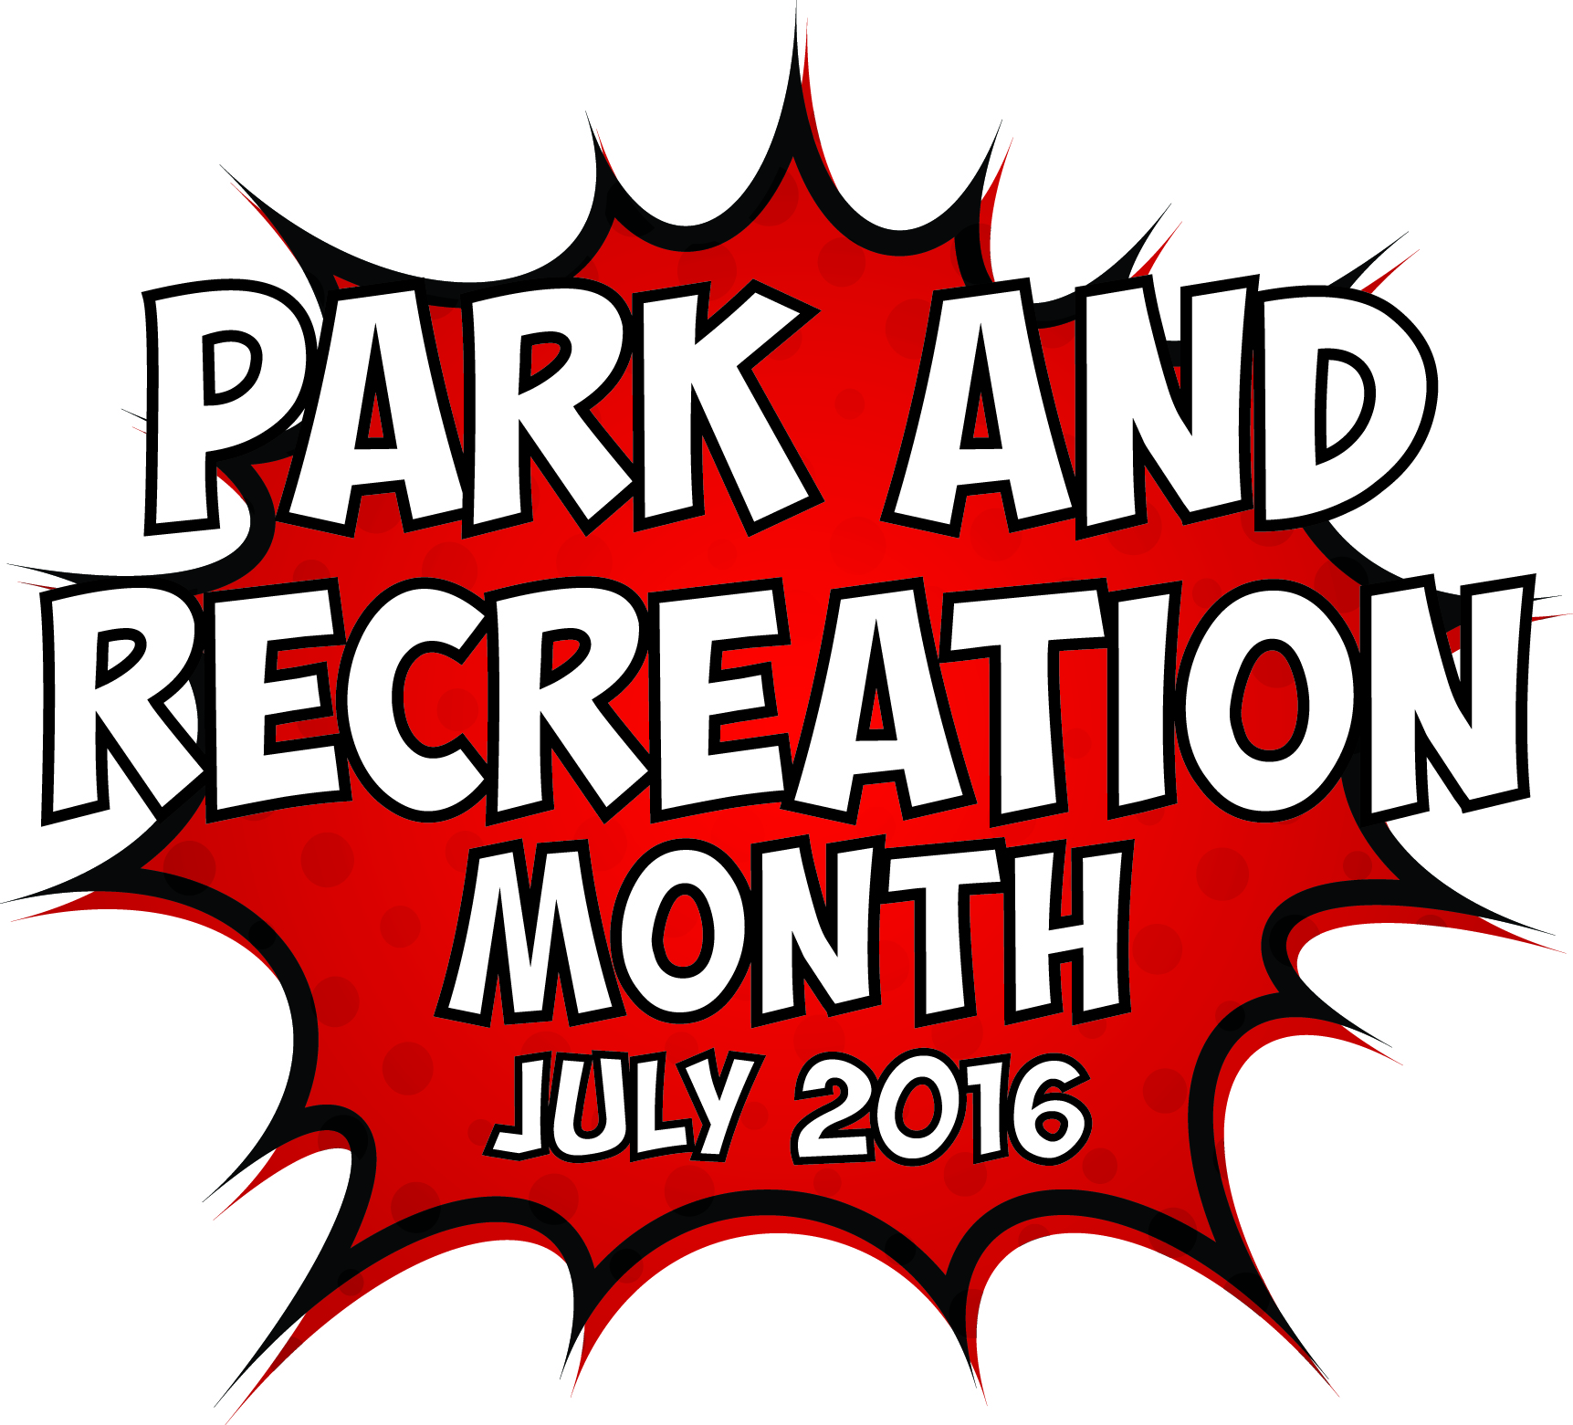
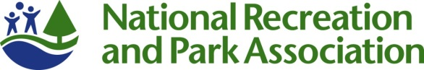

2016 Park and Recreation Month Social Media Materials

  - Social Covers and Badges
You can find social media covers and badges at www.nrpa.org/july/Park-and-Recreation-Month/ToolKit/. We encourage you to update your Facebook and Twitter pages with these images to show your support of Park and Recreation Month all throughout July!

  - Sample Social Media Posts
If you have social media platforms such as Facebook, Twitter and Instagram, here are some sample messages to generate awareness among your friends and followers. Customize these posts for Park and Recreation Month and feel free to develop some more on your own! Please note that the comic book referenced in these sample posts is available in the toolkit.

Tag NRPA in your posts, too.
- Facebook: type @National Recreation and Park Association when you are writing your post.
- Twitter: type @NRPA_News in your post.
- Instagram: type @nrpa in your post.

Official 2016 Park and Recreation Month Hashtags
- #SuperJuly
- #SuperParkSelfie(contest hashtag—you can find more information about this year’s contest at www.nrpa.org/July)

Sample posts for Facebook:

- We’re celebrating Park and Recreation Month by encouraging you to discover your super powers with us at (insert park/facility name)! #SuperJuly
- Parks and recreation have the power to strengthen communities, transform lives and protect the future. When our powers combine, we change lives! #SuperJuly
- Check out our super powered (insert activity) we did today in honor of Park and Recreation Month! #SuperJuly (include photos from activity)
- This #SuperJuly @National Recreation and Park Association is celebrating Park and Recreation superheroes in communities across the country. Who’s your park and recreation superhero?
- Park and Recreation Month encourages everyone to reflect on the value of parks and recreation in our communities. How do (insert City name) park and rec facilities help you discover your superpowers? #SuperJuly

Sample posts for Twitter:

- This #SuperJuly we’re encouraging you to discover your super powers with parks and recreation!
- This Park and Recreation Month go on an adventure with the Park and Rec Brigade! (include link to the comic book)
- What’s your park and recreation superpower? Get inspired by Park and Recreation Month’s #SuperJuly celebration!
- “When our powers combine, we change lives!” Meet Captain Community, the Green Guardian and the Fit Twins (include link to the comic book) #SuperJuly
- We’re discovering our super powers with some of our programs this month in honor of #SuperJuly. Check them out! (insert shortened link to your website or calendar of activities for July)

Sample post for Instagram:

- We’re discovering our super powers at (insert park/facility name) in honor of Park and Recreation Month! #SuperJuly
- We’re celebrating our superpowers all month long in honor of Park and Recreation Month. This is how our parks and recreation change lives! #SuperJuly

  - Ideas for Sharing the Comic Book
The comic book is available at http://www.nrpa.org/july/Park-and-Recreation-Month/ToolKit/#comicbook. Ideas for sharing the comic book include:
- Work with a local printer to have copies made for your events. Customize with your logo!
- Share on your social channels.
- Send the comic book link with your media outreach.
- Download and use the comic book at your facilities.

