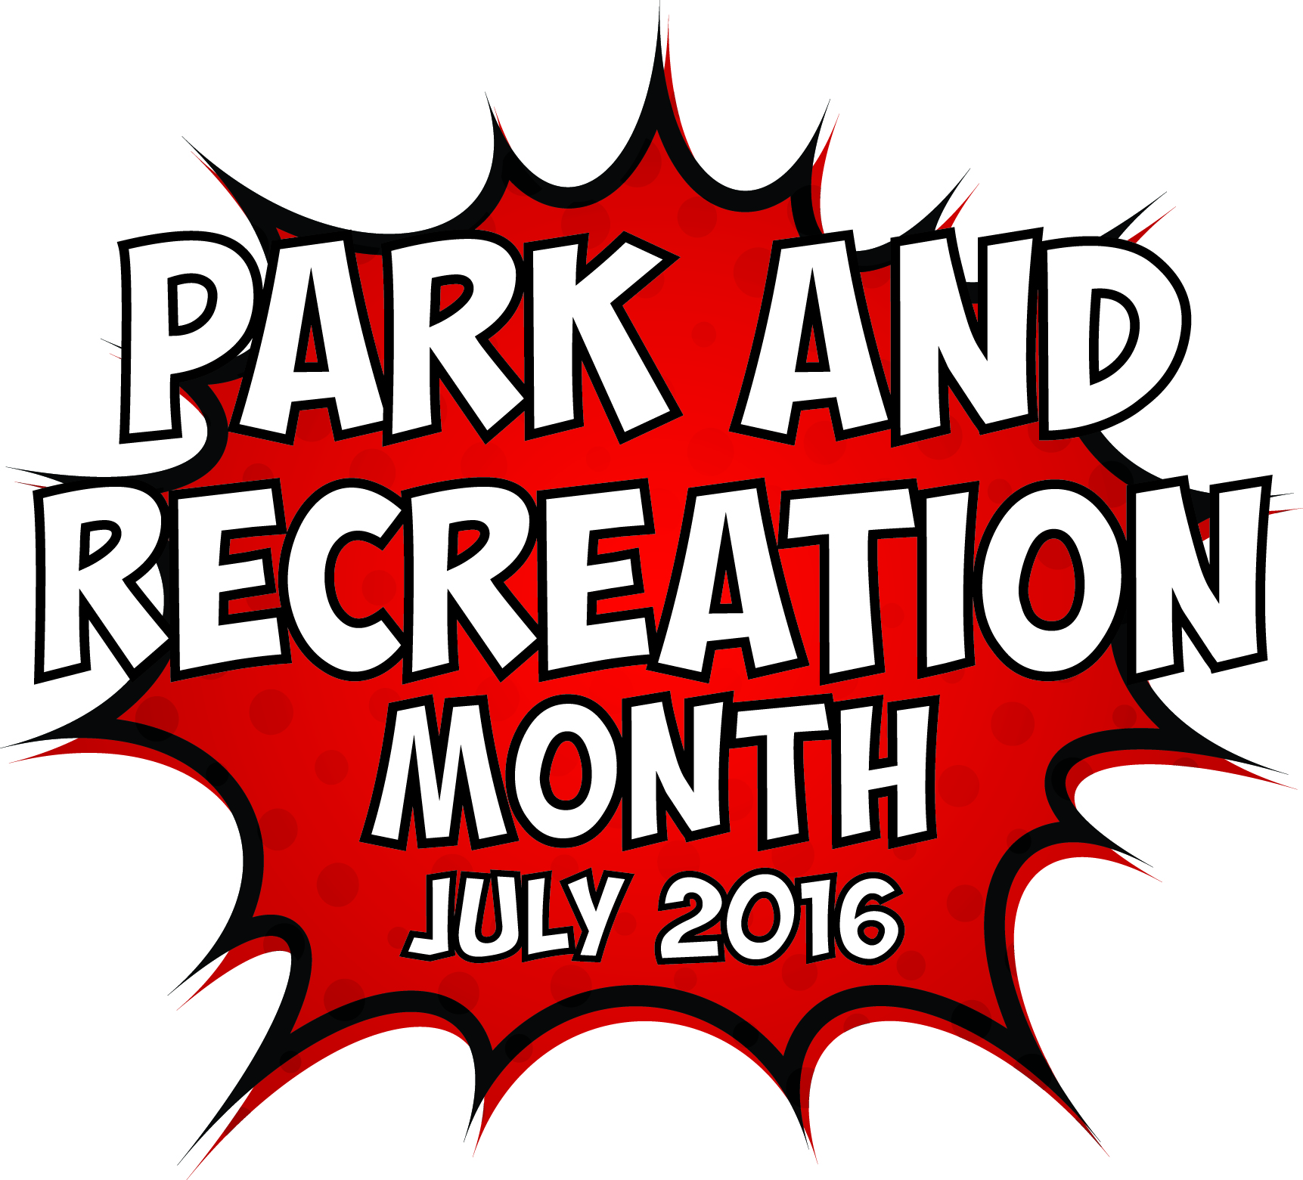
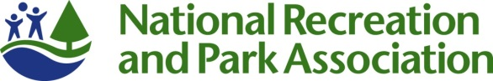

Template 2016 Park and Recreation Month Press Release

[GROUP LOGO/LETTERHEAD]

FOR IMMEDIATE RELEASE
Media Contact:
[Contact Name]
[Agency Name]
[Phone]
[Email]

This July, [City/town/community name] Will Discover the Super Powers of Parks and Recreation
Month-long celebration highlights essential value of local parks and recreation

[CITY, STATE ABRV] – [DATE] – This July, [Community Name] residents don’t need to be bitten by a radioactive spider to discover that they have super powers. They just need to visit their nearest park or recreation center to find super powers they didn’t know they had.

[Agency Name] is celebrating Park and Recreation Month, an initiative of the National Recreation and Park Association (NRPA), and all the ways parks and recreation has the power to transform our daily lives. From providing us places to get fit and stay healthy to fostering new relationships and forging a connection with nature, our close-to-home community park and recreation facilities provide essential services and improve quality of life.

[QUOTE from Agency leadership, discussing ways you impact your community through health and wellness, social equity, conservation, etc. and tie to the celebration of Park and Recreation Month.]

[Agency Name] will celebrate Park and Recreation Month through [provide brief summary of local activities].

NRPA is celebrating the month by hosting a selfie photo contest. From July 4-31, NRPA will issue weekly challenges for people to get out in their parks and recreation facilities and discover their super powers. Weekly prizes will be awarded. The contest can be entered via Facebook or by uploading a photo to Twitter and Instagram using #SuperJuly and #SuperParkSelfie. Visit www.nrpa.org/July for official rules and details. NRPA also encourages all people that support parks and recreation to share their photos and love of parks using the hashtag #SuperJuly on social media.

To learn more about Park and Recreation Month, visit [Add local website information] and www.nrpa.org/July.

[Agency boilerplate/ “about” information]

About The National Recreation and Park Association
The National Recreation and Park Association is a national not-for-profit organization dedicated to advancing park, recreation and conservation efforts that enhance quality of life for all people. Through its network of more than 50,000 recreation and park professionals and citizens, NRPA encourages the promotion of healthy and active lifestyles, conservation initiatives and equitable access to parks and public space. For more information, visit NRPA.org. For digital access to NRPA’s flagship publication, Parks & Recreation, visit ParksAndRecreation.org.

# # #

