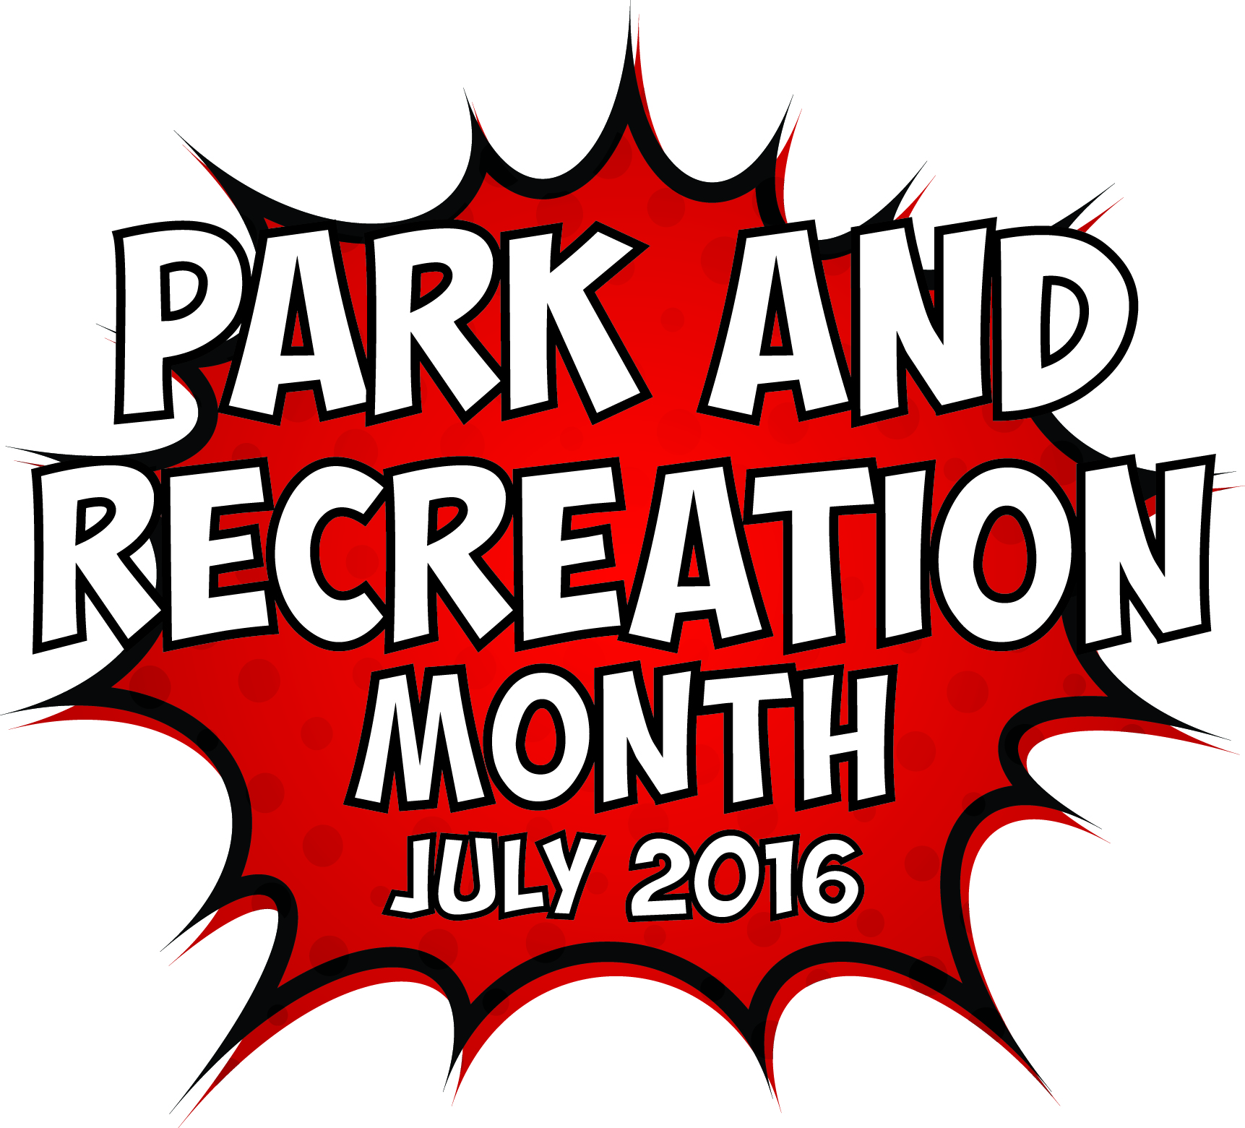
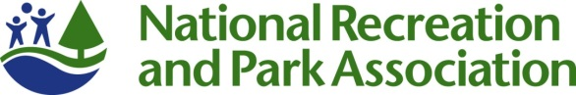

Template Media Advisory
[GROUP LOGO/LETTERHEAD]

MEDIA ADVISORY
Media Contact:
[Contact Name]
[Agency Name]
[Phone]
[Email]

[Agency Name] to Kick Off National Park and Recreation Month at [Park/Facility Name]
[Add a second-line description for a special appearance by celebrity or specific highlight.]

WHO/WHAT: [Name of major public officials or celebrities who are participating, as well as the number of people who will be in attendance.]

[List and briefly describe any programs or activities that will take place. Concentrate specifically on the highlights.]

WHEN: [Date/Time]
[Be sure to mention individual start times for notable speakers/happenings.]

WHERE: [Location/Address]
[Provide parking information, if relevant.]

WHY: Since 1985, America has celebrated July as Park and Recreation Month. A program of the National Recreation and Park Association (NRPA), the goal is to raise awareness of the vital impact that parks, recreation and conservation have on communities across the U.S.

This July, [Agency Name] and the National Recreation and Park Association are celebrating the superheroes and super powers of parks and recreation. Parks and recreation not only give us the opportunity to become our best selves, they also super power our communities economically, improve the environment and provide equitable public spaces for all. For more information, go to www.nrpa.org/july or search Twitter and Instagram using #SuperJuly.
EDITOR’S NOTE: [Mention any opportunities for interesting visuals and tours. Provide onsite contact information.]

