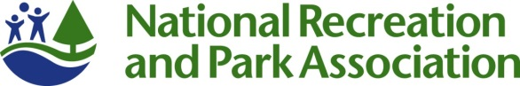
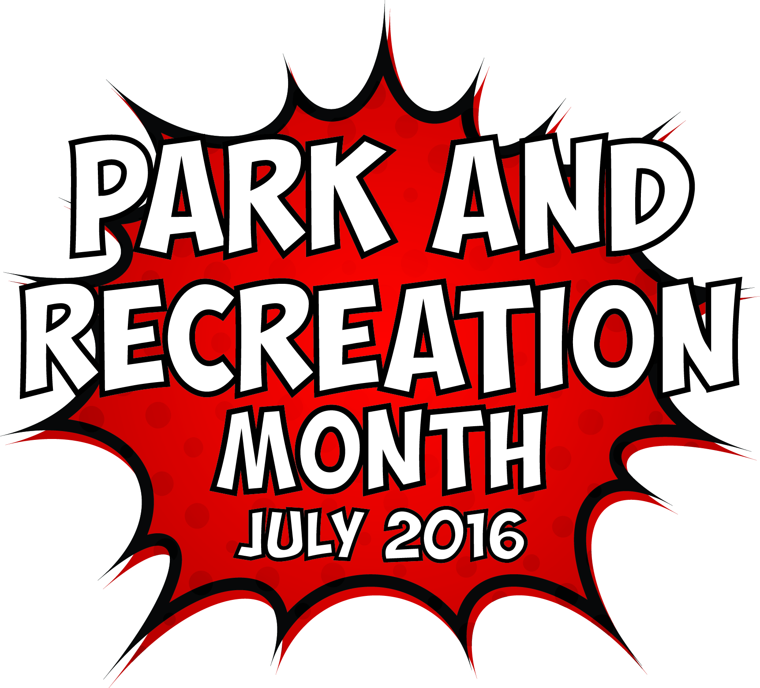
Template 2016 Park and Recreation Month Editorial Story Sample

Headline: Have a Super-Powered July with (Agency Name)
Subhead: Celebrate Park and Recreation Month this July by (list a few planned activities here)
Get ready to discover your super powers this July with (Agency Name) and the National Recreation and Park Association (NRPA).
Since 1985, America has celebrated July as the nation’s official Park and Recreation Month. Created by NRPA, Park and Recreation Month specifically highlights the vital and powerful role local parks and recreation, such as [Agency Name], play in conservation, health and wellness, and social equity efforts in communities all across the country.
This year it’s all about discovering your super powers at your local park and recreation facilities. From learning a new skill like gardening to meeting your fitness goals, your [city/town] park and recreation facilities can have you feeling like a superhero before July is through. NRPA and [Agency Name] are encouraging everyone to get out there to experience the power of parks and recreation for themselves.
In [city/town], you can celebrate this super-powered month by [complete sentence with local activities/ events /contests etc.].
“July is the perfect time to highlight all the benefits parks and recreation provides right here in [city/town],” said [Agency Leader]. Our local parks and recreation directly contribute to reduced obesity rates, an improved ecosystem and increased property values.”
[Agency name] is leading initiatives and providing opportunities for people to achieve healthier lifestyles, promote and understand nature and conservation as well as bringing the community closer through a variety of programs and services. [Add more details on any specific ways you make a difference in your community or any stats or success stories you may have that back up the impact you make.]
Nationally, NRPA is celebrating with a month-long #SuperParkSelfie photo contest and is challenging people to get out to their park and recreation facilities and capture the super powers they gain from them. NRPA also encourages everyone to share their support of parks and recreation on social media with the hashtag #SuperJuly. For more information about the contest and Park and Recreation Month in general, visit www.nrpa.org/July.
Learn about the exciting Park and Recreation Month activities planned for [town/city name] and more at [Fill-in local contact information here] or visit online at [Fill-in local park website URL here].

