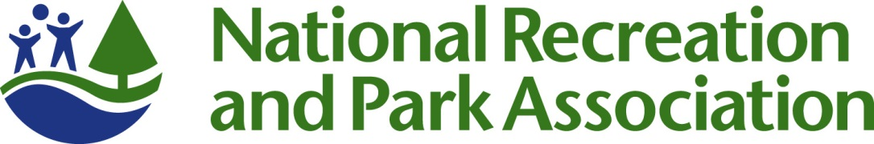

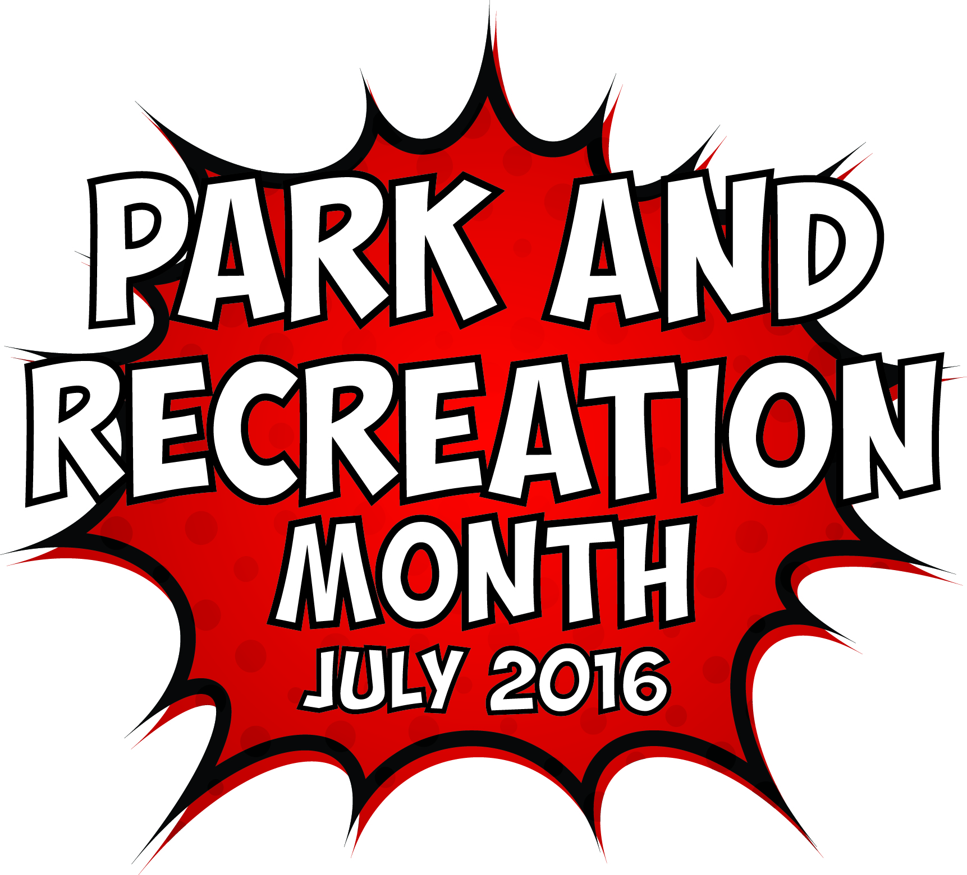

2016 PARK AND RECREATION MONTH

OUTREACH TOOLKIT

Contents
Toolkit Purpose 3
Park and Recreation Month 2016 Fact Sheet 4
NRPA 2016 Park and Recreation Month Key Messages 5
Template Media Advisory 8
Template 2016 Park and Recreation Month Press Release 9
2016 Park and Recreation Month Social Media Materials 11
Template 2016 Park and Recreation Month Editorial Story Sample 13
Media Outreach – “How To” 14

Toolkit Purpose

The purpose of this toolkit is to provide elements that will assist you in promoting Park and Recreation Month through the media and social media. This kit is designed to help you generate positive media coverage and support for your Park and Recreation Month activities and ultimately the work of your agency and the benefits you bring to your community.

This kit includes template media materials such as media alerts for special events, press releases, fact sheets, key messages for use during interviews, social media posts, and a sample editorial article you can submit to your local publications. Feel free to customize these materials with localized information, quotes and details that best meet your needs.

As you earn media hits, please send us a link to the hit at cbelt@nrpa.org. When using social media, please make sure you are tagging NRPA in your Facebook, Twitter and Instagram posts and using the hashtag #SuperJuly.

Don’t forget, we want to see your successes too – send us photos and videos from your Park and Recreation Month events or the creative ways you have used the marketing materials!

If you have questions or need further assistance, please don’t hesitate to contact us.

We hope this toolkit helps you generate great support for Park and Recreation Month!

Thank you,

Roxanne Sutton
Senior Marketing and Communications Specialist, NRPA
703.858.2166
rsutton@nrpa.org

Catrina Belt
Marketing and Communications Coordinator, NRPA
703.858.2165
cbelt@nrpa.org

Park and Recreation Month 2016 Fact Sheet

- Since 1985, America has celebrated July as the nation’s official Park and Recreation Month. In 2009, the U.S. House of Representatives officially mandated July as “Park and Recreation Month.” Hundreds of park and recreation agencies will celebrate with their communities this July.

- This July we’re celebrating the super powers of parks and recreation and all the ways these local, community resources add value to our daily lives.

- We’re challenging everyone to discover their super powers at their local parks and recreation facilities whether it’s running a mile, building a new network of friends or finding your green thumb.

- Various research studies are confirming that community parks and recreation, green space and time outdoors is critical for creating healthy, active and sustainable communities. You can experience the benefits by visiting your community parks and recreation any time of the year, and especially during Park and Recreation Month.

- In addition to visiting a park or recreation area during July, you can get involved in Park and Recreation Month by:

  - Sharing the “Park and Rec Brigade” comic book with your community;
  - Participating in the Park and Recreation Month Super Park Selfie Challenge;
  - Downloading the official Park and Recreation Month poster and hanging it up, taking pictures with it or sharing copies of it with your community; and
  - Using the social media badge during July.

- To encourage the discovery of parks and recreation’s super powers, we’re hosting a month-long selfie photo contest. From July 4-31, NRPA will issue weekly challenges for people to get out in their parks and recreation facilities and discover their super powers. We’ll award weekly prizes to the photo with the most votes that demonstrates the weekly challenge. The contest can be entered via Facebook or by uploading a photo to Twitter and Instagram using #SuperJuly and #SuperParkSelfie. Visit www.nrpa.org/july for the official rules and criteria.
- NRPA is recognizing three outstanding “super heroes” of parks and recreation as well as featuring the winning photo of our Park and Recreation Month Cover Contest this July in Parks & Recreation magazine.

- You can learn more about Park and Recreation Month and find participating park and recreation areas in your community by visiting: www.nrpa.org/July.
- Join the conversation on Facebook, Twitter and Instagram with the hashtag #SuperJuly.

NRPA 2016 Park and Recreation Month Key Messages

  - General Key Messages
- Since 1985, Americans have celebrated Park and Recreation Month in July to promote the importance of parks and recreation in health and wellness, conservation and social equity, and to recognize the thousands of park and recreation employees that maintain our nation’s local and community parks.
- Through efforts by NRPA, the U.S. House of Representatives passed an official resolution for Park and Recreation Month in 2009.
- Park and recreation agencies across the country are recognizing the month with summer programs, events, contests, commemorations and celebrations.
- Parks and recreation services are vital for our communities—from protecting open space and natural resources, to helping fight obesity, to providing activities and resources for all walks of life—Park and Recreation Month encourages everyone to reflect on the exponential value parks and recreation bring to communities.
  - 2016 Key Messages
- This July we’re celebrating the super heroes and super powers of parks and recreation. Parks and recreation not only give us the opportunity to become our best selves, they also super power our communities economically, improve the environment and provide equitable public spaces for all.
- This July we are also celebrating those people who have made significant and positive change in community member’s lives through parks and recreation. The work of these community heroes often goes unnoticed and it’s time we brought their impacts into the spotlight.
- NRPA encourages all people that support parks and recreation to share stories about their own park and recreation super heroes with the hashtag #SuperJuly.
- NRPA has created a comic book showcasing the super powers of parks and recreation and how they make a difference through health and wellness, conservation and social equity. NRPA encourages everyone to download and share the comic book within their communities to show the many benefits of local parks and recreation.
- NRPA is hosting a month-long selfie photo contest. From July 4-31, NRPA will issue weekly challenges for people to get out in their parks and recreation facilities and discover their super powers. Weekly prizes will be awarded to the photo with the most votes that demonstrates the weekly challenge. The contest can be entered via Facebook or by uploading a photo to Twitter and Instagram using #SuperJuly and #SuperParkSelfie. Visit the website for the official rules and criteria.
- We’re challenging everyone to show off their own super powers and celebrate Park and Recreation Month by dressing like their favorite super hero or creating their own!
- For more information visit www.nrpa.org/july.

  - Supporting Key Messages
Messages promoting support for parks and recreation:
- According to a 2015 study conducted by Penn State and commissioned by the National Recreation and Park Association, an overwhelming majority of Americans assert that they personally benefit from local parks and that their communities benefit from local parks.
  - Americans are in agreement that NRPA’s Three Pillars—Conservation, Health & Wellness and Social Equity—are chief priorities for local parks.
  - Parks are a great value: 4 in 5 Americans concur that local parks are well worth the tax dollars spent on them.
  - This passion for local parks has gone unabated over the past 25 years, even with dramatic demographic shifts in the United States and the ways technology transformed how we interact with others and entertain ourselves.
  - Support for local parks is widespread, spanning different age groups, income strata, household types and political affiliations.
Messages promoting health and wellness benefits of parks and recreation:
- According to a 2014 article in the International Journal of Environmental Research and Public Health, higher levels of green space were associated with lower symptoms of anxiety, depression and stress.
- The Centers for Disease Control found that increased access to places for physical activity led to a 25.6 percent increase in people exercising 3 or more times per week.
- Living close to parks and other recreation facilities is consistently related to higher physical activity levels for both adults and youth.
- On average, children who live in greener environments weigh less than children who live in less green areas.
- Children that have easy access to a playground are approximately five times more likely to have a healthy weight than children that do not have easy access to playgrounds.
- The nation’s park and recreation facilities are on the frontline in the battle against the obesity epidemic and other chronic health issues.
- Between 2000 and 2012, more than 85 studies have been published that link parks to better physical and mental health.

Messages promoting environmental benefit of parks and recreation:
- Parks, and particularly the trees in parks, have a direct and important impact on our quality of life. In fact, a 2006 study found that the air pollution removal value by urban trees in the United States is estimated to be 1.56 billion pounds per year – a value of $3.8 billion.
- A park with one acre of trees absorbs the carbon dioxide produced by driving a car 11,000 miles.
- Parks do a great deal to contribute to species richness in urban settings – a review of more than 60 studies by IFPRA shows that there is strong evidence to support the concept that parks support both plant and animal biodiversity. This offers not only an important educational opportunity, but additionally supports overall ecosystem functionality.
- Parks reduce the impact of large storms and flooding by serving as sponges that soak up run off from nearby paved surfaces during rain events. This in turn prevents flooding and decreases property damage. Parks that are well-designed also reduce water usage by recycling and storing this water for use during times of low precipitation.
- Evidence not only shows that parks are cooler than their surrounding cities, but actually shows that parks contribute to overall urban cooling – parks make our cities more comfortable in the summer!

Messages promoting the economic benefits of parks and recreation:
- According to a study conducted by Center for Regional Analysis at George Mason University and the National Recreation and Park Association, America’s local and regional public park agencies generated nearly $140 billion in economic activity and supported almost 1 million jobs from their operations and capital spending alone in 2013.
- According to the National Association of State Park Directors, 725 million people visited state parks in 2013. State parks cost $2.3 billion to operate, but they inject more than $20 billion into local economies.

Template Media Advisory
[GROUP LOGO/LETTERHEAD]

MEDIA ADVISORY
Media Contact:
[Contact Name]
[Agency Name]
[Phone]
[Email]

[Agency Name] to Kick Off National Park and Recreation Month at [Park/Facility Name]
[Add a second-line description for a special appearance by celebrity or specific highlight.]

WHO/WHAT: [Name of major public officials or celebrities who are participating, as well as the number of people who will be in attendance.]

[List and briefly describe any programs or activities that will take place. Concentrate specifically on the highlights.]

WHEN: [Date/Time]
[Be sure to mention individual start times for notable speakers/happenings.]

WHERE: [Location/Address]
[Provide parking information, if relevant.]

WHY: Since 1985, America has celebrated July as Park and Recreation Month. A program of the National Recreation and Park Association (NRPA), the goal is to raise awareness of the vital impact that parks, recreation and conservation have on communities across the U.S.

This July, [Agency Name] and the National Recreation and Park Association are celebrating the superheroes and super powers of parks and recreation. Parks and recreation not only give us the opportunity to become our best selves, they also super power our communities economically, improve the environment and provide equitable public spaces for all. For more information, go to www.nrpa.org/july or search Twitter and Instagram using #SuperJuly.
EDITOR’S NOTE: [Mention any opportunities for interesting visuals and tours. Provide onsite contact information.]
# # #

Template 2016 Park and Recreation Month Press Release

[GROUP LOGO/LETTERHEAD]

FOR IMMEDIATE RELEASE
Media Contact:
[Contact Name]
[Agency Name]
[Phone]
[Email]

This July, [City/town/community name] Will Discover the Super Powers of Parks and Recreation
Month-long celebration highlights essential value of local parks and recreation

[CITY, STATE ABRV] – [DATE] – This July, [Community Name] residents don’t need to be bitten by a radioactive spider to discover that they have super powers. They just need to visit their nearest park or recreation center to find super powers they didn’t know they had.

[Agency Name] is celebrating Park and Recreation Month, an initiative of the National Recreation and Park Association (NRPA), and all the ways parks and recreation has the power to transform our daily lives. From providing us places to get fit and stay healthy to fostering new relationships and forging a connection with nature, our close-to-home community park and recreation facilities provide essential services and improve quality of life.

[QUOTE from Agency leadership, discussing ways you impact your community through health and wellness, social equity, conservation, etc. and tie to the celebration of Park and Recreation Month.]

[Agency Name] will celebrate Park and Recreation Month through [provide brief summary of local activities].

NRPA is celebrating the month by hosting a selfie photo contest. From July 4-31, NRPA will issue weekly challenges for people to get out in their parks and recreation facilities and discover their super powers. Weekly prizes will be awarded. The contest can be entered via Facebook or by uploading a photo to Twitter and Instagram using #SuperJuly and #SuperParkSelfie. Visit www.nrpa.org/July for official rules and details. NRPA also encourages all people that support parks and recreation to share their photos and love of parks using the hashtag #SuperJuly on social media.

To learn more about Park and Recreation Month, visit [Add local website information] and www.nrpa.org/July.

[Agency boilerplate/ “about” information]

About The National Recreation and Park Association
The National Recreation and Park Association is a national not-for-profit organization dedicated to advancing park, recreation and conservation efforts that enhance quality of life for all people. Through its network of more than 50,000 recreation and park professionals and citizens, NRPA encourages the promotion of healthy and active lifestyles, conservation initiatives and equitable access to parks and public space. For more information, visit NRPA.org. For digital access to NRPA’s flagship publication, Parks & Recreation, visit ParksAndRecreation.org.
# # #

2016 Park and Recreation Month Social Media Materials

  - Social Covers and Badges
You can find social media covers and badges at www.nrpa.org/july/Park-and-Recreation-Month/ToolKit/. We encourage you to update your Facebook and Twitter pages with these images to show your support of Park and Recreation Month all throughout July!

  - Sample Social Media Posts
If you have social media platforms such as Facebook, Twitter and Instagram, here are some sample messages to generate awareness among your friends and followers. Customize these posts for Park and Recreation Month and feel free to develop some more on your own! Please note that the comic book referenced in these sample posts is available in the toolkit.

Tag NRPA in your posts, too.
- Facebook: type @National Recreation and Park Association when you are writing your post.
- Twitter: type @NRPA_News in your post.
- Instagram: type @nrpa in your post.

Official 2016 Park and Recreation Month Hashtags
- #SuperJuly
- #SuperParkSelfie(contest hashtag—you can find more information about this year’s contest at www.nrpa.org/July)

Sample posts for Facebook:

- We’re celebrating Park and Recreation Month by encouraging you to discover your super powers with us at (insert park/facility name)! #SuperJuly
- Parks and recreation have the power to strengthen communities, transform lives and protect the future. When our powers combine, we change lives! #SuperJuly
- Check out our super powered (insert activity) we did today in honor of Park and Recreation Month! #SuperJuly (include photos from activity)
- This #SuperJuly @National Recreation and Park Association is celebrating Park and Recreation superheroes in communities across the country. Who’s your park and recreation superhero?
- Park and Recreation Month encourages everyone to reflect on the value of parks and recreation in our communities. How do (insert City name) park and rec facilities help you discover your superpowers? #SuperJuly
Sample posts for Twitter:

- This #SuperJuly we’re encouraging you to discover your super powers with parks and recreation!
- This Park and Recreation Month go on an adventure with the Park and Rec Brigade! (include link to the comic book)
- What’s your park and recreation superpower? Get inspired by Park and Recreation Month’s #SuperJuly celebration!
- “When our powers combine, we change lives!” Meet Captain Community, the Green Guardian and the Fit Twins (include link to the comic book) #SuperJuly
- We’re discovering our super powers with some of our programs this month in honor of #SuperJuly. Check them out! (insert shortened link to your website or calendar of activities for July)

Sample post for Instagram:

- We’re discovering our super powers at (insert park/facility name) in honor of Park and Recreation Month! #SuperJuly
- We’re celebrating our superpowers all month long in honor of Park and Recreation Month. This is how our parks and recreation change lives! #SuperJuly

  - Ideas for Sharing the Comic Book
The comic book is available at http://www.nrpa.org/july/Park-and-Recreation-Month/ToolKit/#comicbook. Ideas for sharing the comic book include:
- Work with a local printer to have copies made for your events. Customize with your logo!
- Share on your social channels.
- Send the comic book link with your media outreach.
- Download and use the comic book at your facilities.

Template 2016 Park and Recreation Month Editorial Story Sample

Headline: Have a Super-Powered July with (Agency Name)
Subhead: Celebrate Park and Recreation Month this July by (list a few planned activities here)
Get ready to discover your super powers this July with (Agency Name) and the National Recreation and Park Association (NRPA).
Since 1985, America has celebrated July as the nation’s official Park and Recreation Month. Created by NRPA, Park and Recreation Month specifically highlights the vital and powerful role local parks and recreation, such as [Agency Name], play in conservation, health and wellness, and social equity efforts in communities all across the country.
This year it’s all about discovering your super powers at your local park and recreation facilities. From learning a new skill like gardening to meeting your fitness goals, your [city/town] park and recreation facilities can have you feeling like a superhero before July is through. NRPA and [Agency Name] are encouraging everyone to get out there to experience the power of parks and recreation for themselves.
In [city/town], you can celebrate this super-powered month by [complete sentence with local activities/ events /contests etc.].
“July is the perfect time to highlight all the benefits parks and recreation provides right here in [city/town],” said [Agency Leader]. Our local parks and recreation directly contribute to reduced obesity rates, an improved ecosystem and increased property values.”
[Agency name] is leading initiatives and providing opportunities for people to achieve healthier lifestyles, promote and understand nature and conservation as well as bringing the community closer through a variety of programs and services. [Add more details on any specific ways you make a difference in your community or any stats or success stories you may have that back up the impact you make.]
Nationally, NRPA is celebrating with a month-long #SuperParkSelfie photo contest and is challenging people to get out to their park and recreation facilities and capture the super powers they gain from them. NRPA also encourages everyone to share their support of parks and recreation on social media with the hashtag #SuperJuly. For more information about the contest and Park and Recreation Month in general, visit www.nrpa.org/July.
Learn about the exciting Park and Recreation Month activities planned for [town/city name] and more at [Fill-in local contact information here] or visit online at [Fill-in local park website URL here].

Media Outreach – “How To”

The following are general guidelines for conducting media outreach for both special events you may be hosting in July and in general for Park and Recreation Month.

  - Leveraging the Press Release

To announce your involvement in Park and Recreation Month and what activities you will have going on throughout the month, customize the Press Release template and distribute it to appropriate reporters, bloggers and broadcast media in your local area.

- Search online for the “news desk” emails and/or submission guidelines of your local TV stations and radio stations.

- Search for the contact information for reporters and publications in your local area that cover topics related to parks, the outdoors and community affairs. Be sure to pitch to only one reporter from each newspaper/print agency. It is a good idea to review the stories the reporter writes to get a feel for what they are most interested in so that you can tailor your outreach to meet their interests. Most reporters prefer email.

- Search online for bloggers in your area; these social media journalists are powerful influencers and can virally spread the word about the events you have going on for Park and Recreation Month.

- Once you have your list together, prepare your pitches. Make sure you tailor the pitch for the type of outlet and personalize it as much as possible for the journalist or blogger you are contacting. Keep it brief.

- You’ll want to send the release out at the end of June or beginning of July to journalists and reporters, and to TV/radio stations approximately two days before an event you want them to attend.

- Customize the press release template with the appropriate information, as marked with brackets and yellow highlight, EX: [NAME].

- You can distribute your press release on any newswires you subscribe to or use regularly. This will give you added visibility in news rooms and with online media.

- In addition to wire distribution, reach out directly via email to journalists and bloggers. Insert your pitch and paste the text of the press release into the email.

- Put an engaging tag line or sentence in the “Subject” line of the email to entice reporters.

- Once you have sent your release, follow up with a phone call to reporters. Be sure to have a short pitch ready, and be prepared to answer questions about why your event or story is a “must see/cover.”

  - Using the Editorial Article Template

Many local newspapers and online media outlets are very interested in receiving already written editorial content that they can instantly use in their outlets. The template editorial article is a great way to get coverage for your agency and what you are doing for Park and Recreation Month.

- Contact your local community print publications and ask them if they take “drop in” articles or editorial content submissions.

- Find out if they have any requirements such as a particular word count and preferences such as submission process and deadline. They may only take submissions on a certain day or require that submissions be made via an online entry form only.

- If they take submissions, keep note of that in your records for the future. You may even want to explore the option of regularly contributing content from your agency.

- Confirm the lead time, or time it takes for content to appear once submitted. You will want to make sure that you provide the article in enough time to the publication so that it appears timed to your event you may be highlighting or within the month of July.

- Customize the sample editorial article with the appropriate information, as marked with brackets and yellow highlight, EX: [NAME].

- Submit your completed article per the outlet’s instructions and confirm when you can expect to see the coverage in print or online.

  - Inviting Press to Your Event

If you are hosting a special event during the month of July and would like to invite reporters to cover your event on site:

- Search online for the “news desk” emails and/or submission guidelines of your local TV stations and radio stations.

- Search for the contact information for reporters and publications in your local area that cover topics related to parks, the outdoors, and community affairs. Be sure to pitch to only one reporter from each newspaper/print agency. Most reporters prefer email.

- Consider inviting local bloggers to your event as well or creating a special opportunity for them to come out and get sneak peek of your Park and Recreation Month event. These social media journalists are powerful influencers and can virally spread the word about the events you have going on for Park and Recreation Month.

- It’s a good idea to send Media Advisories to journalists and reporters at least two weeks in advance and to TV/radio stations approximately two days before an event.

- Customize the media alert template with the appropriate information, as marked.

- Write a brief, one-paragraph pitch to the reporter, and attach the Media Advisory as a PDF or Word Document, or paste the text into the email, beginning with “Media Advisory.”

- Put an engaging tag line or sentence in the “Subject” line of the email to entice reporters.

- Once you have sent your Media Advisory, follow up with a phone call to reporters you are particularly interested in having attend. Be sure to have a short pitch ready, and be prepared to answer questions about why your event is a “must see.”

- Consider sending a post-event press release to generate coverage after the event. It is a good idea to send this immediately following the event or the next morning. Often times, this means drafting most of the release in advance, and adding a few pertinent details afterward.

- Reach back out to the reporters that you previously contacted. If you can, offer footage from the event or high resolution photos.

  - Tips and Tactics

- Remember that timeliness is a big factor in press coverage.

- Try to keep the message brief. One page is best—do not exceed two.

- Don't forget to add complete contact information. If a reporter is interested, they may wish to email or call you with questions or requests for clarification.

- Write using short paragraphs and sentences, and in the third person—don’t refer to yourself as “I” or “we,” except in a direct quote.

- Avoid testimonials or other promotional language. A press release is news; not advertising.

- Don’t be discouraged if you do not receive interest, or if a reporter doesn’t make it to your event. Reporters receive hundreds of press releases every day and cover news based on many factors (timeliness, the amount of current events taking place/space, editor approval, capacity, etc.). It’s never personal.

- If a reporter does email or call with interest, be sure to respond in a very timely manner.

Let us know if your Park and Recreation Month event is covered in the news! Send links of online coverage to cbelt@nrpa.org.

