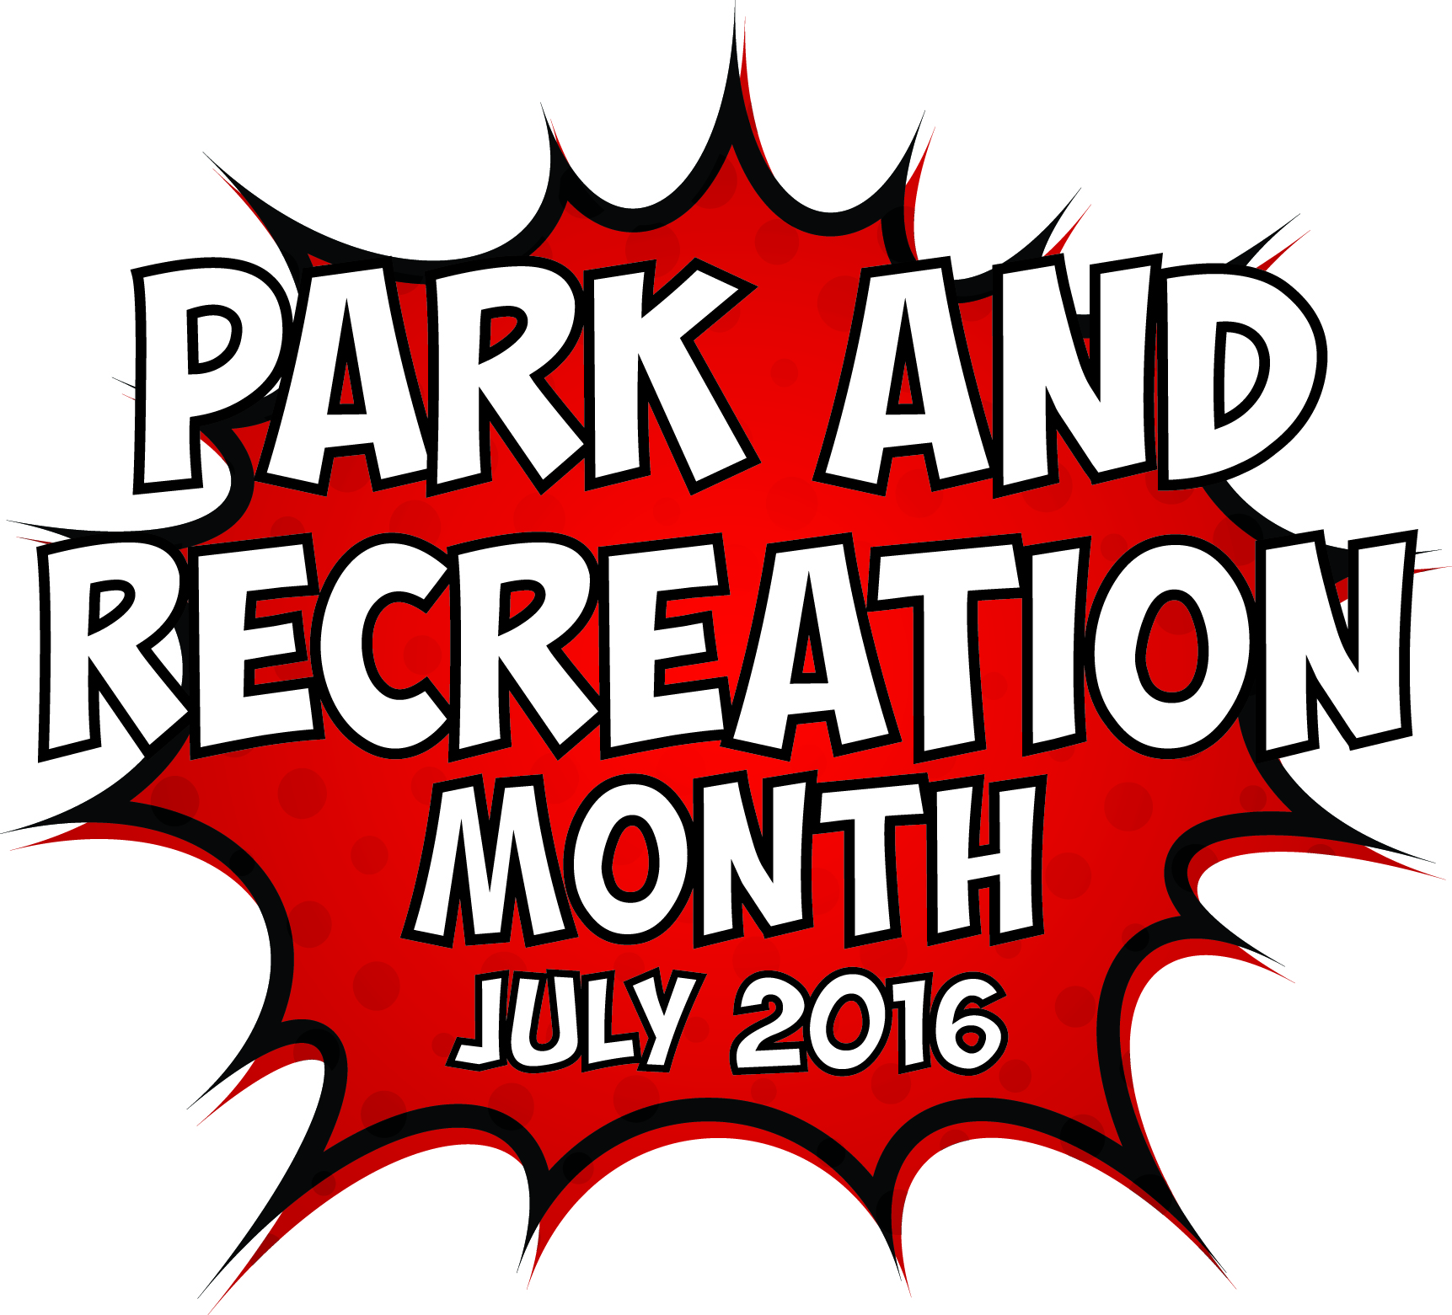
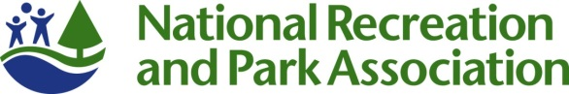

Park and Recreation Month 2016 Fact Sheet

- Since 1985, America has celebrated July as the nation’s official Park and Recreation Month. In 2009, the U.S. House of Representatives officially mandated July as “Park and Recreation Month.” Hundreds of park and recreation agencies will celebrate with their communities this July.

- This July we’re celebrating the super powers of parks and recreation and all the ways these local, community resources add value to our daily lives.

- We’re challenging everyone to discover their super powers at their local parks and recreation facilities whether it’s running a mile, building a new network of friends or finding your green thumb.

- Various research studies are confirming that community parks and recreation, green space and time outdoors is critical for creating healthy, active and sustainable communities. You can experience the benefits by visiting your community parks and recreation any time of the year, and especially during Park and Recreation Month.

- In addition to visiting a park or recreation area during July, you can get involved in Park and Recreation Month by:

  - Sharing the “Park and Rec Brigade” comic book with your community;
  - Participating in the Park and Recreation Month Super Park Selfie Challenge;
  - Downloading the official Park and Recreation Month poster and hanging it up, taking pictures with it or sharing copies of it with your community; and
  - Using the social media badge during July.

- To encourage the discovery of parks and recreation’s super powers, we’re hosting a month-long selfie photo contest. From July 4-31, NRPA will issue weekly challenges for people to get out in their parks and recreation facilities and discover their super powers. We’ll award weekly prizes to the photo with the most votes that demonstrates the weekly challenge. The contest can be entered via Facebook or by uploading a photo to Twitter and Instagram using #SuperJuly and #SuperParkSelfie. Visit www.nrpa.org/july for the official rules and criteria.
- NRPA is recognizing three outstanding “super heroes” of parks and recreation as well as featuring the winning photo of our Park and Recreation Month Cover Contest this July in Parks & Recreation magazine.

- You can learn more about Park and Recreation Month and find participating park and recreation areas in your community by visiting: www.nrpa.org/July.
- Join the conversation on Facebook, Twitter and Instagram with the hashtag #SuperJuly.

NRPA 2016 Park and Recreation Month Key Messages

  - General Key Messages
- Since 1985, Americans have celebrated Park and Recreation Month in July to promote the importance of parks and recreation in health and wellness, conservation and social equity, and to recognize the thousands of park and recreation employees that maintain our nation’s local and community parks.
- Through efforts by NRPA, the U.S. House of Representatives passed an official resolution for Park and Recreation Month in 2009.
- Park and recreation agencies across the country are recognizing the month with summer programs, events, contests, commemorations and celebrations.
- Parks and recreation services are vital for our communities—from protecting open space and natural resources, to helping fight obesity, to providing activities and resources for all walks of life—Park and Recreation Month encourages everyone to reflect on the exponential value parks and recreation bring to communities.
  - 2016 Key Messages
- This July we’re celebrating the super heroes and super powers of parks and recreation. Parks and recreation not only give us the opportunity to become our best selves, they also super power our communities economically, improve the environment and provide equitable public spaces for all.
- This July we are also celebrating those people who have made significant and positive change in community member’s lives through parks and recreation. The work of these community heroes often goes unnoticed and it’s time we brought their impacts into the spotlight.
- NRPA encourages all people that support parks and recreation to share stories about their own park and recreation super heroes with the hashtag #SuperJuly.
- NRPA has created a comic book showcasing the super powers of parks and recreation and how they make a difference through health and wellness, conservation and social equity. NRPA encourages everyone to download and share the comic book within their communities to show the many benefits of local parks and recreation.
- NRPA is hosting a month-long selfie photo contest. From July 4-31, NRPA will issue weekly challenges for people to get out in their parks and recreation facilities and discover their super powers. Weekly prizes will be awarded to the photo with the most votes that demonstrates the weekly challenge. The contest can be entered via Facebook or by uploading a photo to Twitter and Instagram using #SuperJuly and #SuperParkSelfie. Visit the website for the official rules and criteria.
- We’re challenging everyone to show off their own super powers and celebrate Park and Recreation Month by dressing like their favorite super hero or creating their own!
- For more information visit www.nrpa.org/july.

  - Supporting Key Messages
Messages promoting support for parks and recreation:
- According to a 2015 study conducted by Penn State and commissioned by the National Recreation and Park Association, an overwhelming majority of Americans assert that they personally benefit from local parks and that their communities benefit from local parks.
  - Americans are in agreement that NRPA’s Three Pillars—Conservation, Health & Wellness and Social Equity—are chief priorities for local parks.
  - Parks are a great value: 4 in 5 Americans concur that local parks are well worth the tax dollars spent on them.
  - This passion for local parks has gone unabated over the past 25 years, even with dramatic demographic shifts in the United States and the ways technology transformed how we interact with others and entertain ourselves.
  - Support for local parks is widespread, spanning different age groups, income strata, household types and political affiliations.
Messages promoting health and wellness benefits of parks and recreation:
- According to a 2014 article in the International Journal of Environmental Research and Public Health, higher levels of green space were associated with lower symptoms of anxiety, depression and stress.
- The Centers for Disease Control found that increased access to places for physical activity led to a 25.6 percent increase in people exercising 3 or more times per week.
- Living close to parks and other recreation facilities is consistently related to higher physical activity levels for both adults and youth.
- On average, children who live in greener environments weigh less than children who live in less green areas.
- Children that have easy access to a playground are approximately five times more likely to have a healthy weight than children that do not have easy access to playgrounds.
- The nation’s park and recreation facilities are on the frontline in the battle against the obesity epidemic and other chronic health issues.
- Between 2000 and 2012, more than 85 studies have been published that link parks to better physical and mental health.

Messages promoting environmental benefit of parks and recreation:
- Parks, and particularly the trees in parks, have a direct and important impact on our quality of life. In fact, a 2006 study found that the air pollution removal value by urban trees in the United States is estimated to be 1.56 billion pounds per year – a value of $3.8 billion.
- A park with one acre of trees absorbs the carbon dioxide produced by driving a car 11,000 miles.
- Parks do a great deal to contribute to species richness in urban settings – a review of more than 60 studies by IFPRA shows that there is strong evidence to support the concept that parks support both plant and animal biodiversity. This offers not only an important educational opportunity, but additionally supports overall ecosystem functionality.
- Parks reduce the impact of large storms and flooding by serving as sponges that soak up run off from nearby paved surfaces during rain events. This in turn prevents flooding and decreases property damage. Parks that are well-designed also reduce water usage by recycling and storing this water for use during times of low precipitation.
- Evidence not only shows that parks are cooler than their surrounding cities, but actually shows that parks contribute to overall urban cooling – parks make our cities more comfortable in the summer!

Messages promoting the economic benefits of parks and recreation:
- According to a study conducted by Center for Regional Analysis at George Mason University and the National Recreation and Park Association, America’s local and regional public park agencies generated nearly $140 billion in economic activity and supported almost 1 million jobs from their operations and capital spending alone in 2013.
- According to the National Association of State Park Directors, 725 million people visited state parks in 2013. State parks cost $2.3 billion to operate, but they inject more than $20 billion into local economies.

