National Recreation and Park Association
Park and Recreation Certification

Premier Agency Application

“We have a tremendously large CPRP initiative at CPD. The agency package has helped us reduce costs and speed-up the paperwork process.”
- Nicole Ginger, Professional Development Manager, Chicago Park District

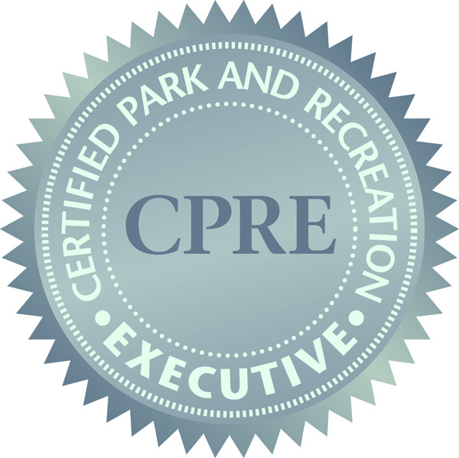

“The agency package gave our agency a discounted rate. But aside from the monetary benefit, applying as a group encouraged us to apply, study and test together for the CPRP exam. It was a great way to build teams and encourage each other to advance our careers.”
- Errin Reese, Sports Coordinator, Town of Parker, CO

National Recreation and Park Association
22377 Belmont Ridge Road
Ashburn, VA 20148
(703) 858-0784
Please complete the following form. You can type directly in the gray squares and tab down to the next square.

PREMIER AGENCY CONTACT NAME:

Phone:

Mailing address:

City:

State:

Zip:

Email address:

Fee Information

3-4 Candidates - $215/person 10-14 Candidates - $185/person 20+ Candidates - $165/person
5-9 Candidates - $200/person 15-19 Candidate - $170/person

Number of Candidates applying for CPRP exam x per person rate =

Number of Candidates applying for CPRE exam x per person rate +$85 =

Optional study materials
Number of Study Guides (20% discount)* x $32*/study guide =

Number of CPRP Practice Exams (20% discount) x $60/practice exam =

Number of Management of Park and Recreation Agencies Book
(CPRE Preparatory Guide – 20% discount) x $52*/book =

Total =
*Shipping and handling not included – invoice for fees will be created after distribution

Payment Information

Please make checks payable to: National Recreation and Park Association (NRPA)

Check Credit Card: Visa MasterCard American Express Discover

Credit Card Number:

Expiration Date:

CVV:

Name on Credit Card:

Billing Address:

Must be checked for credit card to be processed - I authorize the National Recreation and Park Association to charge the credit card indicated on this form, for the total listed above. This payment is for a Premier Agency certification application. I understand that this amount is non-refundable. I certify that I am an authorized user of this credit card and that I will not dispute the payment with my credit card company, so long as the transaction corresponds to the terms indicated on this form.

Please send applications with credit card information to NRPA via fax at (703)858-0794 or applications with checks to: NRPA, 22377 Belmont Ridge Rd., Ashburn, VA 20148.
Premier Agency Application Candidate List

Candidate Name

Email Address

Please Check Certification Examination CPRP CPRE CPRP and CPRE (per person rate x2 + $85)

Candidate Name

Email Address

Please Check Certification Examination CPRP CPRE CPRP and CPRE (per person rate x2 + $85)

Candidate Name

Email Address

Please Check Certification Examination CPRP CPRE CPRP and CPRE (per person rate x2 + $85)

Candidate Name

Email Address

Please Check Certification Examination CPRP CPRE CPRP and CPRE (per person rate x2 + $85)

Candidate Name

Email Address

Please Check Certification Examination CPRP CPRE CPRP and CPRE (per person rate x2 + $85)

Candidate Name

Email Address

Please Check Certification Examination CPRP CPRE CPRP and CPRE (per person rate x2 + $85)

Candidate Name

Email Address

Please Check Certification Examination CPRP CPRE CPRP and CPRE (per person rate x2 + $85)

Candidate Name

Email Address

Please Check Certification Examination CPRP CPRE CPRP and CPRE (per person rate x2 + $85)

Candidate Name

Email Address

Please Check Certification Examination CPRP CPRE CPRP and CPRE (per person rate x2 + $85)

Candidate Name

Email Address

Please Check Certification Examination CPRP CPRE CPRP and CPRE (per person rate x2 + $85)

Premier Agency Application Candidate List (continued)

Candidate Name

Email Address

Please Check Certification Examination CPRP CPRE CPRP and CPRE (per person rate x2 + $85)

Candidate Name

Email Address

Please Check Certification Examination CPRP CPRE CPRP and CPRE (per person rate x2 + $85)

Candidate Name

Email Address

Please Check Certification Examination CPRP CPRE CPRP and CPRE (per person rate x2 + $85)

Candidate Name

Email Address

Please Check Certification Examination CPRP CPRE CPRP and CPRE (per person rate x2 + $85)

Candidate Name

Email Address

Please Check Certification Examination CPRP CPRE CPRP and CPRE (per person rate x2 + $85)

Candidate Name

Email Address

Please Check Certification Examination CPRP CPRE CPRP and CPRE (per person rate x2 + $85)

Candidate Name

Email Address

Please Check Certification Examination CPRP CPRE CPRP and CPRE (per person rate x2 + $85)

Candidate Name

Email Address

Please Check Certification Examination CPRP CPRE CPRP and CPRE (per person rate x2 + $85)

Candidate Name

Email Address

Please Check Certification Examination CPRP CPRE CPRP and CPRE (per person rate x2 + $85)

Candidate Name

Email Address

Please Check Certification Examination CPRP CPRE CPRP and CPRE (per person rate x2 + $85)

