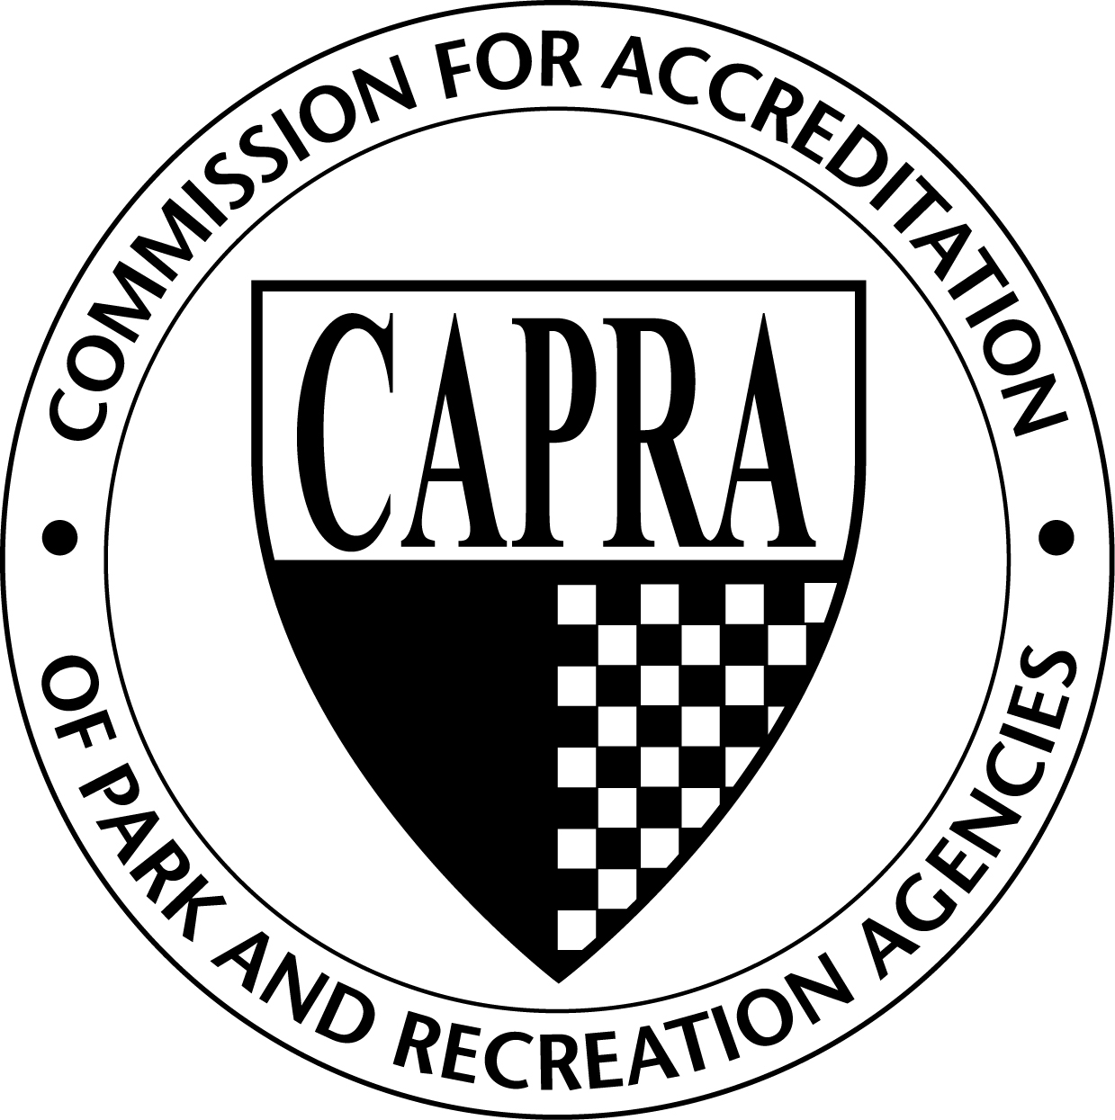
Steps for Initial Agency Accreditation

- Attend a CAPRA Agency training session
- Gather support from your boards, other departments, and elected officials
- Submit the necessary forms and fees to NRPA
  - Notice of Intent to Pursue Accreditation
  - Application for Accreditation
- Establish date for team visit – at least one year in advance, two is more realistic. This schedule should work back from your selected visitation date. Visits may take place January – July. Hearings will be at the NRPA Annual Conference.
- 12-24 months prior to visit - Review the 10 sections of standards with your top management team to determine who or what team will be responsible for each section. Also discuss the types of materials needed to meet each standard (this may take multiple meetings)
- Establish an overall Accreditation Manager who has the Director’s authority to set deadlines and request materials for your files (It is recommended that this be an ongoing responsibility)
- Set up files for each standard to hold your support documents
- 4-6 months prior to visit - Begin the process of collecting documentation for each of the standards and loading files
- Review files; make sure that each document meets the standard, dates of approvals, board approvals noted, etc. Pay close attention to the suggested evidence of compliance (this can be completed by the teams or the Accreditation Manager)
- 5 - 6 months prior to visit - complete the Agency Visit Availability request form to identify your two-week timeframe for your visit
- 3 - 4 months prior to visit - review the proposed visit team resumes and identify any conflicts of interest or approve the team
- 3 - 4 months before submitting self assessment - begin the write up of describing how you meet the standard and the documentation you have to support your statement using the format provided by CAPRA.
- 2 - 3 months prior to visit -work with the Visit Chair to set the exact dates of the visit and start working on travel arrangements for the team. Do not make travel arrangements until the visit is approved by the Commission Review Team.
- 2 months before submitting self assessment - proofread your first draft and match to files
- 1 month before submitting self assessment – finalize proof reading of document and compare to your files again
- 10 weeks prior to visit - submit the self assessment to NRPA and the Commission Lead and Second
- 8 weeks prior to visit – when the Commission Lead and Second approve the visit, send the self-assessment to the visit team and make travel arrangements for the visit team.
- The visit begins: Have all staff that worked on the materials available in the event of questions by the visitors
- After receiving the Visitation Report, the agency has 30 days from the date of receipt to respond, if a response is needed.

