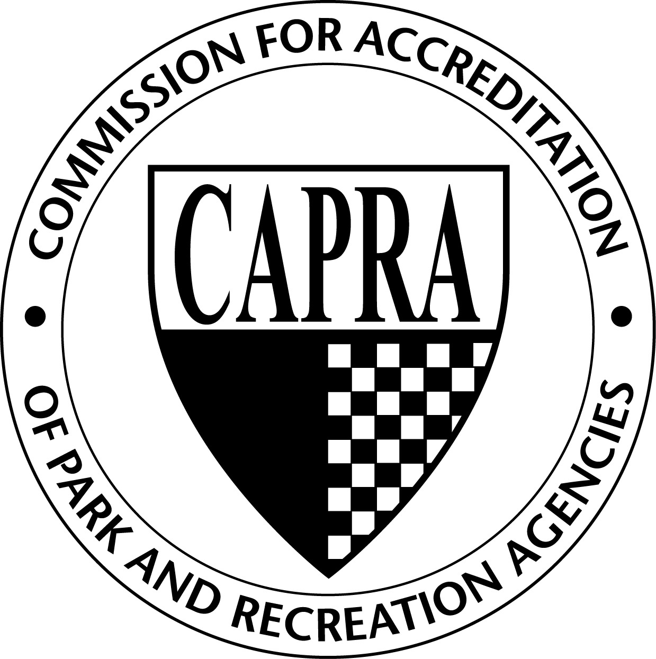

Commission for Accreditation of Park and Recreation Agencies

To: Accredited agencies, applicant agencies, and accreditation visitors

From: James Garges, CAPRA Chair

Subject: Fall 2013 CAPRA Update

Date: October 29, 2013

Thank you for your continued support of CAPRA and the accreditation process. As evidenced by the growing list of agencies seeking accreditation, our profession recognizes the value of accreditation. In times of budget cuts and downsizing, accreditation is still important for many agencies to pursue for the first time and for others to maintain. It demonstrates that an agency is well managed, proactive, reviews its management practices against the standards of practice developed by park and recreation professionals, and is providing cost-effective and comprehensive services.

The Commission met on September 17, 2013 and October 6-7, 2013 and voted to implement the following changes to go into effect immediately. These changes have been reflected in the CAPRA Accreditation Handbook.

2014 Standards – Call For Public Comment
The Commission has been working very hard over the past year to revise the current 2009 CAPRA Standards in order to ensure the CAPRA Standards are up-to-date. The proposed 2014 CAPRA Standards will be released in the next few weeks for public comment. We encourage all currently accredited agencies, prospective/preliminary applicant agencies, visitors, and the general public to read and provide comment on the proposed standards. The Commission will also be hosting a webinar focus group sometime in January to get additional feedback. Please keep an eye for further details.

Report Expectations
Several sections were added to the handbook to address the Commission’s expectations on how agencies should present their narrative and commentary in the self-assessment report and how visitors should present their narrative and commentary in the visitation report. These changes can be found in Self-Assessment Report and the Visitation Report sections of the handbook.

New Visitation Option for Reaccreditation Visits
The past two years the Commission has been testing out a pilot visitation option. After the conclusion of the last set of pilots that took place during the spring/summer of 2013, the Commission acted to implement this option starting with the 2014 visits. The details are below.

This option is available for reaccredited agencies who meet specific eligibility requirements of:
- Must be currently accredited and not on an extension;
- Met 100% of the fundamental standards at the last visit;
- Met at least 98% of the non-fundamental standards at the last visit; and
- Have not had any significant leadership changes since the last visit.
The Self-Assessment Report has the following requirements:
- Must be submitted at least 12 weeks prior to the scheduled visit;
- Meet the new writing requirements; and
- Provide all evidence of compliance with the self-assessment in an electronic format.
The visitors will have the following requirements:
- Only experienced visitors – 5 or more visits, preference is for experienced visit chairs;
- There will be two visitors to complete the electronic review and perform the on-site visit.

The on-site visit will last for two (2) days and will allow the visitors to tour the facilities/parks, meet with staff, and clarify any remaining questions from their self-assessment review. The Commission Lead and Second Reviewers will still review the self-assessment report and provide their approval prior to the travel being arranged.

If the Commission Lead and Second Reviewers are not okay with the self-assessment report, the agency will be required to host a standard 3-visitor, 3-day visit.

CAPRA/Illinois Distinguished Agency Program
The memorandum of understanding between CAPRA and DPRAC has been finalized and the program is now open to any Illinois agency that meets the requirements. Please view the CAPRA Accreditation Handbook for additional details.

Knowledge Center on NRPA Connect
Showcase your agency’s accreditation standards documents by logging in and posting them to the Knowledge Center within NRPA Connect. The Knowledge Center will quickly become a valuable resource for agencies looking for examples of the accreditation process, and we are asking for the assistance of the currently accredited agencies to populate this great resource with their materials. If you have documents you wish to share, follow these steps to post them:
- Log in to NRPA Connect
- Click on Knowledge Center
- Click on the “Accreditation” folder
- Click on the “CAPRA” folder
- Click on the appropriate standard folder
- Click on the “Add Document or Photo” link
- Locate your document, name it, and provide a brief description
- Click on “Upload File” at the bottom of the page

Upcoming Trainings
The list of upcoming CAPRA trainings can be found online at: http://www.nrpa.org/Professional-Development/Accreditation/CAPRA/CAPRA-Trainings/

Next Meeting
The next meeting will take place in December 2013.

Please contact CAPRA@nrpa.org with any questions regarding these changes. Thank you for your support.

