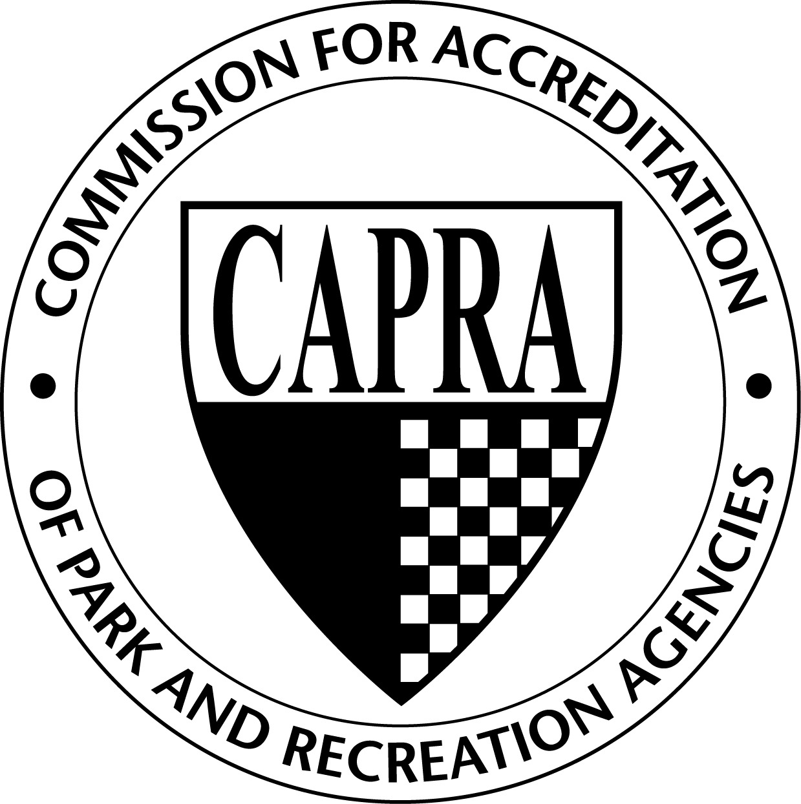
CAPRA Accreditation
Training Request Form

 |  | Date Completed:
Host Organization:
Contact Name: |  |  |  |  |  |  |  |  | Title:
Address 1:
Address 2:
City: |  |  |  |  |  |  | State: |  |  |  |  |  |  |  | Zip:
Phone: |  |  |  |  | Fax: |  |  |  |  |  |  |  | Cell:
Email:
Requested Training Date:
Training Location:
Signature:

I have read and understand the CAPRA Training Program Hosting Process document and following statement:
- Host organization is responsible for the $800 Hosting Fee plus $25 per registrant requesting CEUs, payable to NRPA.
- CAPRA Standards and Handbook booklets are available online at www.nrpa.org/CAPRA. Please have attendees print and bring with them to the training or print a copy for all attendees.
- Payment for the training must be received within 30 days of training.
- Cancelation fees incurred due to the cancelling of a training by the host are the responsibility of the host.
- Requests to host the CAPRA Training must be approved by NRPA Accreditation Manager.

Office Use Only

Date Rcvd: __________ Invoice Sent: ___________ Payment Rcvd: __________ Roster Rcvd:________

