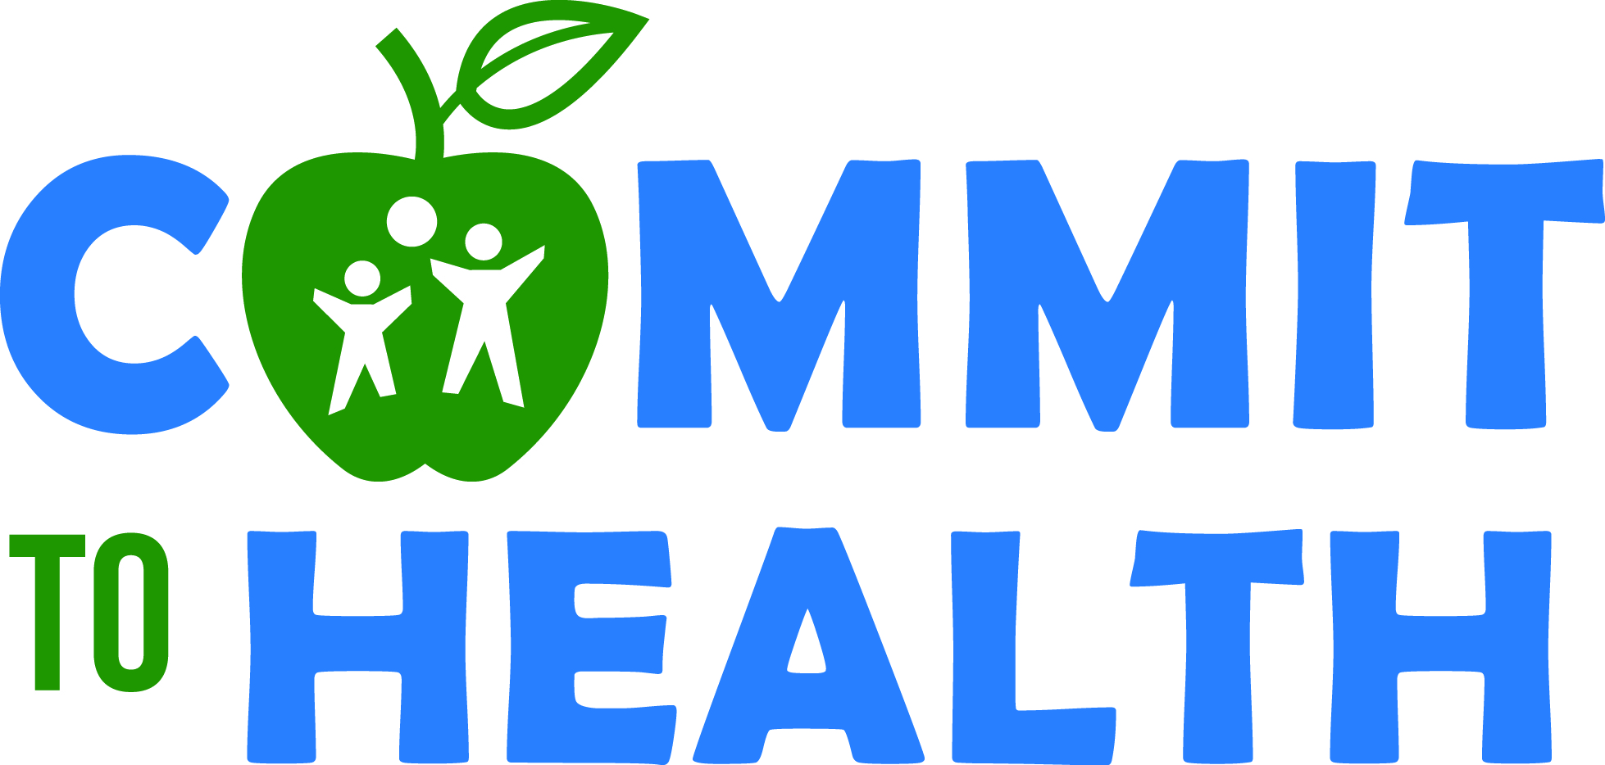
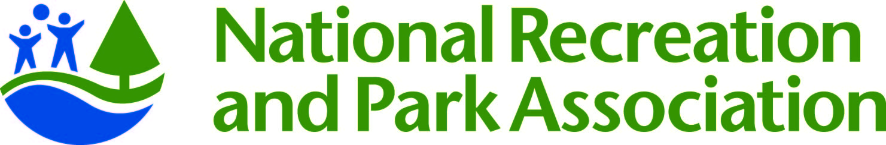
Frequently Asked Questions

- What is the NRPA PHA Commitment (Commit to Health)?
NRPA has teamed up with the Partnership for a Healthier America(PHA- a companion organization of the First Lady’s Let‘s Move initiative) and committed to assist at least 2,000 park and recreation sites with pledges to achieve 19 key national healthy eating and physical activity standards over the next five years. This is a public commitment that will be measured periodically by an independent consultant.

- Why is NRPA making this Commitment?
NRPA is excited to be a leader in this national movement to create healthy out-of-school time settings for the youth and families who participate in our programs. We are joined in making this Commitment by other national out-of-school time providers. We will be collaborating with the Alliance for a Healthier Generation and other members of the national Healthy Out-of-School Time Coalition to achieve the standards and to grow this movement. Our children are counting on us.

- How do you define a site?
A site is defined as a public park, recreation/community center, or park-led program at another community site implementing an out-of-school-time (afterschool and/or summer) enrichment program.

- Does each site within an agency need to pledge individually?
Yes. While there may be many of the Commitment Standards that you prioritize and work on each year as an agency, there will likely also be differences, and we want to ensure each site has the information and resources necessary to implement the Standards in both ways (organizationally and individually).

- What are the HEPA Standards?
NRPA’s Healthy Eating and Physical Activity (HEPA, pronounced he’ - pa) Standards are a subset of standards and best practices adopted by the National AfterSchool Association in 2011 [http://naaweb.org/images/HEPAStandards8-4-11final.pdf]. They were developed by the national Healthy Out-of-School Time Coalition, originally funded by the Robert Wood Johnson Foundation, and based on the best available evidence of programs, policies, and practices shown to positively impact healthy eating and physical activity behaviors among youth.

- Do I have to implement all 19 standards?
NRPA encourages your site to implement as many of the HEPA Standards as you can over a five-year period. We recognize that initiating and sustaining healthy changes takes time, and we’ll introduce you to a continuous quality improvement process to help you on this journey. A variety of planning tools, resources and professional development opportunities will be made available to you to help your site accomplish its goals. Please refer to the assistance question below for more information about how the Alliance for a Healthier Generation (Alliance) will play a supporting role.

- What is the Alliance for a Healthier Generation and why/how is NRPA working with the Alliance?
Founded by the American Heart Association and the Clinton Foundation, the Alliance for a Healthier Generation works to reduce childhood obesity and empower kids to develop lifelong healthy habits. The nonprofit group works with schools, companies, community organizations, health care professionals and families to transform the conditions and systems to lead to healthier children. To learn more, please visit HealthierGeneration.org [http://www.healthiergeneration.org]. NRPA and the Alliance have partnered to provide park and recreation agencies with support to achieve the HEPA Standards over the next five years, and we are asking NRPA sites to utilize the Alliance’s online Inventory tool for Commitment tracking purposes.

- What is the Alliance’s Healthy Out-of-School Time (HOST) Framework and Inventory?
The Alliance offers out-of-school time providers a science-based Framework to help organization and site staff create a setting that provides youth access to healthy snacks and meals and greater levels of physical activity, and encourages youth to eat healthier and move more. The Framework is comprised of the National AfterSchool Association’s HEPA Standards plus a six step continuous quality improvement process to initiate and sustain change tied to program quality.

The Alliance Inventory is part of the Framework and is an easy-to-use online tool that will help you track which HEPA Standards you have implemented and which ones you may select each year to work on as part of an Action Plan (an optional online tool available for your use). As part of Commit to Health, you will utilize the inventory tool to track your progress annually. It contains all 19 of the HEPA Standards, plus others that you may elect to implement after you achieve the first 19.

- How do I access the online Inventory?
Beginning in April, you will be able to complete your initial Inventory by creating an account and logging in to the Alliance website (hyperlink). After logging in, you will be asked to search for and join your site – and will be guided to build your site’s wellness team and then start your Inventory. If you need help, you will be able to reach out to host@healthiergeneration.org or call 1-888-KID-HLTH option 2.

If you make your pledge before April, you can still register and create a member account (hyperlink) on the Alliance’s website. Once you create an account, you will have access to online information and learning opportunities on topics related to implementing the HEPA Standards. When we are ready to ask you to complete the Inventory, you will be notified by email that you can start that part of the process.

- Why do I have to complete this?
The Alliance’s Inventory is the data collection and implementation support tool that NRPA and PHA will be using to verify the progress of our organization’s Commitment. The Alliance will use the data collected in two ways: 1) Monitor data with NRPA to determine park and recreation site needs for resources and technical assistance, and 2) Deliver the data on an annual basis to PHA’s verification consultant so they can track NRPA’s progress towards the Commitment.

- Besides the Inventory, what documentation could I be asked to submit and why?
At a few points throughout the Commitment period, you may be asked to submit a copy of your meal and snack menu, staff handbook, parent/program handbook, program schedule, or similar documentation, to show the progress you are making. A random sample of NRPA sites will be selected at two times throughout the five-year Commitment period to provide this documentation. While your site may not be selected for this part of our verification process, we encourage you to collect these items on a regular basis, as it helps ensure sustained progress of the changes implemented, especially with staffing changes or turnover. We will provide more information about the verification process in the months to come.

- Will we get assistance in achieving the Standards, and how?
NRPA is working closely with the Alliance to provide you access to online guidance, resources and tools via the Alliance’s Healthy Out-of-School Time (HOST) Initiative website.
In addition to using the Alliance’s website to submit and update your responses to the Healthy Out-of-School Time Inventory, you will also be able to create an Action Plan for achieving your wellness goals. To help you implement your Action Plan, you will have access to a broad array of resources and virtual support. This support includes:
- Roadmaps to guide you in implementing each Healthy Eating and Physical Activity Standard
- Ideas for no- or low-cost resources to deliver nutrition education and physical activity in your programs
- On-demand and live virtual learning opportunities that provide out-of-school time staff and stakeholders the opportunity to build new skills and expand their knowledge
- Direct phone and email access to healthy eating, physical activity, and youth engagement experts
- Periodic regional or national in-person training opportunities
- Access to the Alliance’s agreements with the three largest Group Purchasing Organizations (GPOs) in the U.S., that will offer products for purchase that meet food and beverage standards
- Opportunities to tell the story of your accomplishments to promote healthy eating, physical activity and family engagement

- What if my site is already working with the Alliance for a Healthier Generation?
You already have a head start! After you make your pledge, log-in to the Alliance website using the link provided in the confirmation page. Once you log-in on that page, you will be added to the list of sites that have made a pledge – and you will still have access to all of your previously submitted Inventory data. Before you will be able to access your Action Plan, you will be prompted to respond to about 20 new Inventory questions that have been added as a result of the NRPA Commit to Health process.

If you are already working directly with an Alliance HOST Manager in your community, please continue working with them. Your HOST Manager is aware of NRPA’s Commitment and will be able to answer questions you may have about the new Inventory questions and help you focus on the 19 HEPA Standards. We also invite you to serve as a role model for your peers across the country in the months to come. We will be sharing success stories from local parks and recreation sites throughout the commitment process.

- Will the Commit the Health pledge and the partnership with the Alliance change our current health-related programming?
No. Please do not stop any current programming focused on healthy living. You can continue to use all current program resources. This partnership will provide you with even more resources and tools to strengthen your programming. You’ll also have the opportunity to tell the story of the great work you’re already doing to promote healthy eating, physical activity and family engagement.

- Where do I go with questions?
Please email kmay@nrpa.org if you have questions.

