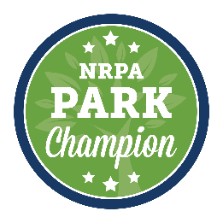
ADD DEPARTMENT LETTERHEAD/LOGO

FOR IMMEDIATE RELEASE
Media Contact:
[Contact Name]
[Agency Name]
[Phone]
[E-mail]
[Agency Name] to Host [Senator/Representative Member Name] at [Park/Facility Name]
Event is part of national Park Champions™ initiative
[City, State Abbr., Date, Year] – [Agency Name] will host [Senator/Representative Member Name] at [Park/Facility Name] on [Date]. The event is part of the National Recreation and Park Association’s (NRPA) Park Champions™ initiative, which empowers park and recreation professionals nationwide to serve as ambassadors for their community to their elected officials.
[Event Details]
[Quote from Agency Director]
Park Champions™ across the country are hosting events highlighting their parks and recreation department and programs to their U.S. representative or senators and/or their staff. To learn more about NRPA’s Park Champions™ initiative, click here.
To learn more about [Agency Name], visit [Agency Website].
To learn more about NRPA, visit www.nrpa.org.
###
[Add Department Boiler Plate]
About the National Recreation and Park Association
The National Recreation and Park Association is a national not-for-profit organization dedicated to ensuring that all Americans have access to parks and recreation for health, conservation and social equity. Through its network of 60,000 recreation and park professionals and advocates, NRPA encourages the promotion of healthy and active lifestyles, conservation initiatives and equitable access to parks and public space. For more information, visit www.nrpa.org. For digital access to NRPA’s flagship publication, Parks & Recreation, visit www.parksandrecreation.org.

