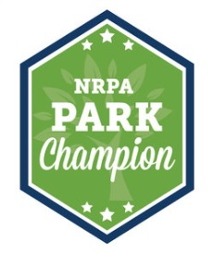
Park Champion Event Talking Points
- Our nation’s trail systems are valuable assets to local communities in improving health, increasing connectivity and driving economic growth.
- Outdoor recreation is among our nation’s largest economic sectors, with consumers spending $887 billion annually on outdoor recreation and creating 7.6 million American jobs.
- Trails are a great investment! Local parks and recreation alone generates over $140 billion in economic activity and supports over a million jobs.
- Trails are a great value! A recent study by NRPA showed that 4 in 5 Americans concur that local parks and recreation is well worth the tax dollars spent on them, with 30% of respondents believing they are worth even more.
- How Congress can support parks and recreation:
  - Support dedicated funding for active transportation, including the Transportation Alternatives Program and the Recreational Trails Program.
  - Fully fund and make permanent the Land and Water Conservation Fund.
  - Include active transportation options as part of any new federal infrastructure investment strategy, including trail development and maintenance on public lands.
  - While volunteers do much of the work, support robust funding for the National Park Service, U.S. Forest Service, and other public land agencies at the federal, state and local level that are responsible for managing trails.

https://outdoorindustry.org/wp-content/uploads/2017/04/OIA_RecEconomy_FINAL_Single.pdf
https://www.nrpa.org/contentassets/f568e0ca499743a08148e3593c860fc5/economic-impact-study-summary.pdf
http://www.nrpa.org/uploadedFiles/nrpa.org/Publications_and_Research/Research/Park-Perception-Study-NRPA-summary.pdf

